Deployment Guide—Windows and Linux
Contents
Deployment Guide—Windows and Linux 1
Preface 5
Deployment Overview 7
Components in a Decentralized Nymi Agent Configuration 7
Components in a Centralized Nymi Agent Configuration 9
Deployment of the Nymi WebAPI 11
Nymi WebAPI Configuration Overview 12
Prepare for Connected Worker Platform Deployment 12
Hardware and Software Requirements 12
NES Requirements 12
Time Synchronization Requirements 13
User Terminal Requirements 13
Nymi Lock Control Considerations 14
Nymi WebAPI Interface Requirements 15
Networking Requirements 15
Domain Name Service Requirements for Non-Clustered Deployment 15
Firewall Port Requirements 16
Connected Worker Platform Certificate Requirements 17
TLS Certificate Requirements 18
Issuing TLS Certificates Using Untrusted Certificate Authorities 19
Certificates for Nymi WebAPI 19
Active Directory Requirements 19
Domain and Trust Requirements 19
Creating the Active Directory Group for NES 20
(Optional) Creating an Organizational Unit for User Terminals 20
Creating the Nymi Infrastructure Service Account 20
Database Requirements 20
Creating the NES database 21
Configuring SQL Database for Remote Access 21
CWP Package Requirements 23
Obtaining the NES Software Package 23
Deploy NES in a Standalone Configuration 24
Install and Configure IIS 24
Installing IIS and ASP.NET 24
Importing the TLS server certificate 26
Adding HTTPS site bindings 29
Creating an Application Pool for Authentication Service 31
Verifying the Authentication Configuration 34
Securing IIS 35
Importing a Fullchain Certificate 37
Importing Certificates 38
Moving the L2 certificate 41
Installing NES 42
Installing the NES Services Suite using the wizard 42
Configuring NES Services Manually 44
Saving the NES Configuration File for Silent Installations 56
Deploying the NES URL to User Terminals by using group policies 57
Deploying the Nymi Agent URL to User Terminals by using group policies 58
Configuring NES from a Configuration File 59
Configuring NES Silently from the Command Line 60
Configuring NES With a Configure File in the NES Setup Wizard 61
Configuring IIS to Prevent NES Offloading 62
Validating the NES Deployment 67
Access the NES Administrator Console 67
Configuring NES to support Nymi Lock Control 69
Hardening the NES Keystore 69
(Optional)Encrypting usernames in the NES Database 77
Set Up a Centralized Nymi Agent 79
Install Nymi Agent on a Centralized Server 79
Performing a Nymi Agent Installation or Update By Using the Installation Wizard 79
Performing a Silent Nymi Agent Installation or Update 83
Adding TLS Certificate for Nymi WebAPI 84
Configuring the Nymi Agent for WebAPI 84
Install and Configure Endpoints 86
Install and Configure Endpoints with a Decentralized Nymi Agent 86
Bluetooth Adapter Placement 87
Set Up the Enrollment Terminal 87
Importing the Root CA certificate 88
Install the Nymi Band Application 90
Install the Nymi Band Application Silently 90
Installing the Nymi Runtime Silently 90
Installing the Nymi Band Application Silently 90
Installing the Nymi Band Application with the Installation Wizard 91
Configuring the Nymi Enterprise Server URL 92
Disabling Evidian Enrollment 93
(Optional) Configuring the Communication Protocol 93
Set Up Windows User Terminals for Authentication Tasks 94
Importing the Root CA certificate 94
(Windows) Install Nymi Runtime 96
Installing the Nymi Runtime Silently 96
Performing a Customizable Nymi Runtime Installation or Update 97
Configuring the Connected Worker Platform Communication Protocol 98
Set Up Windows User Terminals for Lock and Unlock 99
Configuring Nymi Lock Control 99
Importing the Root CA certificate 100
Install Nymi Lock Control 102
Installing Nymi Lock Control Silently 102
Installing the Nymi Runtime Silently 102
Installing or Updating Nymi Lock Control Silently 103
Installing or Updating Nymi Lock Control with the Installation Wizard 103
Configuring the Nymi Enterprise Server URL 104
Configuring the Connected Worker Platform Communication Protocol 105
Edit the Nymi Bluetooth Endpoint Configuration File 106
Editing the nbe.toml File 107
Install and Configure Endpoints with a Centralized Nymi Agent 108
Set Up Enrollment Terminal 109
Deploy a Centralized Enrollment Terminal 109
Install a Centralized Nymi Band Application 109
Install the Nymi Band Application Silently 109
Installing Nymi Bluetooth Endpoint Silently 109
Installing the Nymi Band Application Silently 110
Installing the Nymi Band Application with the Installation Wizard 110
Configuring Nymi Band Application to use a Centralized Nymi Agent 112
Configuring the Nymi Enterprise Server URL 113
Editing the Nymi Bluetooth Endpoint Configuration File 113
Deploy a Decentralized Enrollment Terminal 114
Install the Nymi Band Application 114
Install the Nymi Band Application Silently 114
Installing the Nymi Runtime Silently 114
Installing the Nymi Band Application Silently 114
Installing the Nymi Band Application with the Installation Wizard 115
Configuring the Nymi Enterprise Server URL 116
(Optional) Configuring the Communication Protocol 117
Set Up User Terminals for Authentication Tasks 117
Bluetooth Adapter Placement 118
Importing the TLS Certificate into Firefox 118
Importing the Root CA Certificate in Citrix/RDP Environments 118
(Windows) Install the Nymi Bluetooth Endpoint 120
Installing the Nymi Bluetooth Endpoint By Using the Installation Wizard 120
Installing Nymi Bluetooth Endpoint Silently 123
(HP Thin Pro) Installing Nymi Bluetooth Endpoint 124
(Windows and HP Thin Pro) Editing the Nymi Bluetooth Endpoint Configuration File 124
(IGEL) Installing Nymi Bluetooth Endpoint 125
Uploading Nymi Packages to Universal Management Suite 125
Creating a Profile and Custom Partition 126
Customizing the Custom Partition 129
Assigning the Profile to iGel Devices 132
(Windows and HP Thin Pro) Editing the Nymi Bluetooth Endpoint Configuration File 133
Configuring the Connected Worker Platform Communication Protocol 134
Set Up User Terminals for Lock and Unlock 135
Configuring Nymi Lock Control 135
Importing the Root CA Certificate in Citrix/RDP Environments 136
Install Nymi Lock Control 138
Installing Nymi Lock Control Silently 138
Installing Nymi Bluetooth Endpoint Silently 138
Installing or Updating Nymi Lock Control Silently 139
Installing Nymi Lock Control with the Installation Wizard 139
(Windows and HP Thin Pro) Editing the Nymi Bluetooth Endpoint Configuration File 141
Setting the NES URL 142
Configuring the Connected Worker Platform Communication Protocol 142
Configuring support for Citrix/RDP Lock and Unlock 143
Configuring Support for Virtual Desktop Lock and Unlock 143
Updating Connected Worker Platform 144
Creating the Nymi Infrastructure Service Account 145
Updating NES 145
Update Centralized Nymi Agent 147
Uninstalling the Nymi Runtime 147
Install Nymi Agent on a Centralized Server 147
Performing a Nymi Agent Installation or Update By Using the Installation Wizard 147
Performing a Silent Nymi Agent Installation or Update 151
Updating the Enrollment Terminal 152
Uninstalling the Nymi Runtime 152
Deploy a Centralized Enrollment Terminal 152
Install a Centralized Nymi Band Application 152
Install the Nymi Band Application Silently 152
Installing Nymi Bluetooth Endpoint Silently 153
Installing the Nymi Band Application Silently 153
Installing the Nymi Band Application with the Installation Wizard 153
Deploy a Decentralized Enrollment Terminal 155
Install the Nymi Band Application 155
Install the Nymi Band Application Silently 155
Installing the Nymi Runtime Silently 156
Installing the Nymi Band Application Silently 156
Installing the Nymi Band Application with the Installation Wizard 156
Updating the Centralized Nymi Agent and Windows Thin Clients 158
Uninstalling the Nymi Runtime 158
Update Centralized Nymi Agent 158
Performing a Nymi Agent Installation or Update By Using the Installation Wizard 158
Configuring Nymi Agent 162
Performing a Silent Nymi Agent Installation or Update 163
(Windows) Install the Nymi Bluetooth Endpoint 164
Installing the Nymi Bluetooth Endpoint By Using the Installation Wizard 164
Installing Nymi Bluetooth Endpoint Silently 167
Update Nymi Lock Control 168
Updating Nymi Lock Control with the Installation Wizard 168
Installing or Updating Nymi Lock Control Silently 168
Update IGEL Clients 168
Uploading Nymi Packages to Universal Management Suite 168
Updating Nymi Bluetooth Endpoint on IGEL 169
Updating Thick Client User Terminals 174
Uninstalling the Nymi Runtime 174
(Windows) Install Nymi Runtime 174
Installing Nymi Runtime with the Installation Wizard 174
Installing Nymi Runtime Silently 175
(HP Thin Pro) Installing Nymi Bluetooth Endpoint 176
Update Nymi Lock Control 177
Installing or Updating Nymi Lock Control with the Installation Wizard 177
Installing or Updating Nymi Lock Control Silently 178
Updating the Nymi Band Firmware 178
Updating the Firmware on Multiple Nymi Bands 178
Updating the Firmware on a Nymi Band 180
Firmware updater log files 181
Changing the Connected Worker Platform Communication Protocol 181
Appendix—Recording the CWP Variables 182
Appendix—Recording the CWP Component FQDNs 182
Appendix—TLS Certificates Expiration Dates 183

Preface
NymiTM provides the Connected Worker Platform(CWP) solution, which connects people with technology through safe, simple, and secure solutions. CWP supports numerous use cases and digital systems, and combines point solutions into a single offering. CWP simplifies the connection of workers to the digital space that is found in modern organizations.
CWP contains the following elements:
- Device Hardware—Refers to the Nymi BandTM and firmware.
- Infrastructure—Consists of software, such as the Nymi SDK, Nymi Runtime, Nymi Enterprise Server, and the Nymi Band Application.
Purpose
This guide provides detailed information about the steps that an IT administrator performs to deploy or update the components of the CWP solution in an environment that consists of Windows or Linux machines.
Audience
This guide provides information to IT administrators who manage the CWP infrastructure and are familiar with Windows server, Active Directory, and command line tools.
Revision history
The following table outlines the revision history for this document.
Table 1: Revision history
Version | Date | Revision history
1.0 | March 16, 2024 | First release of this document for the CWP 1.16.0 release.
Related documentation
- Nymi Connected Worker Platform—Overview Guide
This document provides overview information about the Connected Worker Platform (CWP) solution, such as component overview, deployment options, and supporting documentation information.
- Nymi Connected Worker Platform—Administration Guide
This document provides information about how to use the NES Administrator Console to manage the Connected Worker Platform (CWP) system. This document describes how to set up, use and manage the Nymi Band™, and how to use the Nymi Band Application. This document also provides instructions on deploying the Nymi Band Application and Nymi Runtime components.
- Nymi SDK Developer Guide—NymiAPI(Windows)
This document provides information about how to develop Nymi-enabled Applications by using the Nymi API(NAPI).
- Nymi SDK Developer Guide—Webapi(Windows)
This document provides information about how to understand and develop Nymi-enabled Applications (NEA) on Windows by utilizing the functionality of the Nymi SDK, over a WebSocket connection that is managed by a web-based or other application.
- Connected Worker Platform with Evidian Installation and Configuration Guide
The Nymi Connected Worker Platform with Evidian Guides provides information about installing the Evidian components and configuration options based on your deployment. Separate guides are provided for Wearable, RFID-only, and mixed Wearable and RFID-only deployments.
- Nymi Connected Worker Platform—Troubleshooting Guide
This document provides information about how to troubleshoot issues and the error messages that you might experience with the NES Administrator Console, the Nymi Enterprise Server deployment, the Nymi Band, and the Nymi Band Application.
- Nymi Connected Worker Platform with Evidian Troubleshooting Guide
This document provides overview information about how to troubleshoot issues that you might experience when using the Nymi solution with Evidian.
- Nymi Connected Worker Platform—FIDO2 Deployment Guide
The Nymi Connected Worker Platform—FIDO2 Deployment Guide provides information about how to configure Connected Worker Platform and FIDO2 components to allow authenticated users to use the Nymi Band to perform authentication operations.
- Connected Worker Platform with POMSnet Installation and Configuration Guide
The Nymi Connected Worker Platform—POMSnet Installation and Configuration Guides provides information about how to configure the Connected Worker Platform and POMSnet components to allow authenticated users to use the Nymi Band to perform authentication operations in POMSnet.
- Nymi Band Regulatory Guide
This guide provides regulatory information for the Generation 3 (GEN3) Nymi Band.
- Third-party Licenses
The Nymi Connected Worker Platform—Third Party Licenses Document contains information about open source applications that are used in Nymi product offerings.
How to get product help
If the Nymi software or hardware does not function as described in this document, you can submit a support ticket to Nymi, or emailsupport@nymi.com
How to provide documentation feedback
Feedback helps Nymi to improve the accuracy, organization, and overall quality of the documentation suite. You can submit feedback by usingsupport@nymi.com

Deployment Overview
You can deploy the Nymi solution in two different configurations, where you install the Nymi Agent software on each user terminal or you deploy a single instance of the Nymi Agent in a centralized location and configure endpoints to use the centralized Nymi Agent.
Review the following information to decide which configuration to deploy.
Decentralized Nymi Agent | If your environment meets all of the following configuration scenarios, you can deploy a decentralized Nymi Agent solution.  - User terminals are thick Windows clients only.  - User Terminals perform Nymi Band taps in native MES application.
Centralized Nymi Agent | If your environment meets any of the following configuration scenarios, you must deploy a centralized Nymi Agent solution.  - User Terminals are iOS clients.  - User Terminals include thin clients, such as HP ThinPro, RDP, and Citrix.  - User Terminals perform Nymi Band taps in web-based MES applications, such as POMSnet.
Note: You can deploy a configuration that uses a mixture of user terminals with centralized or decentralized Nymi Agent but for simplicity Nymi recommends that it you choose one and configure your all your user terminals to use a centralized or decentralized Nymi Agent.

Components in a Decentralized Nymi Agent Configuration
The Connected Worker Platform(CWP) enables users to use Nymi Bands and administrators to manage Nymi Bands and CWP components in an enterprise setting. CWP is comprised of Nymi-specific components and enterprise components, as shown in the following figure.
Figure 1: Connected Worker Platform components and connection ports
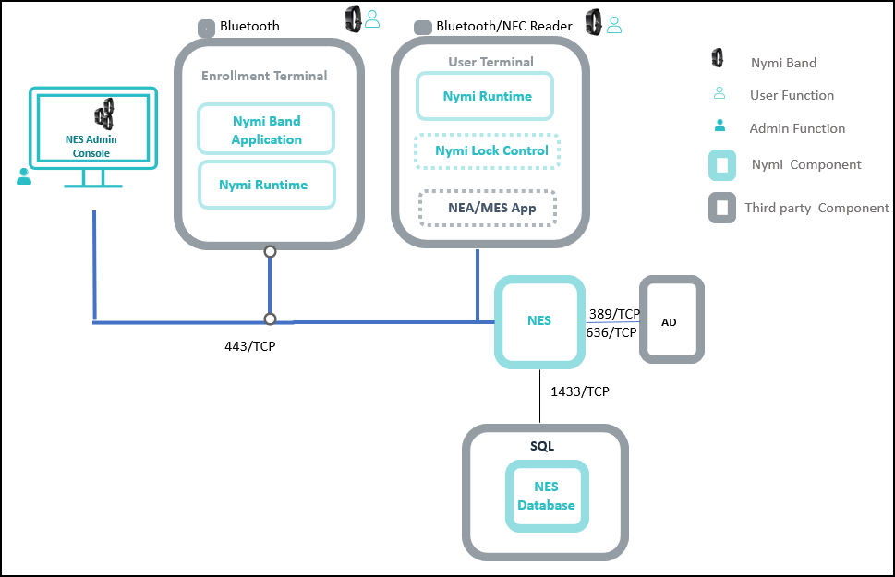
The Connected Worker Platform consists of the following components.
Table 2: Connected Worker Platform Components
Component | Description
Enrollment Terminal | Windows 10 endpoint that users access to enroll their Nymi Band.
Nymi Band Application (NBA) | A Windows application that you install on the enrollment terminal that you use to enroll a new user and link them to their Nymi Band. The Nymi Band Application requires the Nymi Runtime application, which the Nymi Band Application automatically installs. The Nymi Band Application communicates with the Nymi Band through the Nymi-supplied Bluetooth adapter, which you plug into a USB port on the enrollment terminal.
Nymi Runtime | A Windows application that you install on the enrollment terminal and user terminals. Nymi Runtime includes the Nymi Agent and Nymi Bluetooth Endpoint components. Nymi Runtime supports communication between NES, the Nymi Band, NEAs, the Nymi Band Application and Nymi Lock Control. Nymi Runtime supports communication between NES, the Nymi Band and Rockwell Pharmasuite.
User Terminal | Windows 10 endpoint on which you install Nymi components that allow users to perform authentication tasks with the Nymi Band."
Nymi Band | A wearable device that the assigned user with their biometrics. An authenticated Nymi Band is Bluetooth Low Energy (BLE) and Near Field Communication (NFC)-enabled.
Nymi-enabled Application | Developers can create corporate applications that integrate with Connected Worker Platform by using the Nymi API. These applications are called Nymi-enabled Applications (NEAs) and include Manufacturing Execution Systems (MES), Single Sign-On (SSO), and Human Machine Interface (HMI) applications. An NEA requires the Nymi Runtime software.
Nymi Lock Control | A Windows application that allows the user to unlock their terminal without entering their username and password, and automatically lock the user terminal when they walk away.
Nymi Enterprise Server (NES) | - A management server and collection of services that provides the NES Administrator Console and coordinates communication between the Nymi Band and the customer identity ecosystem (Active Directory) to manage policies and certificates.  Includes the following services:  - Enrollment Service (ES)—Authenticates, validates, and authorizes certificate requests from requesters, such as the Nymi Band Application and NEAs.  - Directory and Policy Services (DPS)—Maintains the NES database, which contains a list of Active Directory (AD) users and the Nymi Bands that are associated with each user. Provides IIS web services, which allows the NES Administrator Console access to the NES database.  - Authentication Service (AS)—Provides authentication and authorization support for domain users and computers. AS uses adapters to interface with external directory and database systems, such as an AD adapter to interface with Active Directory.
SQL Server | Database that contains table that store information about NES configuration and Nymi Bands. For Proof of Concept (POC) and pre-production environments, you can use the Nymi-provided SQL Server Express software. For production environments Nymi recommends that you use SQL server.
Domain Controller (DC) | Windows server with Active Directory.

Components in a Centralized Nymi Agent Configuration
A Connected Worker Platform deployment in an environment that uses MES applications that are hosted on an RDP /Citrix server contain the same components as a Connected Worker Platform deployment in a local environment, but some components are configured differently.
The following figure provides an overview of the Connected Worker Platform components in a centralized Nymi Agent environment.
Figure 2: Connected Worker Platform components in a Citrix/RDP environment
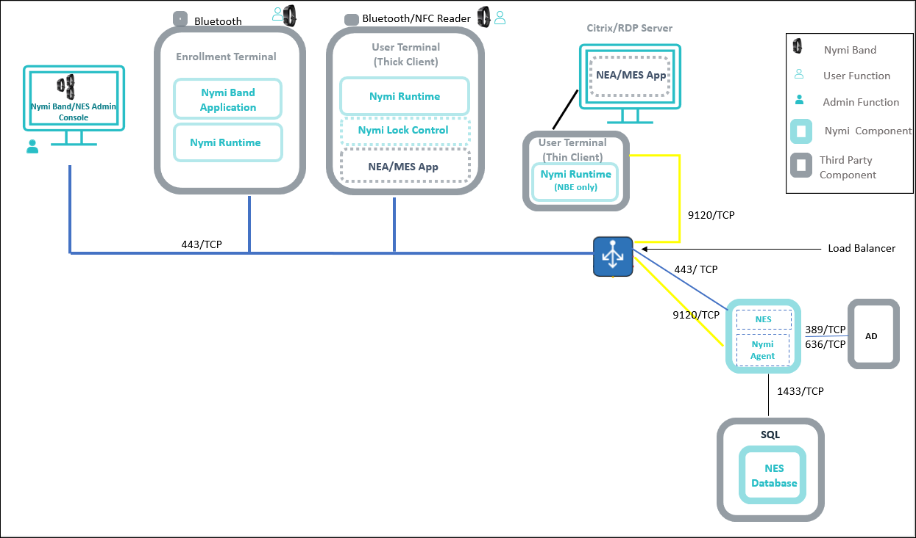
The following table summarizes how the component configurations differ in a remote environment. For general information about the Connected Worker Platform components, see the section Connected Worker Platform Components in a Local Environment.
Note: While not displayed, it is assumed that NES, Nymi Agent, and the CWP Backend components are clustered.
Table 3: Connected Worker Platform Components
Component | Description
Enrollment Terminal | Windows 10 endpoint that users access to enroll their Nymi Band. Nymi recommends that you use a thick client for the enrollment terminal.
User Terminal (thick client) | A Windows 10 endpoint that users use to:  - Access a remote session host and launch an NEA that is installed on a remote session host.  - Use Nymi Lock Control to lock and unlock the desktop.  When you install Nymi Runtime on the user terminal, only install the Nymi Bluetooth Endpoint component. The nbe.toml file defines the location of the centralized Nymi Agent. The Nymi Bluetooth Endpoint service communicates with the Nymi Agent service over websocket port 9120.
User Terminal (thin client) | An endpoint that users use to:  - Access a remote session host and launch an NEA that is installed on a remote session host.  - Use Nymi Lock Control to lock and unlock the remote or virtual desktop.  When you install Nymi Runtime on the user terminal, only install the Nymi Bluetooth Endpoint component. The nbe.toml file defines the location of the centralized Nymi Agent. The Nymi Bluetooth Endpoint service communicates with the Nymi Agent service over websocket port 9120.
Citrix/RDP server | Remote session host. In Citrix and RDP environments, the user uses a thin client to connect to a remote session host and then launches an NEA that is installed on a remote session host. Different user sessions run their own NEA instance.
Centralized Nymi Agent | Nymi Runtime component that you install in a central location on a single machine or a cluster of two or more machines that is accessible to all user terminals, for example on the server with the NES application. Provides BLE management, manages operations and message routing. Facilitates communication between NEAs and the Nymi Band, and maintains knowledge of the Nymi Band presence and authenticated states. .

Deployment of the Nymi WebAPI
You can deploy the Nymi WebAPI in a centralized or decentralized Nymi Agent configuration.
In a decentralized Nymi Agent configuration, you deploy Nymi Agent and Nymi Bluetooth Endpoint components on each workstation to access a locally installedNymi-enabled Application(NEA).
In a centralized Nymi Agent configuration, for example, when you use the Nymi Band with Citrix and RDP published applications or desktops, you install:
- Nymi Agent component on a server that multiple workstations can access, such as the Nymi Enterprise Server(NES) server.
- Nymi Bluetooth Endpoint component on each workstation.
Note: For more information about how to deploy a centralized Nymi Agent see the Nymi Connected Worker Platform—Deployment Guide.
The Nymi Bluetooth Endpoint and NEA must know the identity of the workstation to which the application wants to connect. By default, this identity is the IP address of the workstation. When you deploy Nymi Agent locally on the client workstation, both components use the loopback address, so they will connect automatically. When you deploy a centralized Nymi Agent, the Nymi Agent subscribes the Bluetooth Endpoint, the Nymi DLL, and WebSocket connections to the Nymi WebAPI by using the source IP of the connection. Therefore, if the Bluetooth Endpoint and application that is using the Nymi WebAPI are on the same host the application will work on connection.
For deployments in an RDP/Citrix environment or when the MES application (NEA) resides on a different host (such as a web or application server), the IP address of the client that runs the NEA is different from the IP address of the workstation. Therefore, ensure that the NEA can determine the IP address of the client workstation that runs the Nymi Bluetooth Endpoint.
- In remote desktop sessions, the IP address is usually available through Windows Terminal Services APIs.
- If you are not using RDP or Citrix, the IP address is usually available through vendor-specific environments or APIs.
- For remote applications, such as web-based application, you can determine the IP address by using the source IP address of the client requests.
When the application determines the IP address of the client workstation, the application must use the subscribe operation to connect to the correct Nymi Bluetooth Endpoint. Keep in mind that multiple IP addresses on the user workstation or NAT between components can interfere with determining client IP addresses and should be taken into consideration during deployment of an application.
If users might move between two or more client workstations, they must terminate their session before switching to another workstation, or the application must take this into account and start a new subscribe operation after reconnection.

Nymi WebAPI Configuration Overview

Review the following requirements for the Nymi WebAPI and Nymi Agent components:
- Provide access to a distinct port for each component, port numbers are described later in this document.
- Configure transport layer security: on the server or by offloading.
- Ensure that both components have connectivity to NES.
- Ensure that there is no Network Address Translation (NAT) between the Nymi WebAPI of the Nymi Agent and the user terminals.
- When you use a centralized Nymi Agent on the same server as NES, ensure that each component can co-locate with the NES (ensure that you use distinct TCP ports).

Prepare for Connected Worker Platform Deployment
Review this section for information about the requirements and steps that you mus preform to prepare for the Connected Worker Platform(CWP) components .

Hardware and Software Requirements
The following sections provide more information about the hardware and software requirements for Connected Worker Platform components.

NES Requirements
The following sections define the hardware and software requirements to consider before you deploy NES.
Hardware Requirements
The NES hardware requirements differ based on the nature of user operations, load and other software that is deployed on the same server. The following section lists the recommendations for minimum hardware requirements.
- 1-5000 users:
  - 4 Core CPU
  - 8GB RAM
  - 20GB free disk space
- 5000-10000 users:
  - 4 Core CPU
  - 16GB RAM
  - 40GB free disk space
Software Requirements
NES has the following software requirements.
- Microsoft Windows Server 2016, 2019, or 2022
Note: Ensure that the NES host is not a Domain Controller (DC).
- Microsoft IIS
- Microsoft .NET Framework 4.8
Note: The NES installation package includes Microsoft .NET Framework 4.8, and installs the software if required.

Time Synchronization Requirements
Nymi Band enrollments require time synchronization between the Enrollment Terminal and NES.
When the Enrollment Terminal is on a domain, the time source for both the Enrollment Terminal and NES is Active Directory Domain Services (AD DS). If your Enrollment Terminal is not joined to a domain, ensure that you find an alternate method to synchronize both the Enrollment Terminal and NES with a reliable time source.

User Terminal Requirements
User terminals are endpoints that can perform different functions in the environment, including enrollment, MES authentication tasks, and desktop locking and unlocking with Nymi Lock Control. User terminals include thick clients and thin clients.
Hardware and Software Requirements
All thick client user terminals require connectivity to the server on which you install Nymi Enterprise Server(NES). The following table summarizes the supported operating systems and the hardware device requirements for each user terminal use case.
Note: You can configure and use a user terminal for multiple use cases.
Use Cases | Supported Operating System/Browser | Hardware
Enrollment | - Windows 10, 64-bit, minimum build version 1607  - Windows 7, 64-bit  Note: Nymi recommends that you use 125% scaling and 1920 x 1080 screen resolution for the terminal hosting the Nymi Band Application | - 4GB RAM  - 5GB free disk space  - 2 core CPU (recommended)  - 1 USB 2.0 port  - Nymi-supplied bluetooth adapter
Authentication tasks with a Nymi Band in a MES application(Nymi-enabled Applications(NEAs) on Windows, HP ThinPro, and IGEL | - Windows 10 x86-64, including on Citrix, RDP, and VMWare Horizon, minimum build version 1607  - HP ThinPro x86-64, including on VMWare Horizon  - IGEL OS v10, including IGEL Thin Client on Citrix  Tested web browsers for web-based NEAs:  - Firefox 70 and later  - Chrome 78 and later  - Internet Explorer 11 and later  - Microsoft Edge 44.18362.387.0 | - Nymi-supplied Bluetooth adapter  - NFC reader (optional)
Locking and Unlocking the Desktop | - Windows 10 x86-64, including on Citrix, RDP, and VMWare Horizon. Minimum build version 1607  - HP ThinPro x86-64, including on VMWare Horizon | - Nymi-supplied Bluetooth adapter  - NFC reader (optional)
Windows N Edition Requirements
Windows N Edition does not include media features by default. The Nymi Band Application includes embedded video that cannot display without the media feature pack.
To obtain the media feature pack, perform one of the following actions:
- For Windows 10, version 1909 and later, navigate to Start > Settings > Apps & features > Optional features. Click Add a feature. From the list of available optional features, select Media Feature Pack.
- For Windows 10 versions that are earlier than 1909, download and install the media feature pack from Microsoft.
- For Windows 11, navigate to Start > Settings > Apps > Optional features. Next to Add an optional feature, select View features, and then form the list of optional features, select the Media Feature Pack.

Nymi Lock Control Considerations
Review the following information about Nymi Lock Control
- Nymi Lock Control is a single domain solution. All terminals must be on the same domain as the Nymi Enterprise Server host, not across separate domains.
- Nymi Lock Control users can lock the desktop of a user terminal and the desktop of a Microsoft Remote Desktop Connection and Citrix when Network Level Authentication (NLA) is disabled.
- Each user terminal requires a connected Bluetooth Low Energy (BLE) radio antenna, such as a Bluegiga BLE adapter..

Nymi WebAPI Interface Requirements
Nymi provides an API interface that supports web-based Nymi-enabled Applications called Nymi WebAPI.
Consider the following:
- In an environment where thick clients access web-based NEAs, you can install both the Nymi Bluetooth Endpoint and Nymi Agent components of the Nymi Runtime package.
- In an environment where thin clients access web-based NEAs on an RDP/Citrix server you must install the Nymi Bluetooth Endpoint component of the Nymi Runtime on the thin client user terminal, and install the Nymi Agent on a server that is accessible to all thin clients.
Configuring and deploying in a environment with thin client user terminals
Take the following into consideration when configuring the solution in a physical environment.
- Ensure that Nymi Agent and user terminals have connectivity to NES.
- Ensure that the Nymi Agent and Nymi WebAPI components use a distinct TCP port.
- Determine how to configure transport layer security, either by configuring it on the server or by offloading.
- If there is a Network Address Translation (NAT) between the Nymi Agent and the thick clients, ensure that your NEA use the subscribe operation. See the Nymi SDK Developer Guide—Webapi(Windows) provides more information.
- Each component can co-locate with the NES (ensure that distinct TCP ports are being used).

Networking Requirements
TheNymi solution requires Domain Name Service (DNS) and firewall port changes to support inter-component communications.

Domain Name Service Requirements for Non-Clustered Deployment
The Connected Worker Platform(CWP) solution uses fully-qualified domain names (FQDNs) that point to CWP infrastructure services that are accessed by CWP applications, such as Nymi Band Application or by administrators through a browser (Nymi Band Management Console).
Non-Clustered CWP Deployment
In a non-clustered CWP deployment, you must assign FQDNs to the following components.
Note: This guide uses company.com as an example domain name and cwp.company.com as an example subdomain name.
Record each FQDN value in Appendix—Recording the CWP Component FQDNs.
Table 4: FQDN Requirements
Component | FQDN Example
Nymi Enterprise Server(NES) | nes.cwp.company.com

Firewall Port Requirements
The Nymi Solution uses connection ports to facilitate bidirectional communications between components.
Connection Port Requirements
The following table provides a summary of the connection port requirements for the Nymi Solution and FQDNs. Ensure that you replace the sample FQDNs with the actual FQDNs for your virtual servers. For each row that contains load balancer port information, you must configure virtual server on a load balancer to distribute traffic to the destinations. The load balancer must accept incoming traffic on the load balancer port.
Note: Your firewall and load balancer might require configuration changes to allow the specific protocol that is specified in the Protocol column of the table. Refer to your firewall or load balancer documentation for more information.
Record the virtual server FQDN and port for each component in Appendix—Record the CWP Variables.
Table 5: Connection Port Requirements
Purpose | Protocol | Source | Virtual Server FQDN & Port | Destination and Port
SQL Access | MS SQL  Proprietary | NES | n/a | SQL Server:  1433/TCP
LDAP Access-Active Directory(AD) | LDAP/LDAPS | NES | n/a | AD Server:  389/TCP (For LDAP configurations)  636/TCP (For LDAPS configurations)
NES Communications | HTTPS | Machine that accesses NES Administrator Console  All User Terminals (thick).  RDP/Citrix server that run NEAsCentralized Nymi Agent | nes.cwp. company.com:  443/TCP | NES:  443/TCP
Supports Centralized Nymi Agent communications. Nymi Agent receives incoming WebSocket connections on TCP port 9120, which is used for communication with Nymi Bluetooth Endpoint and native Nymi-enabled Applications(NEAs) | Websocket | All User Terminals (thick and thin)  RDP/Citrix Servers that run NEAs | nymiagent.cwp. company.com  9120/TCP | nymiagent-0.cwp. company.com  nymiagent-1.cwp. company.com:  9120/TCP
Supports centralized Nymi Agent (in Webapi mode) from Nymi Bluetooth Endpoints and web-based NEAs. | Websocket (WS) / Secure Websocket (WSS) | All User Terminals (thick) | nymiagentwebapi. cwp.company.com  8080/TCP (WS protocol)  4443/TCP (WSS protocol) | nymiagentwebapi-0. cwp.company.com  nymiagentwebapi-1. cwp.company.com  8080/TCP (WS protocol)  4443/TCP (WSS protocol)

Connected Worker Platform Certificate Requirements
The Connected Worker Platform relies on several certificates to ensure secure communications.
The Connected Worker Platform(CWP) solution uses the following certificates:
- TLS Certificates—Required to support secure communications over TLS between CWP components. These certificates serve the same purpose as typical TLS certificate that support secure communications within your enterprise network, for example for web and email traffic. Contact your security team to obtain the TLS certificates for your CWP deployment.
Note: If you use a self-signed TLS certificate or a certificate that was issued by an untrusted private root CA, you require a Root CA Certificate. You must import the Root CA Certificate on each user terminal, the enrollment terminal, Citrix/RDP clients, and the NES server. This guide describes how to import the Root CA Certificate.
- Nymi-specific Certificates—Required to support secure communications between Nymi Bands and CWP services. Nymi provides two certificate files:
  - Fullchain PFX file, which you obtain from your Nymi Solution Consultant. This certificate is unique for each organization and includes the following content:
    - Nymi Infrastructure Root CA certificate
    - NES L1 certificate
    - NES L2 certificate and associated private key
This guide describes how to implement the full chain certificate when you deploy NES.
  - Nymi Band PKI certificate files:
    - Nymi Band Root CA Gold
    - Nymi Band Subordinate CA Gold
The Nymi Band PKI certificate files are included in the NES installation package and the NES installation automatically installs the certificate.
- For more information about the Nymi-specific certificates, refer to the Connected Worker Platform Security Whitepaper.
The following figure provides a high-level overview of the certificates that the Connected Worker Platform requires.
Figure 3: Certificates required in a Connected Worker Platform environment
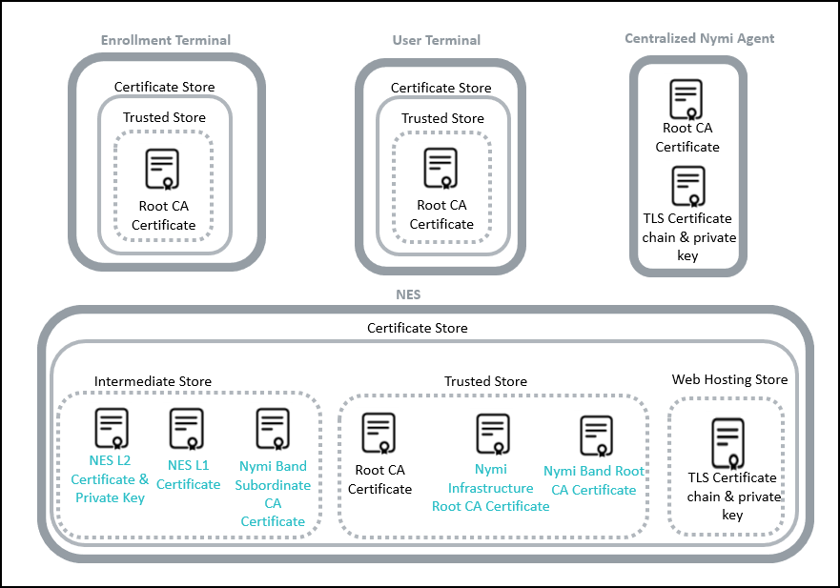

TLS Certificate Requirements
Ensure that you use a trusted Certificate Authority(CA) to issue the TLS certificate for NES. The TLS certificate must contain the appropriate fully qualified domain name(FQDN) for the subject alternative name(SAN).
Package TLS certificate and CA certificate chain that the CA provides to you with the private key of the certificate into a PKCS#12 file. Record the password of the TLS certificate in a secure manner. You will be required to provide during deployment.
Record the expiration date of the TLS certificate in Appendix—Certificate Expiration Dates.

Issuing TLS Certificates Using Untrusted Certificate Authorities
In some situations, it is not possible to issue the required TLS certificates by using a trusted Certificate Authority(CA).
An untrusted CA can be used subject to the following conditions:
- Use a single untrusted root CA to issue all TLS certificates.
- You must import the untrusted root CA certificate into each machine that communicates with the Connected Worker Platform services. The methods that you use to import the untrusted root CA certificate into each component is described later in this guide.

Certificates for Nymi WebAPI
Nymi WebAPI relies on web sockets for communications with Nymi-enabled Applications(NEAs). Nymi recommends that you secure WebSocket communications for Nymi WebAPI.
To ensure that WebSocket uses trusted communication, obtain the following certificates in base64 PEM format from your security team, and copy the files to the server that you designate as the Nymi Agent server:
- TLS Server Certificate chain including any intermediate CA certificates.
Note: You cannot use a wildcard certificate.
- Unencrypted private key that corresponds to the TLS server certificate.
- Certificate of the root Certificate Authority (CA) that issued the TLS server certificate.
The Nymi WebAPI connects to NES over HTTPS. Nymi recommends that you issue the NES TLS server certificate from a Root CA that is trusted by the workstation. If the Root CA is not trusted by the workstation, install the root CA certificate in the Trusted Root Certification Authorities container for the local machine. See Microsoft documentation for information about installing Trust Root Certificates:https://docs.microsoft.com/en-us/skype-sdk/sdn/articles/installing-the-trusted-root-certificate.html

Active Directory Requirements
The Connected Worker Platform(CWP) relies Windows Active Directory(AD) for user identity and authentication. Review the following sections for information about AD domain, AD groups, and service account requirements.

Domain and Trust Requirements
Connected Worker Platform(CWP) supports environments that have users and administrators in a domain that differs from the domain in which the NES server resides, within the same forests or different forests.
Domain Requirements
Record the following configuration information about the Active Directory in Appendix—Record the CWP Variables. You require this information during the NES deployment process.
- Communication protocol that NES uses to connect to the Active Directory. For example, LDAP or LDAPs.
- Port number on which to contact the Active Directory. The default port number for LDAP is 389. The default port number for LDAPS is 636.
- The NetBIOS domain name, which you can see in the properties of an AD user account.
Trust Requirements
The domain in which NES resides must trust the user domain.
Note: For Nymi with Evidian deployments, you require a selective two-way trust. The Nymi Connected Worker Platform with Evidian Guides provide more information.

Creating the Active Directory Group for NES
Perform the following actions to prepare the Domain Controller for the NES deployment.
Create an Active Directory group for users that act as an. NES Administrator. An NES Administrator is the person in the enterprise that manages the Connected Worker Platform for their workplace.
- Log into the Active Directory server with a domain administrator account.
- Create a group that contains the users who will act as NES Administrator. For example, a group named NES_admins.
When you create the group, in the Group Type section, select Security. The selection for the Group Scope depends on the configuration of the environment.
  - In a single domain environment, choose a group scope according to your IT policy.
  - In a multi-domain environment:
    - When you select Universal, you can add users and groups from any domain to the NES admins group.
    - When you select Global, you can only add users and groups that are local to the domain. If users in multiple domains require admin access to NES, you must create a global group in each domain with NES Administrator users, and add the NES Administrator users to this group.
- Record the administrator group name and a list of user accounts that you added this group, in Appendix—Record the CWP Variables.

(Optional) Creating an Organizational Unit for User Terminals
Create an Organizational Unit(OU) in Active Directory(AD) to limit the user terminals in your environment on which users can use the Nymi Lock Control software.
The NES installation wizard prompts you for this OU.

Creating the Nymi Infrastructure Service Account
Connected Worker Platform(CWP) 1.12.x and later solution uses a service account to support interprocess and SQL server communications.
Create a service account in Active Directory, that meets the following requirements:
- User account is a domain user.
- Password never expires.
Record the account name and domain in Appendix—Record the CWP Variables, which specify the credentials during the NES deployment.

Database Requirements
The Connected Worker Platform(CWP) solution can use a new or existing SQL server instance, which you can reside on the NES server or on another server in the environment.
Supported SQL Versions
CWP solution supports the following Microsoft SQL versions:
- SQL Server/SQL Server Express 2016
- SQL Server/SQL Server Express 2017
- SQL Server/SQL Server Express 2019
The NES installation package includes Microsoft SQL Server Express 2017; however, Nymi recommends that you use SQL Server in production environments.
Note: The CWP solutions uses TLS 1.2. If you use SQL Server / SQL Express 2016 or SQL Server / SQL Express 2017 you must apply a patch to provide TLS 1.2 support. Microsoft provides more information.
Configuration Requirements
Nymi recommends that you configure the SQL database to use Windows authentication mode and:
- Ensure that the account that starts the SQL Server has permissions to register an SPN in Active Directory Domain Services. Microsoft provides more information.
- Assign dbowner rights to the NES service account. Creating the Service Account for SQL Server Access provides more information about creating the service account.

Creating the NES database
If you use an SQL server that is not on the same machine as NES, install the SQL Server software if required, and then create the NES database.
Perform the following steps on a machine that has SSMS installed and has access to the SQL Server.
- Open SQL Server Management Studio (SSMS), and then login to the SQL Server.
- Right-click the SQL instance, and the select Properties.
- In the Object Explorer, select Security.
- Select SQL Server and Windows Authentication Mode, and then click OK.
- In the Object Explorer right-click Databases, and the select New Database.
- In the New Database window, perform the following actions:
  - In the Name field, type nes.
  - Click the elipses (...) beside Owner, and then in the Enter the object names to select field, type the name of the service account.
  - Click Check names.
  - In the Multiple Objects Found field, select the service account name, and then click OK.
  - On the Select Database Owner window, click OK.
  - On the New Database window, click OK.

Configuring SQL Database for Remote Access
Enable TCP/IP on the SQL instance to allow access to the database.
Perform the following actions in the SQL Server Configuration Manager application.
- In the left navigation pane, expand SQL Server Network Configuration, and then select the appropriate Protocols for the SQL Server option.
- In the right pane, select TCP/IP, and then right-click and select Enabled.
- Double-click TCP/IP.
- In the TCP/IP Properties window, select the IP addresses tab.
- Navigate to the IPALL section, and then for the TCP port value, type 1433.
The following figure provides an example of the port setting.
Figure 4: Configuring SQL Port
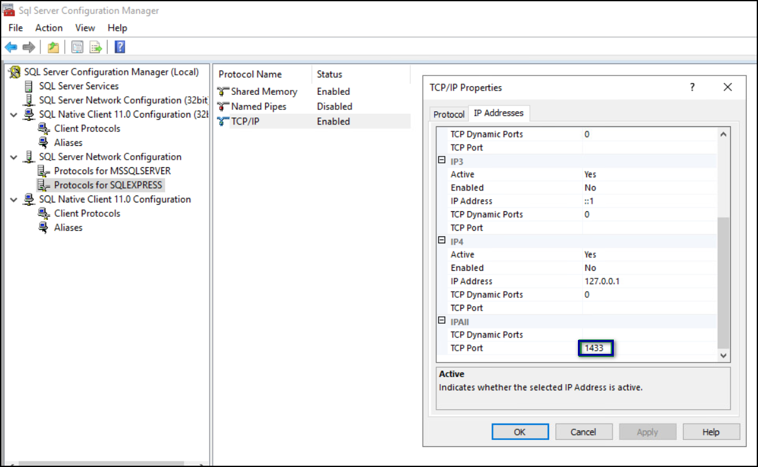
- Click OK, and then click Apply.
- On the prompt to restart the SQL services, click OK.
- Restart SQL Server services.
- For SQL Express only, perform the following steps in SQL Configuration Manager.
  - In the left navigation pane, select SQL Services.
  - Right-click SQL Server Browser, and then select Properties, as shown in the following figure
Figure 5: SQL Browser Properties option
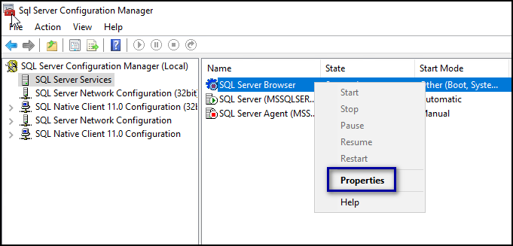
  - On the Service tab, from the Start Mode list, select Automatic, as shown in the following figure.
Figure 6: Start Mode
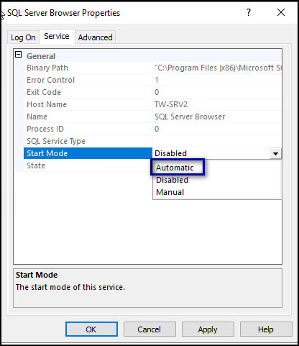
  - Right-click SQL Server Browser and select Start.
The SQL Server Browser service state changes to Start, as shown in the following figure.
Figure 7: SQL Server Browser service
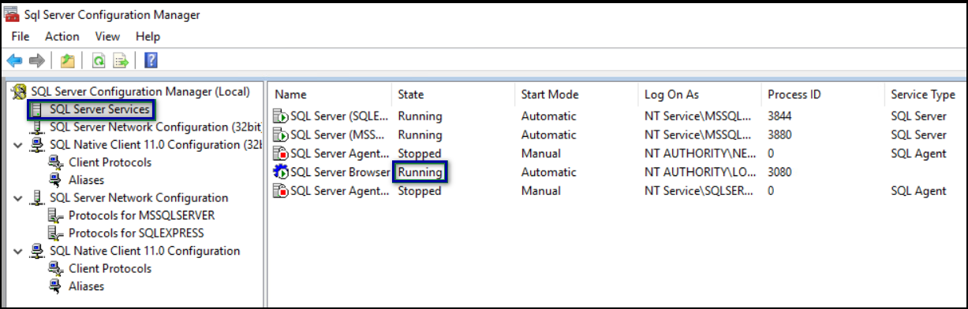

CWP Package Requirements

Obtaining the NES Software Package
Your Nymi Solution Consultant provides you with a package that installs NES.
Extract the contents of the NES software package into the C:\nestemp\ folder of the designated NES server. The package extracts the following files into the folders:
- AccessControl
- AuthenticationService
- NEnrollment
- nes
- NesCmdInstall
- NesInstaller
- NesSystemInfo
- PreRequisites

Deploy NES in a Standalone Configuration
The following sections provide information about how to deploy a standalone NES.

Install and Configure IIS
NES supports HTTP and HTTPS for communication between NES services. It is recommended to use HTTPS. To complete prerequisite activities for NES deployment, install Microsoft Internet Information Server (IIS) and Microsoft ASP.NET on the NES host, and then import the TLS server certificate into IIS for secure deployments (HTTPS).

Installing IIS and ASP.NET
This section describes how to install IIS and ASP.NET on the NES host.
- Open the Server Manager application, and then click Add roles and features.
- On the Before You Begin page, click Next.
- On the Select installation type page, leave the default value Role-based or feature-based installation, and then click Next.
- On the Select destination server page, leave the default selection Select a server from the server pool, select the host in the Server Pool list box, and then click Next.
- On the Select server roles page, click Web Server (IIS).
The Add features that are required for Web Server (IIS) dialog box appears and provides a summary of tools that are required to install IIS.
- On the Add features that are required for Web Server (IIS) dialog box, click Add Features.
- On the Select server roles page, click Next.
- On the Select features page, click Next.
- On the Web Server Role (IIS) page, click Next.
- On the Select role services page, expand Application Development, and then perform the following actions:
  - Select Application Initialization.
  - Select the latest available version of ASP.NET 4.x.
Note: NES supports ASP.NET 4.4 and later.
  - On the Add features that are required for ASP.NET dialog box, click Add Features, as shown in the following figure, and then click Next.
Figure 8: Add features that are required for ASP.NET
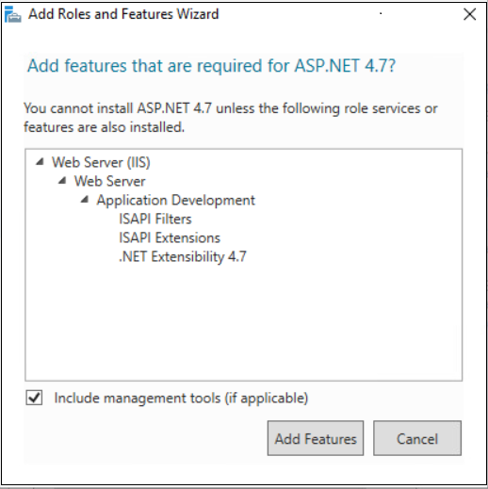
  - On the Select role services page, leave the other default options selected, and then click Next.
The following figure shows the Select server roles page.
Figure 9: Select server roles page
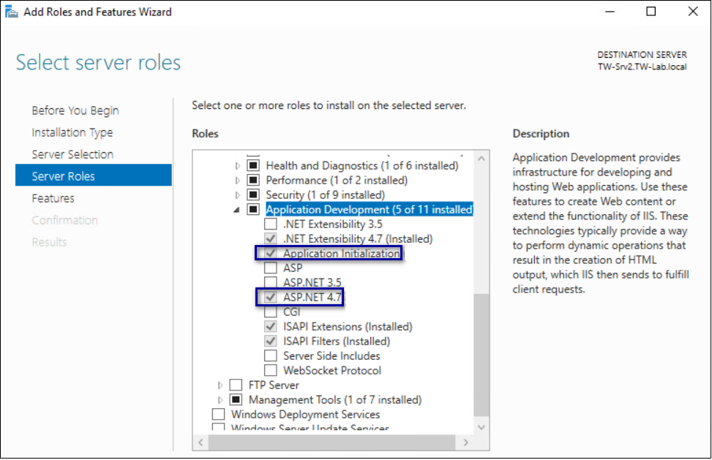
- On the Select Features page, click Next.
- On the Confirm installation selections page, click Install.
The Installation Progress page appears and provides the status of the IIS installation, which takes several minutes. When the installation completes, click Close. Restart the host, if prompted.

Importing the TLS server certificate
For HTTPS deployments, import the TLS server certificate obtained for the NES host. If the TLS server certificate is not signed by a Trusted Root CA, then you also need to import the Root CA certificate.
Note: The following procedure assumes that the TLS server certificate and the associated private key are packaged in the same file. Depending on how the private key for your certificate is generated, your procedure might differ. If you have already imported the certificate or you do not require step-by-step instruction, proceed to Adding HTTPS site bindings.
Perform the following steps in the IIS Manager to import the TLS server certificate and the associated private key.
- In the Connections navigation pane, click Computer_Name, and then in the IIS section, double-click Server Certificates.
Note: If you cannot find Server Certificates, click the Features View tab, which appears at the bottom of the window.
Figure 10: Server Certificates option
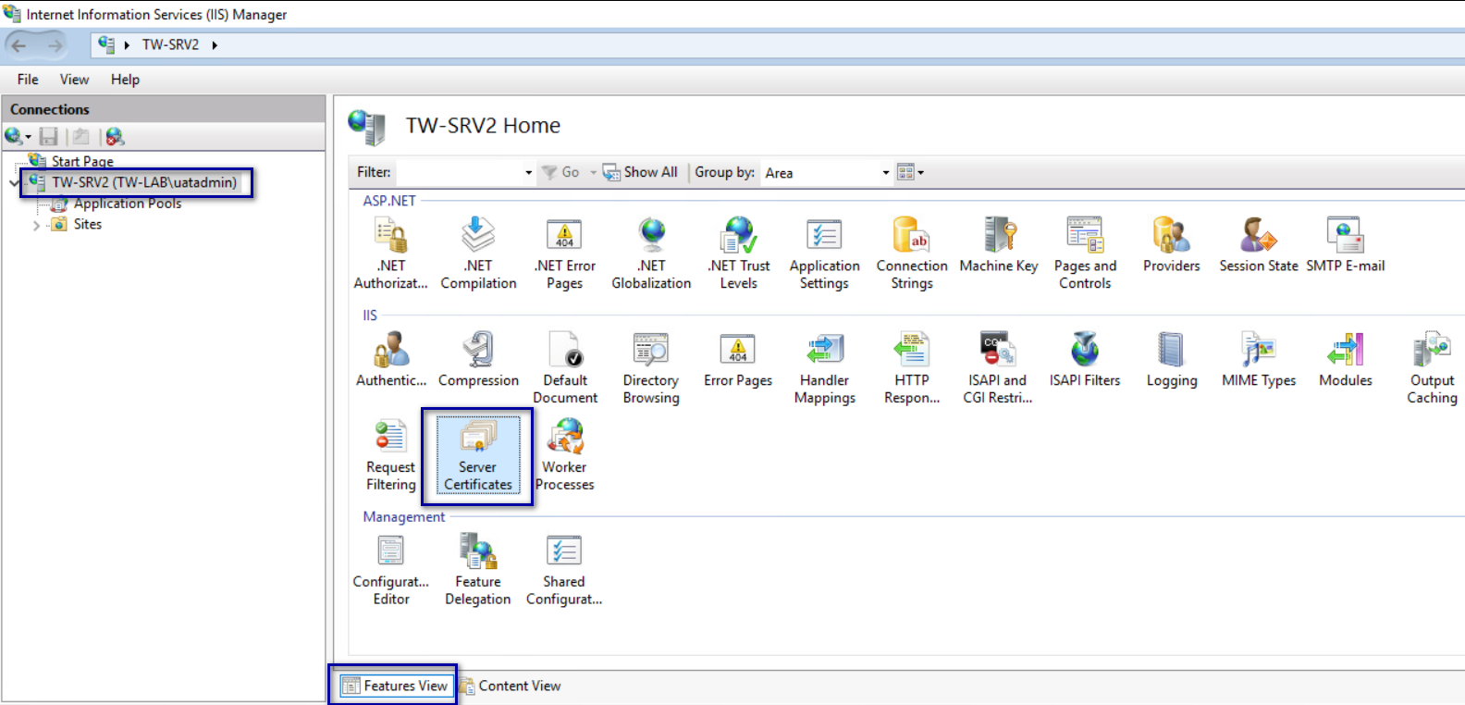
- In the Actions navigation pane, on the right side of the window, click Import.
- In the Import Certificate window perform the following actions:
  - In the Certificate file (.pfx) field, click the ellipsis (…) button, change the extension list to *.*, browse to the location of the TLS certificate, select the certificate file, and then click Open.
  - In the Password field, type the password that was used to encrypt the private key, and then click OK.
  - In the Select Certificate Store list, select Web Hosting.
The following figure provides an example of the Import Certificates window.
Figure 11: Server Certificates option
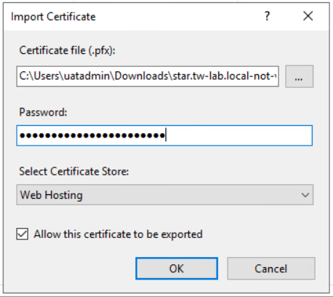
  - Click OK.
- Minimize IIS.
- Perform the following steps using the Certificate MMC to import the Root CA certificate (if needed).
  - From the Window toolbar, in the Search field, type Manage Computer, and then select Manage computer certificates.
  - On the User Account Control dialog, click Yes.
  - Expand Certificates - Local Computer > Trusted Root Certificate Authority.
  - Right-click Certificates, and then select All Tasks > Import, as shown in the following figure.
Figure 12: Import Certificate option
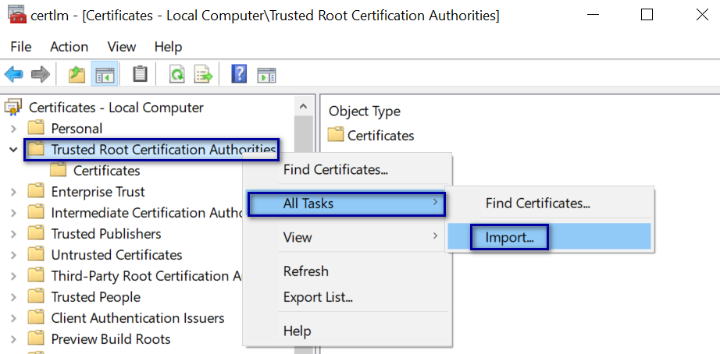
  - On the Welcome to the Certificate Import Wizard screen, click Next.
The following figure shows the Welcome to the Certificate Import Wizard screen.
Figure 13: Welcome to the Certificate Import Wizard screen
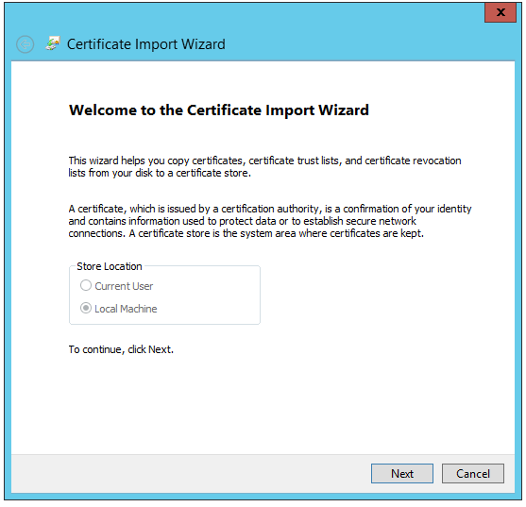
  - On the File to Import screen, click Browse, navigate to the folder that contains the root certificate file, select the file, and then click Open.
The following figure shows the File to Import screen.
Figure 14: File to Import screen
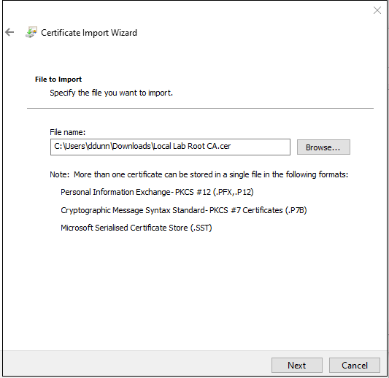
  - On the File to Import screen, click Next.
  - On the Certificate Store screen, accept the default value Place all certificates in the following store with the value Trusted Root Certification Authorities, and then click Next.
  - On the Completing the Certificate Import Wizard screen, click Finish.
  - On the Certificate Import Wizard dialog, click OK.
  - Close the certlm window.

Adding HTTPS site bindings
HTTPS provides TLS-encrypted communication between the NES host and the host that an administrator uses to connect to the NES Administrator Console web application.
Perform the following steps in Internet Information Service Manager (IIS Manager) to add HTTPS bindings to the NES website.
If you have already created the bindings or you will use HTTP only, proceed to Importing a Fullchain Certificate.
- In the Connections navigation pane, click Computer_Name > Sites, as shown in the following figure.
Figure 15: Edit Bindings Option
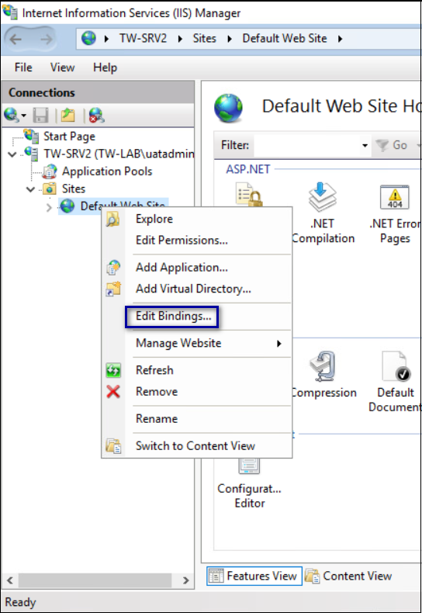
- Right-click Default Web Site, and then select Edit Bindings.
- Click Add.
The Add Site Binding dialog box opens.
- In the Add Site Binding dialog perform the following actions:
  - From the Type list, select https.
  - In the IP Address field, leave the default setting All Unassigned.
  - In the Port field, leave the default setting 443.
  - Leave the Host name field blank.
  - From the SSL certificate list, select the TLS certificate that you imported.
The following figure provides an example of the Add Site Binding dialog.
Figure 16: Add Site Binding Dialog
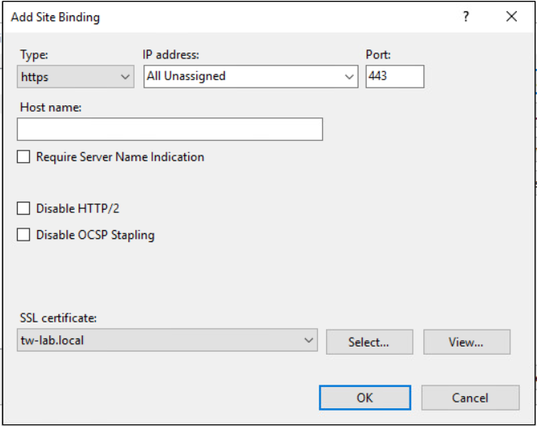
  - Click the View button, and identify the expiration date of the TLS certificate (see the line Valid from (start date to expiration date).
  - Record the expiration date in the Certificate Expiration Date table.
  - Click OK.
- On the Site Bindings dialog, click Close.

Creating an Application Pool for Authentication Service
To support Windows authentication to a remote SQL Server, the NES Enrollment Service and Directory service must run under the NES service account. If the NES Authentication service runs under a specific user account, the configuration requires HTTP Service Principal Names (SPNs). To avoid the need to configure HTTP SPNs, create a separate Application Pool for the Authentication service that uses the NetworkService account as the application pool identity.
Note: This procedure only applies to a configuration that uses a single NES instance on a remote SQL server (not local to the NES server).
Perform the following steps in IIS Manager:
- Expand server_name, right-click Application Pools, and then select Add Application Pool, as shown in the following figure.
Figure 17: Create New Application Pool
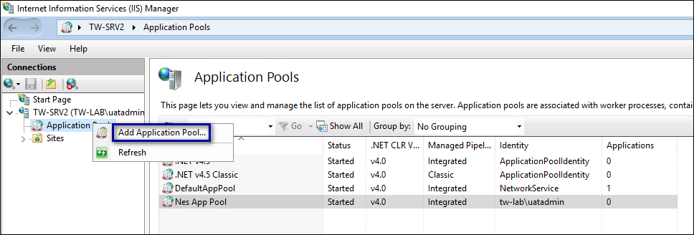
- In the Name field, type NES_AS App Pool, and then click OK.
The following figure provides an example of the Add Application Pool window.
Figure 18: Add New Application Pool
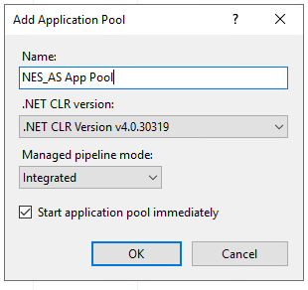
- Right-click NES_AS App Pool, and then select Advanced Settings, as shown in the following figure.
Figure 19: Advanced Settings for Application Pool
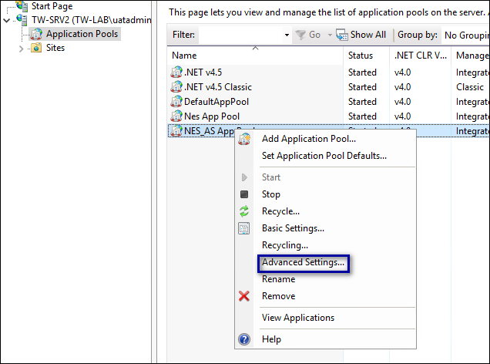
- Click the Ellipses for the Identity parameter, as shown in the following figure.
Figure 20: Edit Identity
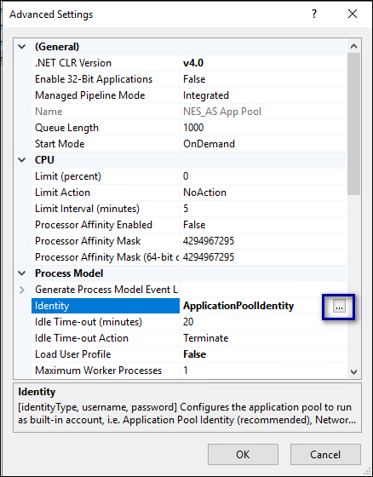
- From the Built-in account list, select network service, as shown in the following figure, and then click OK.
Figure 21: Built-in account list
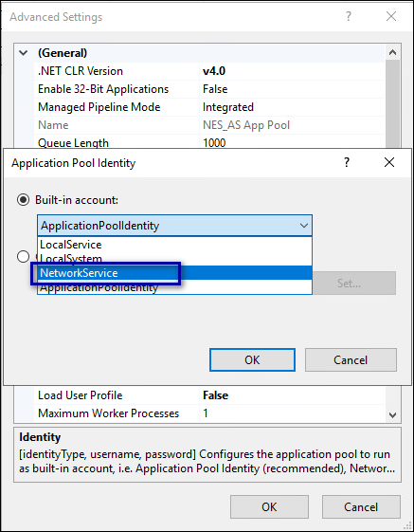
- On the Advanced Settings window, click OK.

Verifying the Authentication Configuration
Perform the following steps in the Internet Information Services (IIS) Manager application to verify that the authentication configuration is correct.
- Open IIS Manager.
- On the Connections navigation pane, expand Computer_Name > Sites, select Default Web Site, and then double-click Authentication.
Figure 22: Authentication Option
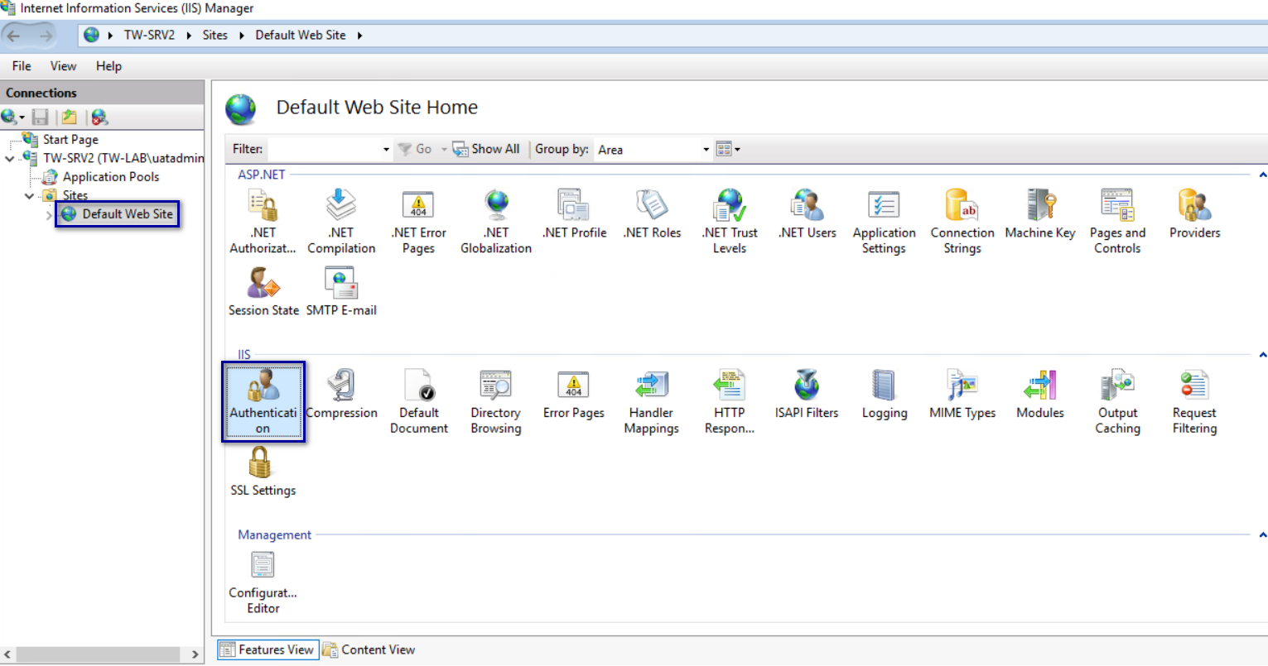
- In the Authentication pane, ensure that Anonymous Authentication is the only enabled option.
The following figure provides an example of the Authentication pane with only the Anonymous Authentication option enabled.
Figure 23: Authentication pane with Anonymous Authentication enabled
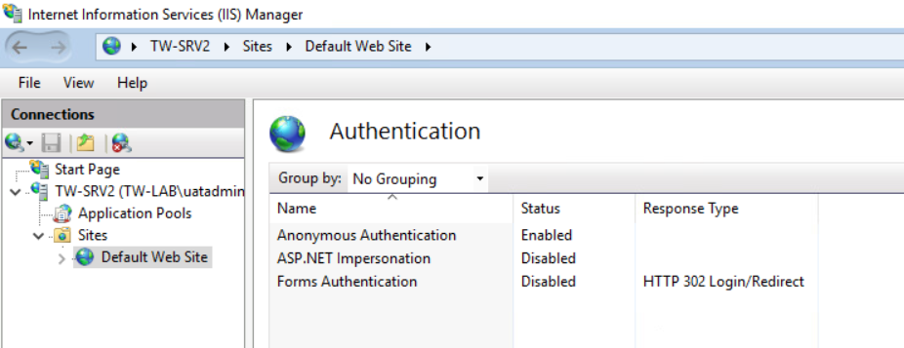

Securing IIS
Secure IIS by disabling the default page and creating an response header.
Perform the following steps in the Internet Information Services (IIS) Manager application.
- On the Connections navigation pane, expand Computer_Name > Sites, select Default Web Site, and then double-click Default Document.
Figure 24: Default Document Option
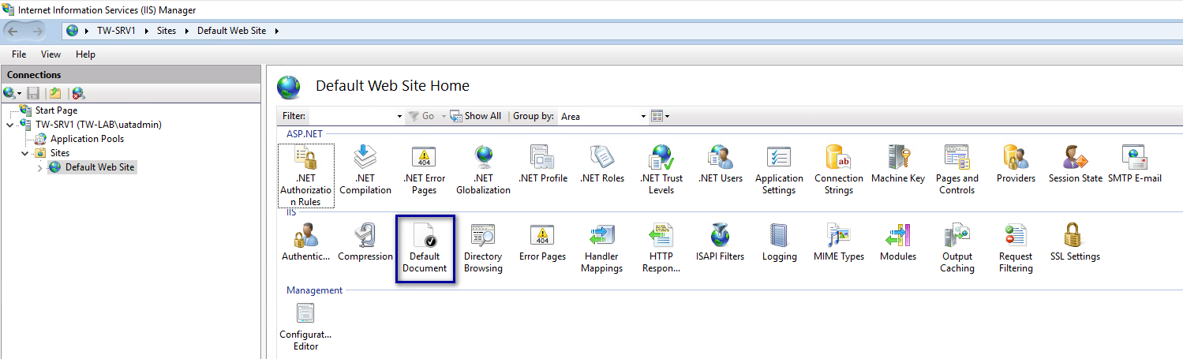
- On the Default Document page, select Default.htm, and then click Disable from the right menu, as shown in the following figure.
Figure 25: Disable Default.htm
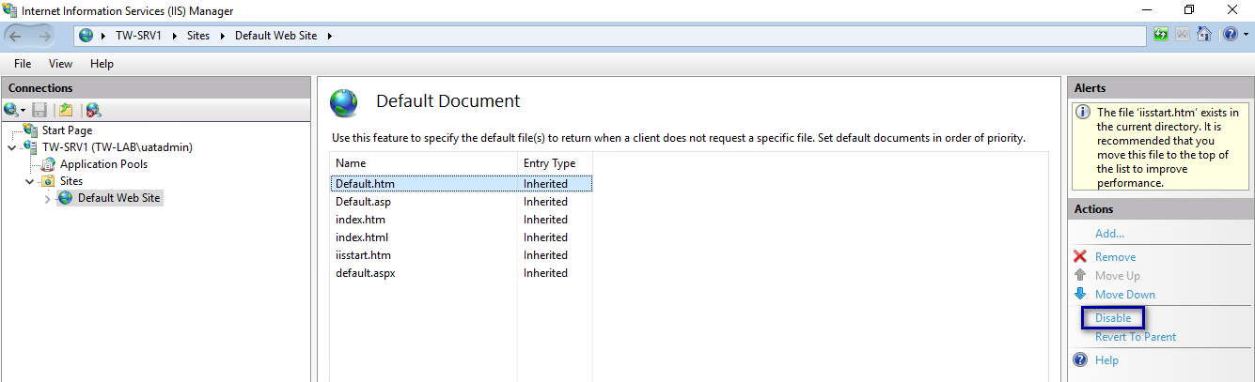
After you click Disable, the Alerts section states that the page is disabled, as shown in the following figure
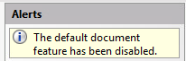
- From the Connections navigation pane, select Default Website, and then double-click HTTP Response Headers
Figure 26: HTTP Response Headers Option
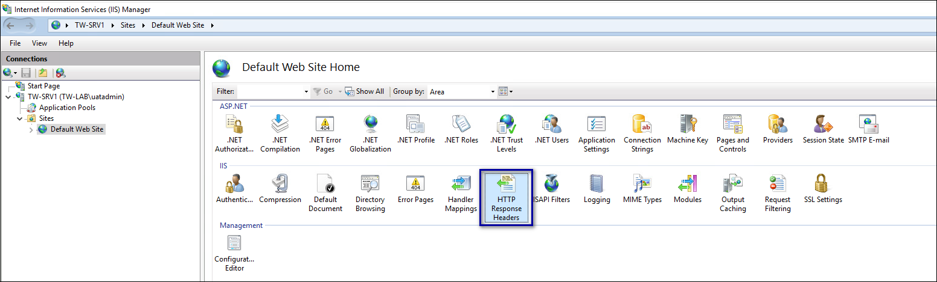
- From the Actions section, click Add, as shown in the following figure.
Figure 27: Add HTTP Response Headers Option
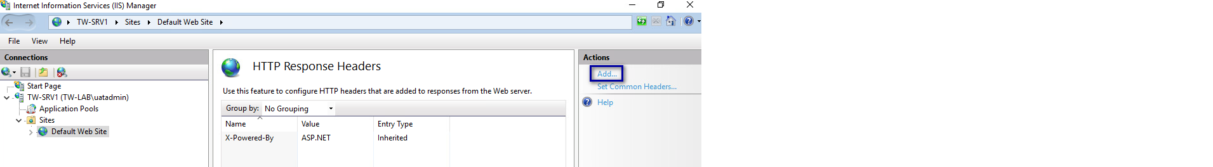
- In the Add Custom HTTP Response Headers dialog box, perform the following actions:
  - In the Name field, type Strict-Transport-Security.
  - In the Value field, type max-age=31536000.
The following figure provides an example of the Add Custom HTTP Response Headers dialog box.
Figure 28: Add Custom HTTP Response Headers dialog box
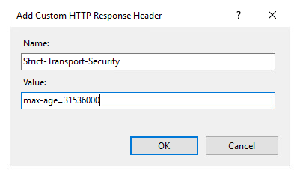
  - Click OK.
The Strict-Transport-Security header appears in the HTTP Headers table, as shown in the following figure.
Figure 29:
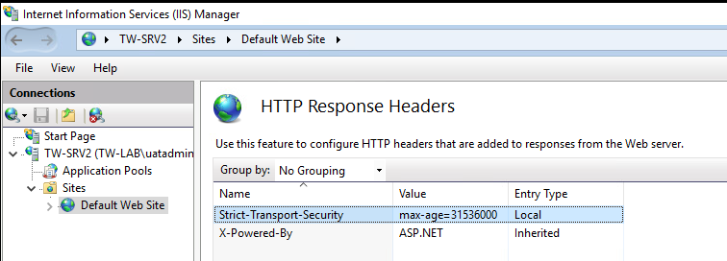
- Close IIS Manager

Importing a Fullchain Certificate
To support certificate management in Connected Worker Platform, you must install and configure the certificates. Nymi provides you with a zipped certificate file package that contains a PKCS12 file. The password for the PKCS12 file is provided to you separately.
The PKCS12 file (fullchain.p12) excludes the password, but contains the following certificates:
- Root certificate
- L1 certificate
- L2 certificate
- L2 private key
Perform the following steps to import the certificates on the NES host.

Importing Certificates
Perform the following steps to import the certificates on the NES host.
- Extract the certificate zip file to a directory.
- Right-click the fullchain.p12 certificate file, and then select Install PFX, as shown in the following figure.
Figure 30: Install PFX Option
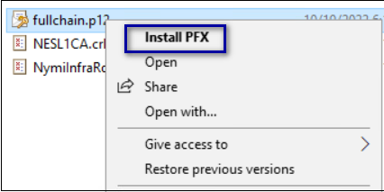
- In the Open File - Security Warning dialog, click Open.
The Certificate Import Wizard dialog box opens.
- On the Welcome to the Certificate Import Wizard page, in the Store Location page, select Local Machine, as shown in the following figure.
Figure 31: Local Machine Store Location
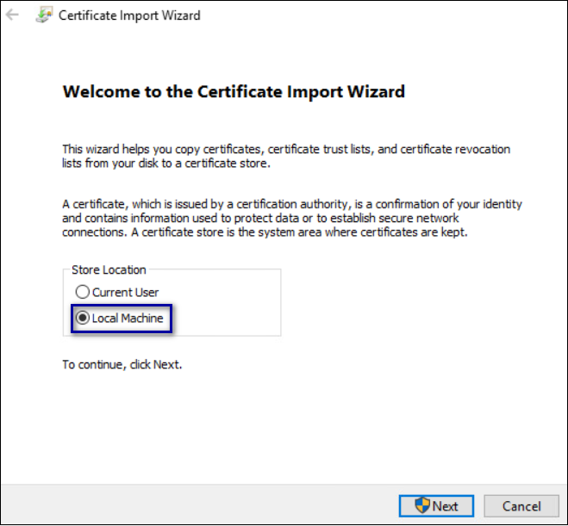
- Click Next.
- On the User Account Control window, click Yes.
- On the Files to import page, ensure that the fullchain.p12 file appears in the File name field, and then click Next.
- On the Private Key Protection page, in the Password field, type the Nymi-provided private key password, and then click Next.
The following figure provides an example of the Private Key Protection page.
Figure 32: Private Key Protection Page
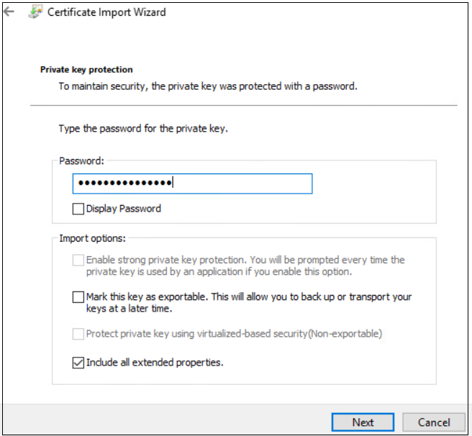
- On the Files to import page, ensure that the fullchain.p12 file appears in the File name field, and then click Next.
- On the Certificate Store page, leave the default option Automatically select the certificate store based on the type of certificate, and then click Next.
This options ensures all the certificates in the certification path (Root, Intermediate) are placed in the correct store. The following figure provides an example of the Certificate Store page.
Figure 33: Certificate Store Page
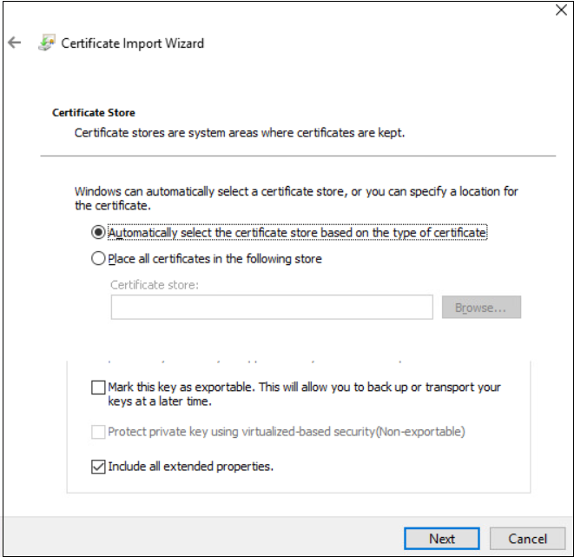
- On the Completing the Certificate Import Wizard page, click Finish.
- On the Certificate Import Wizard dialog, click OK.

Moving the L2 certificate
Perform the follow steps to move the L2 certificate from the Personal Certificates folder to the Intermediate Certification folder.
- From the Windows Start Menu, type Manage Computer, and then select Manage Computer Certificates.
The certlm window appears.
- On the User Account Control dialog, click Yes.
- Navigate to Personal > Certificates folder.
- Expand Intermediate Certification > Certificates, and then move the NES L2 CA certificate from Personal > Certificates to the Intermediate Certification > Certificates folder.
You can move the file by dragging and dropping it from one folder to the other folder. The following figure provides an example of the certificates window.
Figure 34: Certificates window
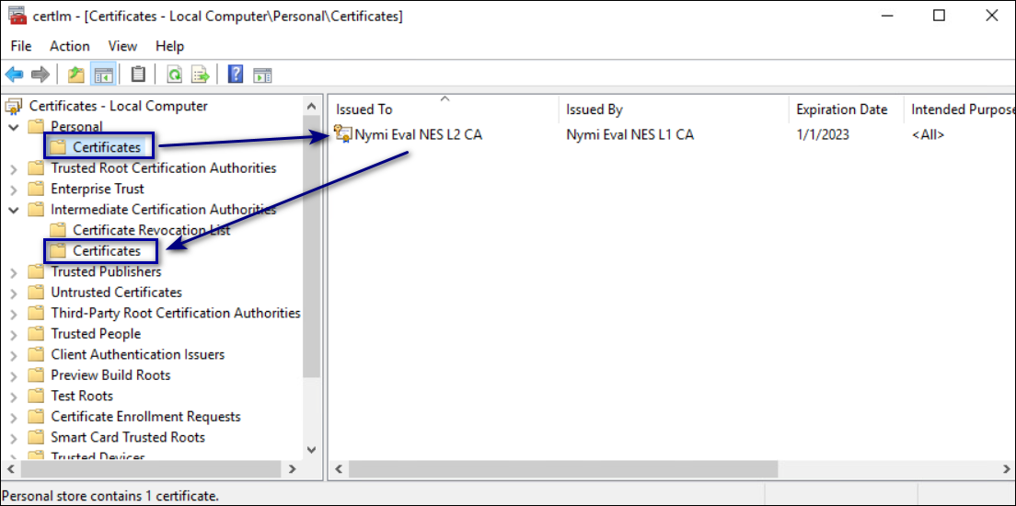
- In Intermediate Certification > Certificates verify that NES L2 CA certificate has a key.
When the L2 certificate has a key, a key symbol displays in the upper-left corner of the L2 certificate icon as shown in the following figure.
Figure 35: L2 Certificate with key
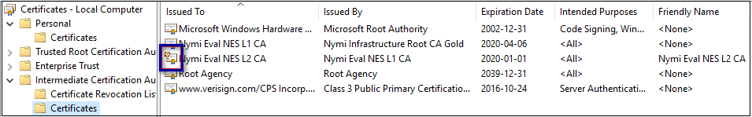
- Record the expiration date of the NES L2 CA certificate (shown in the Expiration Date column) in the Certificate Expiration Dates table.
- Close the certlm window.

Installing NES
After you install and configure IIS, install and configure NES. You can configure NES in one of the following ways:
- Using the NES Service Suite Wizard and specifying each configuration option.
- Using the NES Service Suite Wizard and loading configuration options from a .ninst file.
- Using the NESCmdInstall.exe file to load configuration options from a .ninst file, from a command prompt.

Installing the NES Services Suite using the wizard
Perform the following steps to install required third party software and the NES Services Suite.
For the best user experience with the NES installation wizard, use display settings that include a resolution of 1920 x 1080 and 100% scaling.
Note: The installation process prompts you to install Microsoft .NET Framework 4.8 and SQL Server Express, if the applications are not previously installed on the NES host. If your environment already has a SQL Server that is not locally installed on the NES server and you will create the database on that SQL server, you can skip the SQL Server Express installation.
- Log in to the host with a domain user account that has local administrator rights.
- In the C:\nestemp\NesInstaller folder, run install.exe.
- If you see the User Account Control dialog, click Yes.
- If you see the Open File – Security Warning page, click Run.
- On the NESg2. Installer Setup page, review the Microsoft .NET EULA, and then click Accept.
- If you see the Open File - Security Warning dialog, click Run.
The installer installs .NET.
- Restart the host when the installation process prompts you.
- If the installation process does not continue after the restart, rerun C:\nestemp\NesInstaller\install.exe.
- If you see the Open File - Security Warning dialog, click Run.
- On the Application Install Security Warning pop-up, click Install.
Figure 36: Security Warning
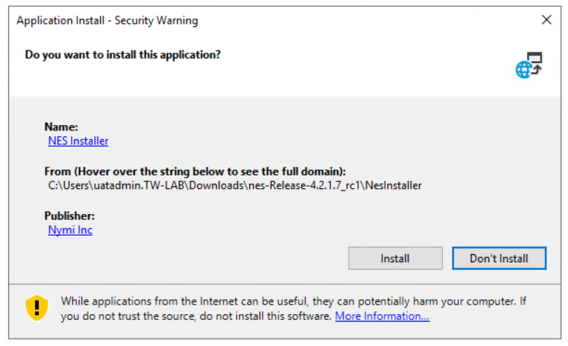
An NESg2. Installer Setup page appears, and a status bar displays the progress of the installation.
- If you see the Open File – Security Warning page, click Run.
- If you see the User Account Control dialog, page, click Yes.
- If the installer does not detect a version of SQL Express on the host, the Install Prerequisites dialog appears. Perform of the following actions:
  - To install SQL Express on the NES server, click Yes.
  - To use an existing instance of SQL server on this machine or on another machine, click No. When you configure NES in the following section, you provide connection information for the remote SQL Server.
After the third party software installation completes, the installation process performs a prerequisite check and the Prerequisite Check dialog appears.
- If the prerequisites check fails, the installer provides you with more information. Review the information, and then click Exit. Correct any prerequisite requirements before running the installation again.
- If the prerequisite check is successful, the Prerequisite check dialog briefly appears, then closes and the NES Setup wizard opens. See the Configuring NES Services section for information on the installation wizard.
The following figure shows the Prerequisites Check dialog.
Figure 37: Prerequisites Check Dialog
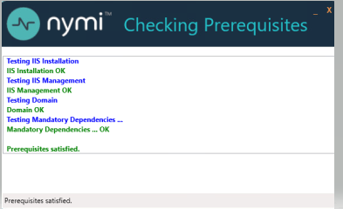
Note: If you see an error message indicating that the installer was not run with a domain user, you did not run the installer under a domain user account. To resolve this, you must go to Add or Remove Programs and uninstall Microsoft SQL Server. When prompted to select the features to remove, select all features. When the uninstall completes, log in to the NES host as a domain user and then run setup.exe again.
Additional Information
- During NES installation, the process of creating the NES database on the NES server, provides users with administrative privileges to the database. It is recommended that you create a second database user with view access to the audit tables after NES deployment.
- During installation, the installer may disappear and then resume. This is normal behavior as processes are working in the background.

Configuring NES Services Manually
After the NES Setup wizard completes the installation of .NET and SQL server, the wizard configures and installs the NES Service Suite.
NES configuration requires several configuration settings values that you recorded in Appendix—Record the CWP Variables. If the Nymi Band users complete authentication tasks in a web-based Nymi-enabled Application(NEA) on a Windows user terminal by tapping their Nymi Band on a Bluetooth adapter, you must also provide the path to the Nymi-supplied Full Chain PFX file and the password.
The following figure provides an example of the NES Setup wizard.
Figure 38: NES Setup Help wizard
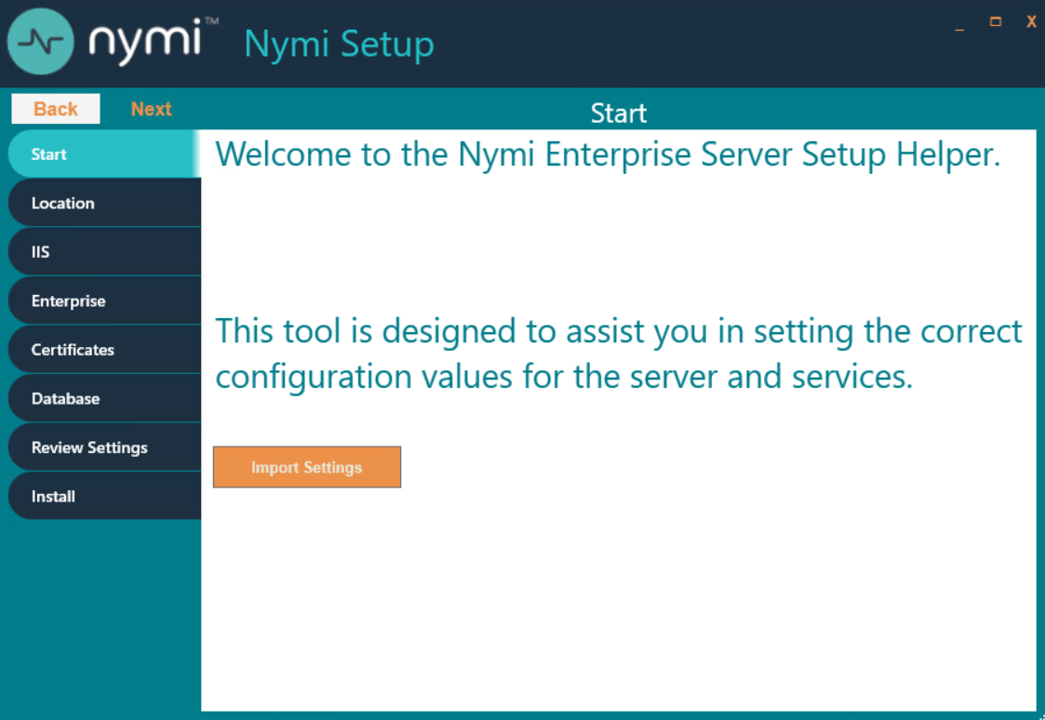
Perform the following actions to configure the NES Services Suite.
Note: The Import Settings button allows you to load a configuration file to install NES. Creating the configuration file to deploy a subsequent NES is explained later in this document.
- In the left navigation pane, select Location, and then perform the following actions:
  - In the Install Root field, leave the default location C:\inetpub\wwwroot or, to select an alternate installation path for the NES services, click the ellipses and navigate to the folder.
  - In the Instance Name field, type a descriptive name for the NES web application instance name, for example NES.
This step optional, but recommended. The name cannot contain spaces. Record the Instance Name in Appendix—Record the CWP Variables.
  - Click the Test button to determine the status of the installation. The test result specifies the type of installation, and the paths for the Authentication Service, NES, and Enrollment Service. The service locations are based on the value specified in the Instance Name field.
The following figure provides an example of the Location page.
Figure 39: Location page in the NES Setup wizard
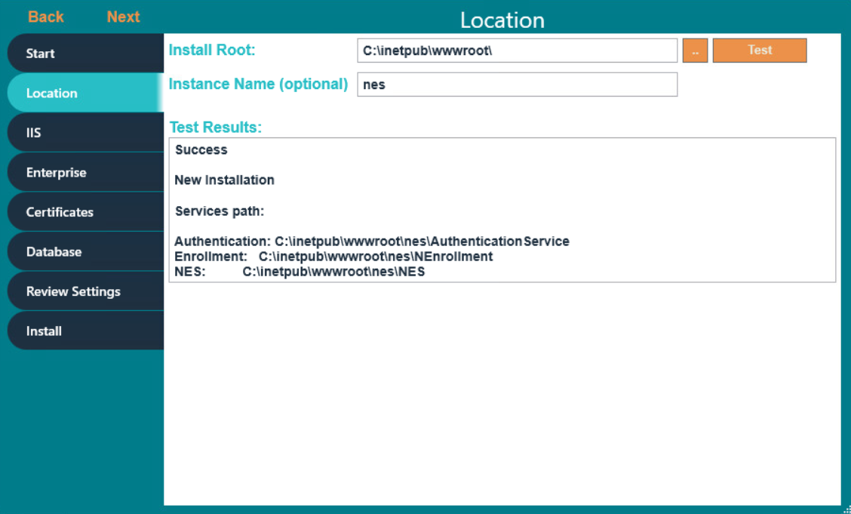
- In the left navigation pane, click IIS, and then perform the following actions:
  - From the IIS web site drop-down list, leave the default selection Default Web Site.
Alternatively, to install the services on a different existing IIS website, select another website from the list.
  - In the Communication Protocol section, available IIS site bindings appear. Select a communication protocol for the deployment.
Nymi recommends that you select HTTPS to ensure secure communication and HTTPS is required for CWP with Evidian deployments. If an HTTPS address is not available, review Adding HTTPS site bindings to add a HTTPS site binding.
Note: HTTP is not encrypted. Sensitive information is sent in plain text.
  - In the NES Admin and Enrollment Application Service and Authentication Service sections, perform the following actions, based on your configuration scenario:
Single NES instance, remote SQL server | - In Application Pool, leave the default application pool.  - From the Application Pool Identity list:  - Select SpecificUser from the drop-down list.  - In the User Name field, type the username of the Nymi Infrastructure Service Account in the format domain\username.  - In the Password field, type the password for the Nymi Infrastructure Service Account.  - Click the Test button to validate the user credentials. | - From the Application Pool list, select NES_AS App Pool.  - From the Application Pool Identity list, select Network Service.
Multiple NES instances in a high-availability configuration, remote SQL Server | - In Application Pool, leave the default application pool.  - From the Application Pool Identity list:  - Select SpecificUser from the drop-down list.  - In the User Name field, type the username of the Nymi Infrastructure Service Account in the format domain\username.  - In the Password field, type the password for the Nymi Infrastructure Service Account.  - Click the Test button to validate the user credentials. | - From the Application Pool list, leave the default application pool.  - From the Application Pool Identity list:  - Select SpecificUser from the drop-down list.  - In the User Name field, type the username of the Nymi Infrastructure Service Account in the format domain\username.  Note: Ensure that you specify the same user account that you provided for the NES Admin and Enrollment service configuration. If you specify a different user, both application pools use the username that you specify for the Authentication service configuration.  - In the Password field, type the password for the Nymi Infrastructure Service Account.  - Click the Test button to validate the user credentials.  Note: A message appears warning you that the implementation requires Service Principle Names (SPNs).
Local SQL configuration (SQL Express) (POC/POV) | In the Application Pool and Application Pool Identity, leave the default selections. | In the Application Pool and Application Pool Identity, leave the default selections.
  - In the Service Mapping area, review the recommended mapping names for each service. If required, edit the mapping and specify a name that does not contain spaces.
Note: Service mapping defines the relative address of each of the web services (web apps) that run on the server.
The following figure provides an example of the IIS Setup page for a single NES instance deployment that uses a remote SQL database.
Figure 40: IIS Setup page in the NES Setup wizard
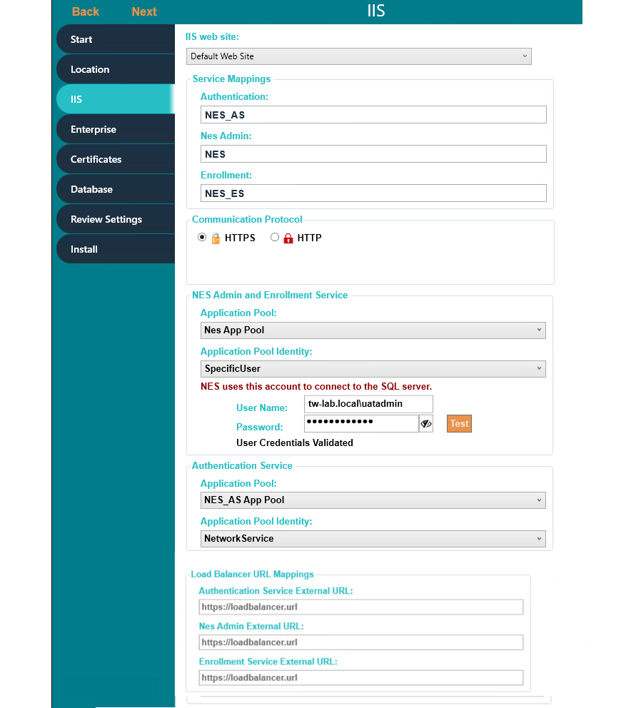
  - For a highly-available NES configuration only, in the Load Balancer URL Mappings section, perform the following actions:
    - In the Authentication Service External URL field, specify the load balancer URL for the Authentication Service, for example https://loadbalancer.org_name.com/NES_AS.
    - In the NES Admin External URL field, specify the load balancer URL for the NES Administrator Service, for example https://loadbalancer.org_name.com/NES.
    - In the Enrollment Service External URL field, specify the specify the load balancer URL for the NES Enrollment Service, for example https://loadbalancer.org_name.com/NES_ES.
- In the left navigation pane, click Enterprise, and perform the following actions:
  - In the LDAP protocol section, select LDAP or LDAPS.
Refer to Appendix—Record the CWP Variables for your site-specific configuration information.
  - In the Domains table, the domain in which the NES host resides appears. If Nymi Band users, NES Administrators, or the NES service account reside in other domains, perform the following steps to add the additional domains:
    - In the Domain table, on an empty line, type the NetBIOS (Pre-Windows 2000) name of the domain that contains the user accounts. Refer to Appendix—Record the CWP Variables for your NetBIOS domain name.
    - Type a domain username and password for the domain if the one of following conditions are met:
      - The domain is not in the same forest as the NES domain.
      - A two-way trust does not exist between the domain and the domain in which NES resides.
      - The domain is not in the same forest as the NES domain and does not have a two-way trust with the domain in which the NES service account resides.
Note: Select a domain user whose password never expires.
    - Press Enter.
    - Press Test to confirm that all domains are reachable.
  - In the Nes Admin Groups table, specify the NES Administrator group name by right clicking in the field, selecting Add, and then typing the name of the group.
In a multi-domain configuration where you have configured multiple global NES Administrator groups in different domains, add each group. Refer to Appendix—Record the CWP Variables for the name of the NES Administrator group(s).
  - Press Test to confirm that NES can find each defined group.
  - If the solution in includes user terminals with Nymi Lock Control, in the NES API Authorization Based on Organizational Unit(Optional) table, perform one of the following actions:
    - To restrict the user terminals on which users can use Nymi Lock Control, specify the OU name. If your organization has multiple OUs of the same name, specify the entire DN of the OU.
    - To allow users to use Nymi Lock Control on any user terminal, leave the table empty.
  - Press Test to confirm that NES can find each defined OU.
  - In the Nymi Infrastructure Service Account section, in the User Name field, enter the Nymi Infrastructure Service Account in the format domain\name.
The following figure provides an example of the Enterprise page.
Figure 41: Enterprise page in the NES Setup wizard
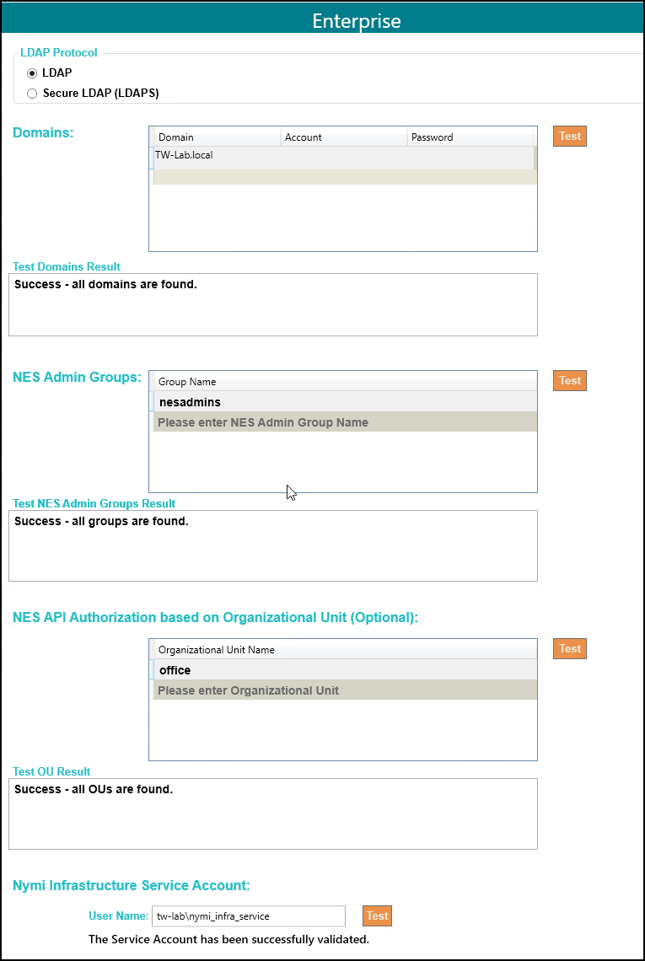
- In the left navigation pane, click Certificates, and then perform the following actions:
  - From the Level One Certificate list, select the L1 certificate from the list.
The L1 certificate name is in the form enterprise_name NES L1 CA.
  - From the Level Two Certificate list, select the L2 certificate.
  - From the Full Chain list, click the ellipses (...) and navigate to the folder that contains Full Chain PFX certificate file, and then select the file.
  - In the Password Required pop-up, type the Full Chain certificate password, and then click OK.
The following figure provides an example of the Certificates page.
Figure 42: Certificates page in the NES Setup wizard
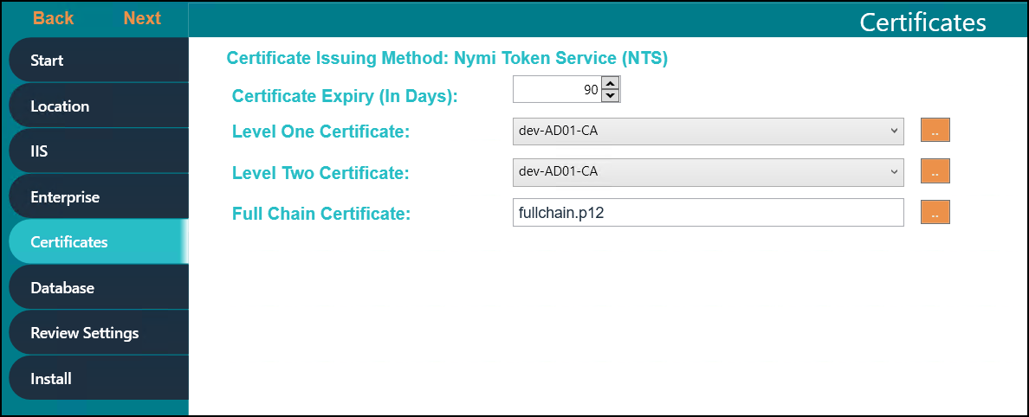
- In the left navigation pane, click Database. The Database page provides database configuration settings that enable NES to create a database. Perform the following actions to ensure that NES can create the database. The steps required differ depending on whether the SQL server uses SQL authentication or Windows authentication.
  - Windows Authentication
    - Leave the Integrated Security option selected. This sets the security property in the Connection String to True.
The default connection string for SQL Express is Data Source=.\SQLEXPRESS;Initial Catalog=Nymi.{0};Integrated Security=True;MultipleActiveResultSets=True
    - If required, update the connection string with the database instance that you want to use, instead of the default SQL Express 2012. Refer to https://docs.microsoft.com/en-us/dotnet/framework/data/adonet/connection-string-syntax for more information about defining the connection string.
    - Click Test to verify that the database connection string is valid and NES can connect to the database server.
Note: If you do not use an existing database, the test returns a message that the database does not exist. NES creates the database during the installation process.
    - In Manage Database Logins section, click the Verify Users button to ensure that NES can create users with access to the SQL database.
The table displays the default account settings for the Application Pool and Application Policy identity settings that were defined on the IIS page appear. By default, the Service type login is an account that provides NES with access to the SQL database (Nymi Infrastructure Service Account). The Auditor type login is an account that provides a user with access to view the NES audit tables. For additional information about adding, editing and deleting database users or accounts, see Managing Database Logins.
  - SQL Authentication
    - Clear the Integrated Security option. This sets the security property in the Connection String to False.
    - If required, update the connection string with the database instance that you want to use instead of the default SQL Express string. Refer to https://docs.microsoft.com/en-us/dotnet/framework/data/adonet/connection-string-syntax for more information about defining the connection string.
    - In the SQL Login section, enter the username and password, and then click Verify to ensure that the provided credentials are valid.
    - Click Test to verify that the database connection string is valid and NES can connect to the database server.
Note: If you do not use an existing database, the test reports that the database does not exist. NES creates the database during the installation process.
The following figure provides an example of the Database Setup page for Windows Authentication.
Figure 43: Database Setup page in NES Setup wizard for Windows Authentication
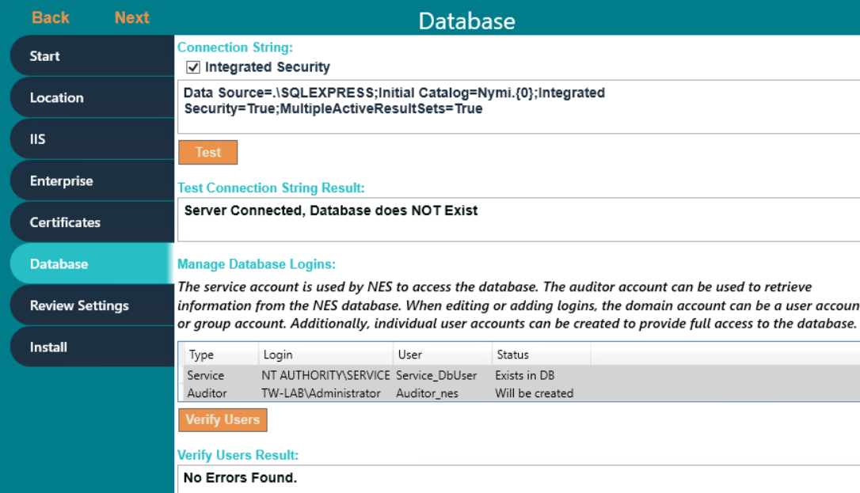
- In the left navigation pane, click Review Settings. The parameters for the NES installation are displayed for final review.
  - Click Test to verify the configuration. Review the test results and address any errors if applicable.
Figure 44: Review Settings window
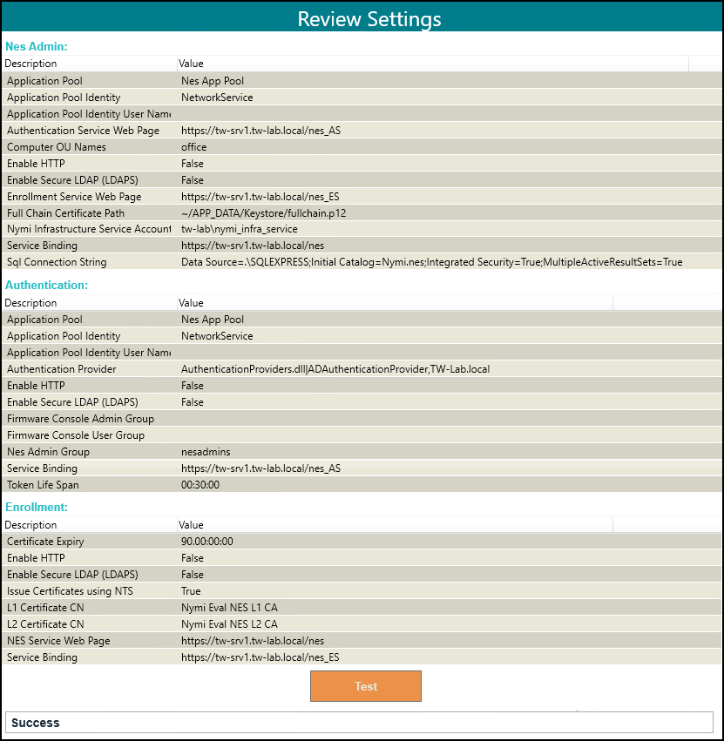
Consider the following information for some common warnings that might appear and how to resolve the issue.
Error | Resolution
SelectedSiteBindings: The underlying connection was closed: Could not establish a trust relationship for the SSL/TLS secure channel. | Import the TLS certificate as described in the Importing the TLS server certificates section, and the retry.
Error in 'Fullchain Certificate Path': PKCS12 Keystore MAC invalid - wrong password or corrupted file. | The password for the Fullchain certificate is incorrect, or the wrong file was selected. From the Full Chain list, click the ellipses (...) and navigate to the folder that contains Full Chain PFX certificate file, and then select the file. In the Password Required pop-up, type the Full Chain certificate password, and then click OK.
>
- In the left navigation pane, click Install. The Install page provides different options depending on the status of the installation.
Table 6: Install page Options
Button | Description
Install | Installs a fresh installation of NES.
Upgrade | Upgrades an existing installation of NES.
Apply Settings | Apply settings to an existing NES installation.
Export Settings | Export the configuration file for NES settings.
Exit | Exit installation wizard without installing NES.
- For a new installation, click the Install button.
The following figure provides an example where the installation succeeds with a warning that the L2 certificate expires within 90 days.
Figure 45: Install NES page in NES Setup wizard
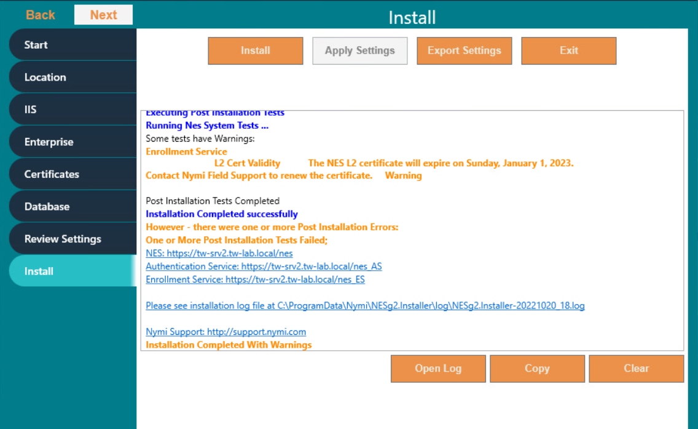
Note: If the NES installation fails with the error message "Cannot Allow Access to certificate: 'Nymi Eval NES L2 CA' for account: 'NT AUTHORITY\SERVICE'.", additional troubleshooting actions are required for the fullchain certificate. Save the NES configuration using Export Settings and close the NES installer. Delete the L1 and L2 certificates from the intermediate certificate authority, and re-import the fullchain certificate following Importing a Fullchain Certificate. Move the L2 certificate from the personal certificate store to the intermediate certificate store and re-run the NES installer using the saved NES configuration file. On the Start page, the Import Settings button allows you to load a configuration file to install NES.
- When the installation completes, perform one of the following actions:
  - Close the NES Setup wizard.
  - Click Export Settings to save the NES configuration settings for future deployments.
The section Saving the NES configuration for silent installations provides more information.

Saving the NES Configuration File for Silent Installations
The NES Setup wizard provides you with the ability to save the NES configuration to a file. The NES configuration file allows you to perform a silent installation of the NES host, with the configuration settings that you have defined during a previous NES deployment.
The NES configuration can be saved and used for a future NES deployment.
- In the C:\nestemp\NesInstaller folder, run install.exe.
- On the Location tab, in the Instance Name field, type the instance name that was specified during the deployment.
- On the Database tab, click Test and Verify Users to load the database information.
- On the Install tab, click Export Settings.
- On the Export Settings dialog, perform the following actions:
  - In the File Name section, click the ellipses, and then navigate to the location where you want to save the configuration file.
The default location is the Documents folder for the logged in user.
    - In the Name field, type the file name. The default file name is the Instance Name of the NES configuration.
    - Click Save. The configuration file is saved as a file with a .ninst extension.
  - In the Encryption section, select one of the following options:
    - None, to save the configuration file without encrypting sensitive information.
    - Machine, to save the configuration with machine encryption.
Note: This saves the file with machine-specific encryption; therefore, you can only load the configuration file on the same machine on which you save the configuration.
    - Private key, to save the configuration and encrypt the configuration file with a private key.
Note: This option allows you to load the configuration file with the generated private key file, on a different machine.
NES Setup can create a new private key for you or you can use an existing private key.
      - To use an existing private key, click the Ellipsis, and then navigate to the location of the file. Select the file, and then click Open.
      - To create a new private key file, click New. Navigate to the location where you want to save the file. In the Name field, type the file name. The default file name is the Instance Name for the configuration. Click Save. Click OK. The configuration file is saved as a file with a .key extension.
    - Click OK.
  - Click OK.

Deploying the NES URL to User Terminals by using group policies
Use Windows group policies to modify the registry on each network terminal to specify the address of the NES web application.
The user that creates the group policy requires domain administrator rights. Create a group that contains all the user terminals that require this change.
Perform the following actions to create a group policy object to change the registry.
- On a Domain Controller, open the Group Policy Management panel.
- Expand Forest > Domains, right-click the domain that contains the hosts, and then select Create a GPO in this domain, and Link it here.
- In the Name field, type Nymi.
- In the Source Starter GPO field, leave the default value (none).
- Click OK.
- Expand the domain and select Nymi. Click OK.
- On the Scope tab, under Security Filtering, perform the following actions:
  - Select Authenticated Users.
  - Click Remove.
  - On the Group Policy Management confirmation window, click OK.
  - On the warning window, click OK.
  - Click Add.
  - On the Select Users, Groups and Computers window, type the name of the group that contains the user terminals, click Check Names, and then click OK.
The group appears in the Security Filter section.
- On the Setting tab, right-click Computer Configuration, and then select Edit.
- Expand Computer Configuration > Preferences > Windows Settings.
- Right-click Registry, and then select New > Registry Item.
The New Registry Properties window appears.
- From the Action list, select Create.
- From the Hive list, leave the default value HKEY_LOCAL_MACHINE.
- In the Key Path field, type SOFTWARE\Nymi\NES.
- In the Value name field, type URL.
- In the Value type list, leave the default selection REG_SZ.
- In the Value Data field, type https://nes_server/NES_service_name/
where:
  - nes_server is the FQDN of the NES host. The FQDN consists of the <hostname>.<domain>. You can also find the FQDN by going to the terminal where NES was deployed and viewing the properties of the system. The nes_server is the Full computer name.
  - NES_service_name is the name of the service mapping for NES in IIS, which maps a virtual directory to a physical directory.
The website that you specified in the Value Data field is the address of the NES Administrator Console website that NES Administrators access to manage NES. Record the value in the Configuration Attribute Values table.
Figure 46: URL properties page
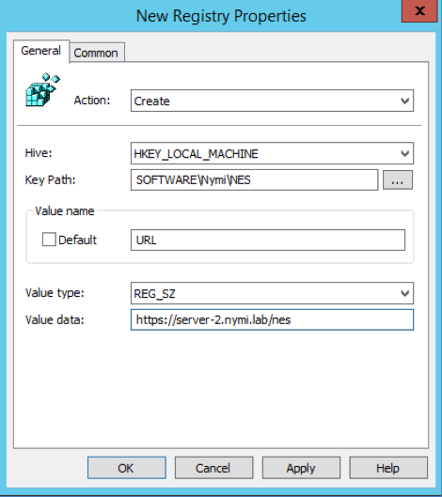
- Click OK.

Deploying the Nymi Agent URL to User Terminals by using group policies
Perform the following steps when you use a centralized Nymi Agent. Use Windows group policies to modify the registry on user terminals to enable Nymi Bluetooth Endpoint to communicate with the remote Nymi Agent.
The user that creates the group policy requires domain administrator rights. Create a group that contains all the user terminals that require this change.
Create a group policy object to update the registry.
- On a Domain Controller, open the Group Policy Management panel.
- Expand Forest > Domains, right-click the domain that contains the hosts, and then select Create a GPO in this domain, and Link it here.
- In the Name field, type Nymi Agent.
- In the Source Starter GPO field, leave the default value (none).
- Click OK.
- Expand the domain and select Nymi Agent. Click OK.
- On the Scope tab, under Security Filtering, perform the following actions:
  - Select Authenticated Users.
  - Click Remove.
  - On the Group Policy Management confirmation window, click OK.
  - On the warning window, click OK.
  - Click Add.
  - On the Select Users, Groups and Computers window, type the name of the group that contains the user terminals, click Check Names, and then click OK.
The group appears in the Security Filter section.
- On the Setting tab, right-click Computer Configuration, and then select Edit.
- Expand Computer Configuration > Preferences > Windows Settings.
- Right-click Registry, and then select New > Registry Item.
The New Registry Properties window appears.
- From the Action list, select Create.
- From the Hive list, leave the default value HKEY_LOCAL_MACHINE.
- In the Key Path field, type SOFTWARE\Nymi\NES.
- In the Value name field, type AgentUrl.
- In the Value type list, leave the default selection REG_SZ.
- In the Value Data field, type ws://NymiAgent:port/socket/websocket
where:
  - NymiAgent is the FQDN of the Nymi Agent host.
  - portis the port number
  - socket is the name of the socket
  - websocket is the communication protocol that connects the Nymi Band Application to the Nymi Agent. You can choose any name for this mapping, but it is recommended that you specify a name that is descriptive.
The IP address that you specified in the Value Data field is the address of the Nymi Agent that the Nymi Band Application connects to. Record the value in the Configuration Attribute Values table.
- Click OK.

Configuring NES from a Configuration File
You can configure NES based on values that are defined in a configuration file. The option to create a configuration file (.ninst file) is available to you when you perform an NES configuration by using the NES Setup wizard. You can configure NES from the command line or with the NES Setup wizard.
Before Installing NES using the Silent Installer
Before installing NES using the Silent Installer, perform the following:
- Log into your machine with a domain user account that has local administrative privileges
- Copy and extract the installation files to the machine
Installing .NET and SQL Server Express
The installation package contains the .NET 4.8 software and Microsoft SQL Server Express 2017 in the following directories:
- .NET 4.8 software: ..\NesInstaller\DotNetFX48\
Note: The .NET software may require you to restart your computer.
- Microsoft SQL Server Express 2017: ..\PreRequisites\SqlExpress
Note: During the installation, accept all defaults. The Silent Installer creates all Microsoft SQL Server users automatically. On the Database Engine Configuration screen, add additional users that require access to the audit reports in the SQL database.

Configuring NES Silently from the Command Line
Perform the following steps to install Nymi Enterprise Server (NES) from command line, by using the configuration values defined in an ninst file.
Before perform a silent installation NES by using a configuration file, perform the following actions:
- Log into your machine with a domain user account that has local administrative privileges
- Copy and extract the installation package to the machine
- Install .NET. The installation package contains the .NET 4.8 software and Microsoft SQL Server Express in the following directories: .NET 4.8 software: ..\NesInstaller\DotNetFX48\ . The .NET installation may require you to restart your computer.
- Install SQL Express if you do not have an existing MS SQL Server to store the NES database. The installation package contains Microsoft SQL Server Express 2019 in the following location: ..\PreRequisites\SqlExpress During the SQL installation, accept all defaults. The installation process creates all Microsoft SQL Server users automatically. On the Database Engine Configuration screen, add additional users that require access to the audit reports in the SQL database.
- If you are using a .ninst file from a pre-CWP1.6 NES installation, edit the file and add the following entries before the last } that appears in the file:
"JwtSecretKey": "C44E0537D518B9540B15131D0708A4825E995EF08BE8D10ACAB028CBE65C4F8F",
"NesBinding": "https://nes_server/NES_service_name}"
where:
  - nes_server is the Fully Qualified Domain Name (FQDN) of the NES host.
  - NES_service_name is the service mapping name for the NES web application. The default service mapping name is nes.
For example, https://nes.cwp.company.com/nes.
Note: The service mapping name for NES is defined during deployment. Contact the person who performed the deployment to obtain the NES service mapping name value. Record the URL of ph conkeyref="prod_names/nes"/> in Appendix—Record the CWP Variables. You will use this URL to connect to the NES Administrator Console and require it during the CWP Backend deployment.
- To use an ninst file that you created before CWP 1.12.2, you need to perform several modifications to the file:
  - Create a new entry for the Nymi Infrastructure Service Account
  - Create a new entry for the Fullchain certificate password
  - Add the following entry that appears in the sample .ninst:
"PFXFullChainPath": "~/APP_DATA/Keystore/fullchain.p12"
Note: Do not modify the path value for this entry, but if required, change the fullchain filename to match the name of the certificate file that Nymi provided you.
The sample .ninst file located in the NES installation package in the NesCmdInstall folder provide you with information about the new entries.
To install NES using the silent installer:
- Copy the .ninst files and if created, the private key file to the C:\nestemp\nes-Release-x.x.x.x\NesCmdInstall directory.
- Open a command prompt as an Administrator and change the path to C:\nestemp\nes-Release-x.x.x.x\NesCmdInstall directory.
- Type NesCmdInstall.exe --fullchain path_to_fullchain_cert\cert_filename --config path_to_config_file\ninst_filename [--key path_to_private_key_file\key_filename] --allowwarnings
where:
  - path_to_fullchain_cert is the absolute or relative path to the Nymi-provided fullchain PFX certificate file.
  - cert_file is the name of the Nymi-provided fullchain PFX certificate file.
  - ninst_filename is the name of the NES configuration file.
  - path_to_config_file is the absolute or relative path to the configuration file.
  - path_to_private_key_file is the absolute or relative path to the key file.
  - key_filename is the name of the private key file.
Note: Use the --key parameter with the path_to_private_key_file to install the private keys manually.
For example, to configure NES when the configuration file and private key file are in the C:\nestemp\nes-Release-x.x.x.x\NesCmdInstall directory, type NesCmdInstall.exe --config NTS.ninst --key nes.key --allowwarnings
- On the User Account Control dialog, click Yes.
Installation log files are located in C:\Program Data\Nymi\NesCmdinstall\log directory. The installation process provides output to the screen as well as installation log files.

Configuring NES With a Configure File in the NES Setup Wizard
Perform the following steps to install Nymi Enterprise Server (NES) with the NES Setup Wizard, by using the configuration values defined in an ninst file.
- In the NES Setup Wizard, on the Start screen, click Import Settings.
- In the Open window, navigate to the directory that contains the ninst configuration file, and then double-click the .ninst file.
A Loaded Successfully message appears on the screen.
- If you used a ninst file that was created prior to CWP 1.12.x, perform the following actions:
  - In the left navigation pane, click Enterprise, scroll down to the Nymi Infrastructure Service Account section. In the User Name field, enter the Nymi Infrastructure Service Account in the format domain\name.
  - In the left navigation pane, click Certificates, and perform the following actions.
  - From the Full Chain list, click the ellipses (...) and navigate to the folder that contains Full Chain PFX certificate file, and then select the file.
  - In the Password Required pop-up, type the Full Chain certificate password, and then click OK.
- On the Review Settings tab, click Test
The window displays a Success message when the configuration file values are valid or displays error messages when the configuration file requires correction.
- If the Review Settings test did not report errors, on the Install tab, click Install.
- When the installation completes, close the NES Setup wizard.

Configuring IIS to Prevent NES Offloading
Configure IIS to ensure that NES applications are always available to service the requests, and not off-loaded.
Perform the following steps in Internet Information Service Manager (IIS Manager).
- In the Connections navigation pane, expand Computer_Name > Sites > Default Web Site, and then perform the following steps to determine the application pool name for each NES application.
  - Select the nes application, and then in the Actions menu on the right side of the window, select Basic Settings.
  - In the Edit Application window, make note of the value that appears in the Application Pool field, and then click OK.
  - Select the nes_AS application, and then in the Actions menu on the right side of the window, select Basic Settings.
  - In the Edit Application window, make note of the value that appears in the Application Pool field, and then click OK.
  - Select the nes_ES application, and then in the Actions menu on the right side of the window, select Basic Settings.
  - In the Edit Application window, make note of the value that appears in the Application Pool field, and then click OK.
The following figure provides an example of the Basic Settings menu option and the Edit Application window.
Figure 47: Edit Application window
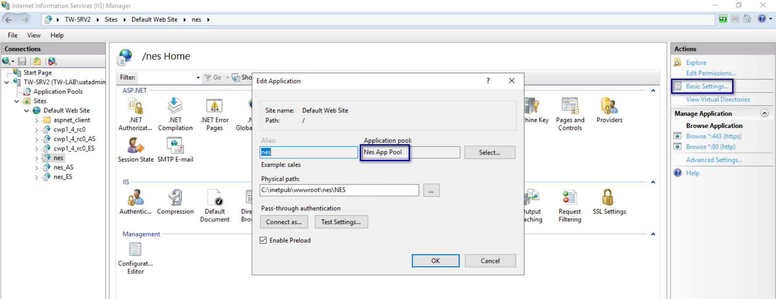
- In the Connections navigation pane, expand Computer_Name > Application Pools, right-click the application pool for the NES applications, and then select Advanced Settings, as shown in the following figure.
Figure 48: Advanced Settings menu option
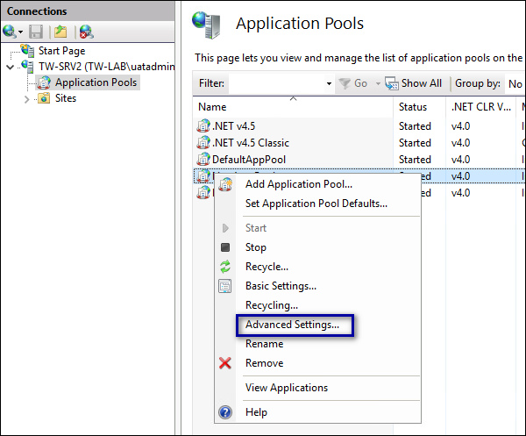
- In the Advanced Settings window, perform the following actions.
  - In the General section, confirm that the .NET CLR Version value is v4.0.
  - In the General section, from the Start Mode list, select Always Running.
  - In the Process Model section, for the Idle Timeout (minutes) value, type 0.
  - Click OK.
The following figure provides an example of the Advanced Settings window.
Figure 49: Advanced Settings window
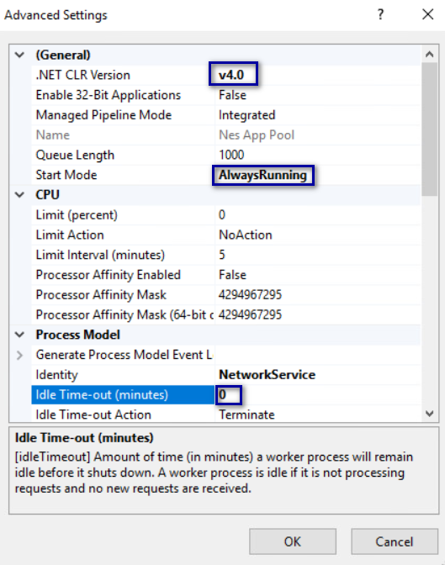
Note: If the NES applications use different application pools, configure the Advanced Settings option for each application pool.
- In the Connections navigation pane, expand Computer_Name > Sites > Default Web Site, and then perform the following steps.
  - Right-click nes and then select Manage Application > Advanced Settings, as shown in the following figure.
Figure 50: Advanced Settings option
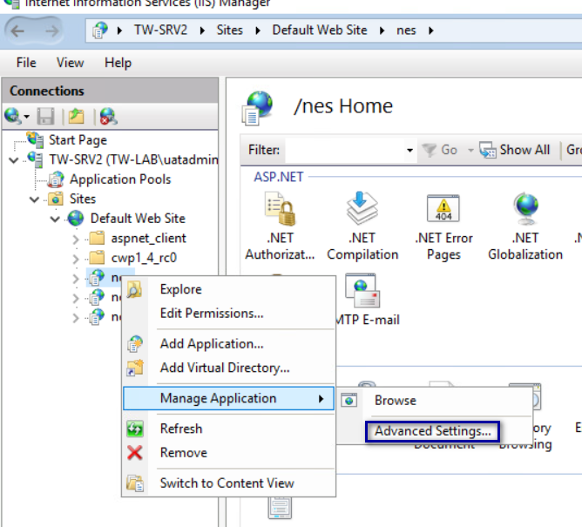
  - On the Advanced Settings window, from the Preload Enabled list, select True.
  - Click OK.
  - Right-click nes_AS and then select Manage Application > Advanced Settings.
  - On the Advanced Settings window, from the Preload Enabled list, select True.
  - Click OK.
  - Right-click nes_ES and then select Manage Application > Advanced Settings.
  - On the Advanced Settings window, from the Preload Enabled list, select True.
The following figure provides an example of the Advanced Settings window.
Figure 51: Advanced Settings window
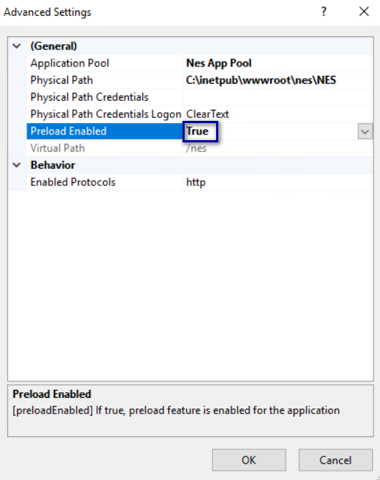
  - Click OK.
- In the Connection pane, select the server name, and then in the Actions menu on the right side of the window, click Restart, as shown in the following figure.
Figure 52: Restart IIS
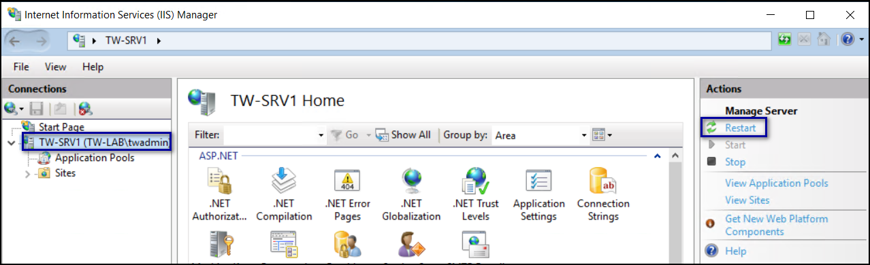
- Close IIS Manager.

Validating the NES Deployment
NES provides users with a web-based interface called the NES Administrator Console to manage NES and monitor the status of the components of the system.
Use the NES Administrator Console to validate the NES deployment.

Access the NES Administrator Console
Perform the following steps to connect to the NES Administrator Console and confirm the status of the system.
- Connect to the NES Administrator Console in a browser by typing https://nes_server/NES_service_name or http://nes_server/NES_service_name
depending on the NES configuration, where:
  - nes_server is the Fully Qualified Domain Name (FQDN) of the NES host.
  - NES_service_name is the service mapping name for the NES web application. The default service mapping name is nes.
For example, https://nes.cwp.company.com/nes.
Note: The service mapping name for NES is defined during deployment. Contact the person who performed the deployment to obtain the NES service mapping name value. Record the URL of ph conkeyref="prod_names/nes"/> in Appendix—Record the CWP Variables. You will use this URL to connect to the NES Administrator Console and require it during the CWP Backend deployment.
- On the Sign in window, type the credentials of a user that is a member of the NES Administrators group, and then click Sign In.
- On the main menu, click About.
The System Diagnostics page appears.
- Click View Full System Diagnostics.
The NES server analyzes the status of dependencies and displays the results on the page. The following figure shows the various tests that are performed and the status. In this example, all tests passed and there was one warning the that L2 certificate will expire soon.
Figure 53: System Diagnostic Tests
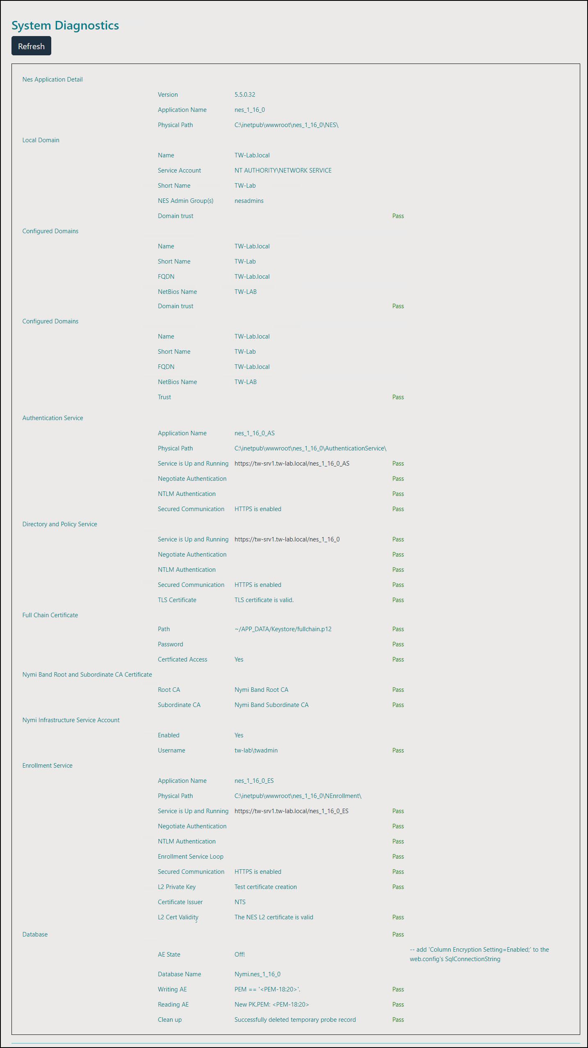
- Verify the username has administrative access by observing Policies, and Search in the main menu.
The Nymi Connected Worker Platform—Troubleshooting Guide provides information about how to resolve issues that you might encounter when you run system diagnostics and attempt to access the NES Administrator Console.

Configuring NES to support Nymi Lock Control
Edit the active policy in NES to enable the use of Nymi Lock Control.
Users can use an authenticated Nymi Band to unlock user terminals, when Nymi Lock Control is installed on the user terminal.
Note: If you enabled Nymi Lock Control in NES after users already enrolled their Nymi Bands, the Nymi Band user must log into the Nymi Band Application to receive the update in the group policy. The Nymi Band Application will prompt the user to create an internal security key, which allow the Nymi Band to operate with Nymi Lock Control.

Hardening the NES Keystore
Hardening is the process of reducing vulnerabilities by eliminating attack vectors and condensing the system's attack surface. Hardening NES can be based on enterprise IT policy or any industry standard hardening guideline.
Nymi has taken steps to harden IIS according to the CIS Microsoft IIS 10 Benchmarks from the Centre for Internet Security (CIS).
To harden the SQL server based on an industry standard hardening guideline, for example, CIS Microsoft SQL Server Benchmarks, you must secure the external authenticator private keys by encrypting columns.
Perform the following steps on the NES host to enable column encryption and encrypt sensitive information.
- Edit the C:\inetpub\wwwroot\NES\NEnrollment\web.config file, and perform the following steps:
  - Search for the string SqlConnectionString.
  - Add Column Encryption Setting=Enabled within the value attribute tags, as shown in the following example:
<add key="SqlConnectionString"
value="Data Source=.\SQLEXPRESS;Initial Catalog=Nymi.{0};Integrated Security=True; MultipleActiveResultsSets=True;
Column Encryption Setting=Enabled"/>
  - Save the file.
- Edit the C:\inetpub\wwwroot\NES\NES\web.config file, and perform the following steps:
  - Search for the string SqlConnectionString.
  - Add Column Encryption Setting=Enabled; within the <value> </value> attribute tags, as shown in the following example:
<setting name="SqlConnectionString" serializeAs="String">
<value>"Data Source=.\SQLEXPRESS;initial catalog=Nymi.{0};Integrated Security=True; MultipleActiveResultsSets=True;
Column Encryption Setting=Enabled;"</value> </setting>
  - Save the file.
- Download and install the SQL Server Management Studio (SSMS) software.
- Open SSMS by using the Run as Administrator option.
- Click Connect > Database Engine.
- On the Connect to Server page, if you are using SQL authentication, type the server name and your credentials, and then click Connect, otherwise, click Connect.
- Expand Databases > Nymi.NES > Security > Always Encrypted Keys. Right click Column Master Key, and then select New Column Master Key, as shown in the following figure.
Figure 54: New Column Master Key option
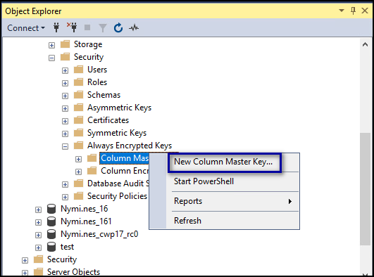
- On the New Column Master Key window, perform the following actions:
  - In the Name field, type a name for the key.
For example, CMK_LocalMachine.
  - In the Key store field, select Windows Certificate Store – Local Machine.
The following figure shows the New Column Master Key page.
Figure 55: New Column Master Key page
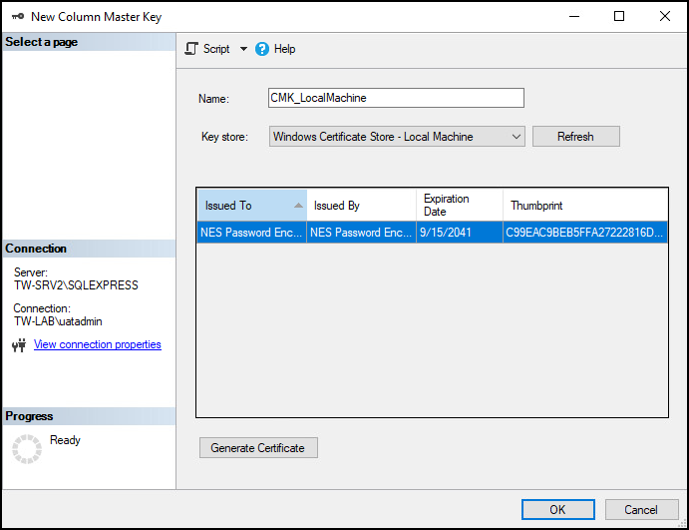
  - Click Generate Certificate.
The table refreshes with the Always Encrypted Certificate, as shown in the following figure.
Figure 56: Always Encrypted Certificate
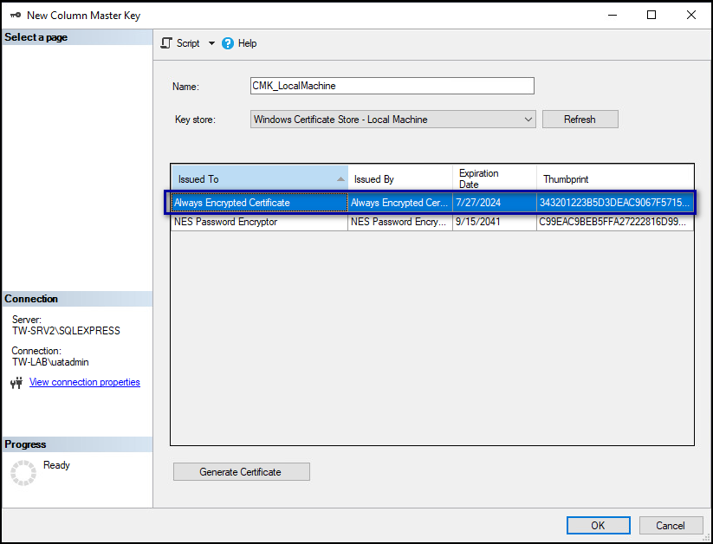
  - Click OK.
- While in Nymi.NES > Security > Always Encrypted Keys, right-click Column Encryption Keys, and then select New Column Encryption Key, as shown in the following figure.
Figure 57: New Column Encryption Key option
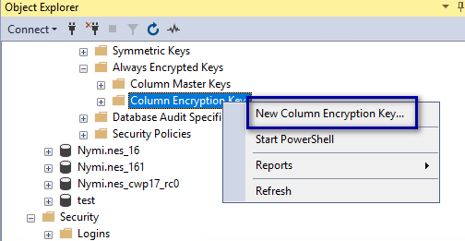
- On the New Column Encryption Key page, perform the following actions:
  - In the Name field, type a name for the key.
For example, CEK_LocalMachine.
  - In the Column master key field, select the name of the column master key that you created.
For example, CMK_LocalMachine.
The following figure shows the New Column Encryption Key page.
Figure 58: New Column Encryption Key page
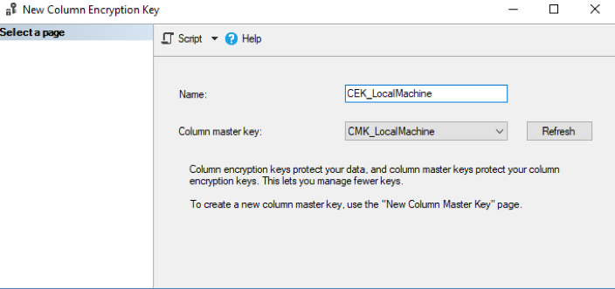
  - Click OK.
- In the left navigation pane, expand Database > Nymi.NES > Tables.
- Under tables, right-click nub.PrivateKeyStore, and then select Encrypt Columns, as shown in the following figure.
Figure 59: Encrypt Columns option
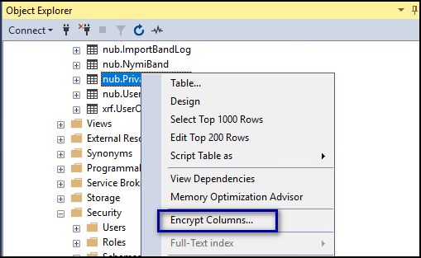
The Always encrypted wizard opens.
- On the Introduction page, click Next.
- On the Column Selection page, perform the following actions:
  - Enable Apply one key to all checked columns and ensure that CEK_LocalMachine appears in the list to the right.
  - In the table, select PEM, and then from the Encryption Type list, select Randomized.
  - In the table, select DER, and then from the Encryption Type list, select Randomized.
The following figure shows the Column Selection page.
Figure 60: Column Selection page
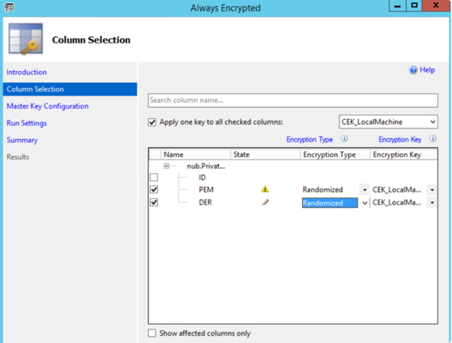
  - Click Next.
- On the Master Key Configuration page, click Next.
- On the Run settings page, leave the default value Proceed to finish now, and then click Next.
- On the Summary page, review the results, and then click Finish. Click Close.
- Under tables, right-click nub.NymiBand, and then select Encrypt Columns.
- On the Introduction page, click Next.
- On the Column Selection page, perform the following actions:
  - Select Apply one key to all checked columns and ensure that CEK_LocalMachine appears in the list to the right.
  - In the table, expand nub.NymiBand, scroll down and select Adv_key_1 and then from the Encryption Type list, select Randomized.
The following figure provides an example of the Encrypted Columns window.
Figure 61: Encrypted Columns window
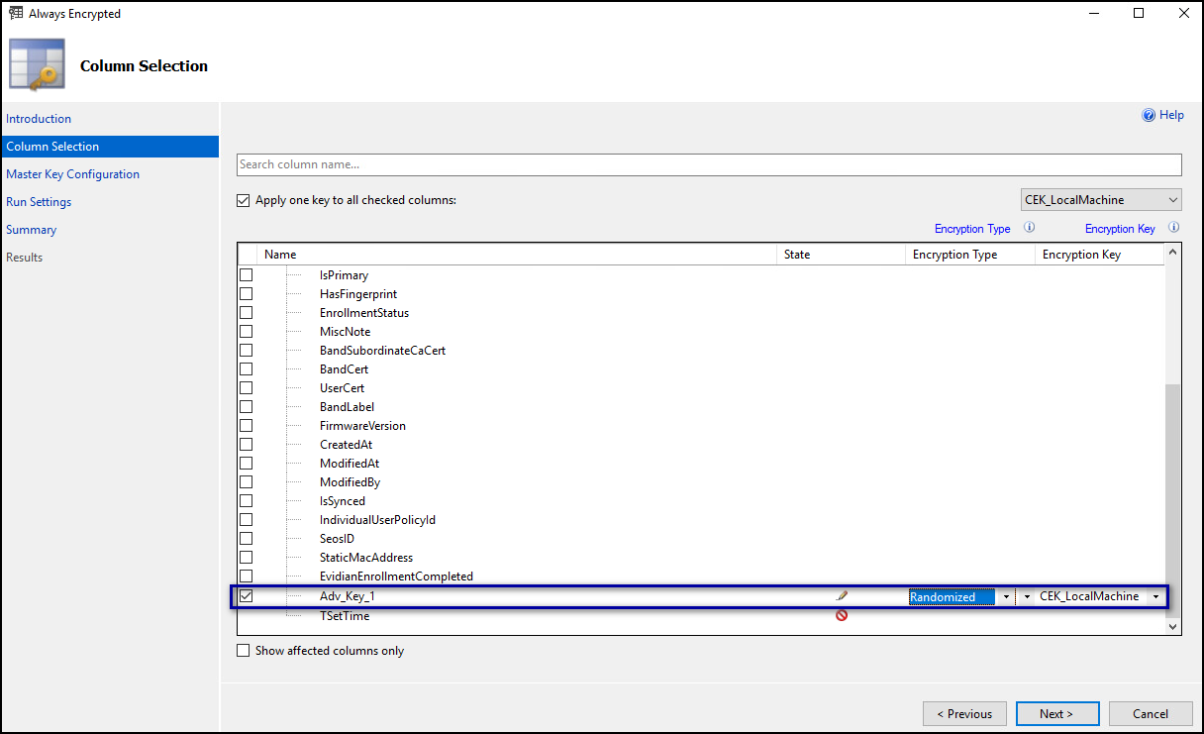
  - Click Next.
- On the Master Key Configuration page, click Next.
- On the Run settings page, leave the default value Proceed to finish now, and then click Next.
- On the Summary page, review the results, and then click Finish. Click Close.
- Close SSMS.
Ensure that NES Application Pool Identity has access to the encryption key:
- Open Manage Computer Certificates.
- Expand Personal and then select Certificates folder.
- In the right pane, right-click Always Encrypted Certificate and then select All Tasks > Manage Private Keys, as shown in the following figure.
Figure 62: Manage Private Keys option
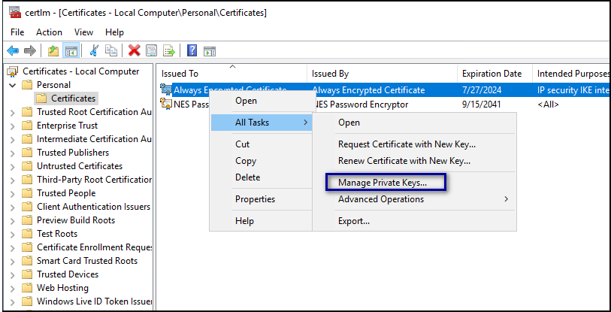
The Permissions for Always Encrypted Certificate window appears.
- Click Add, as shown in the following figure.
Figure 63: Add Permissions window
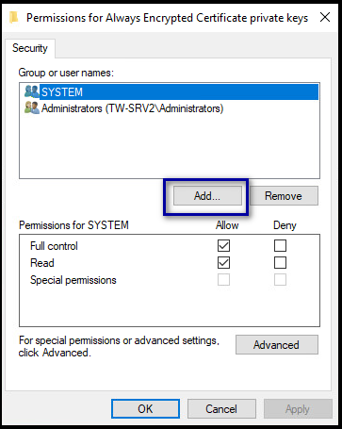
- In the Select Users, Computers, Service Accounts, or Groups window, type the Application Pool Identity, and the select Check Names. The following figure provides an example of the Select Users, Computers, Service Accounts, or Groups window when the application identity is the network service account.
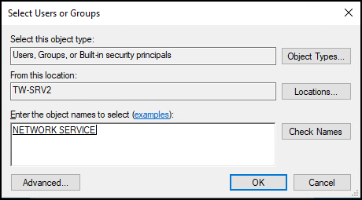
- Click OK.
- Click OK.
- Close Manage Computer Certificates.

(Optional)Encrypting usernames in the NES Database
Perform the following steps to encrypt the usernames in the audit.UserCore table.
- Open SSMS by using the Run as Administrator option.
- Encrypt the audit.UserCore table by performing the following steps:
  - In Tables, right-click audit.UserCore, and then select Encrypt Columns, as shown in the following.
Figure 64: Encrypt Columns option
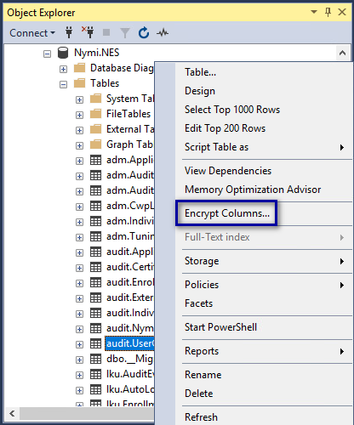
  - On the Introduction page, click Next.
  - On the Column Selection window, enable Apply one key to all checked columns and ensure that CEK_LocalMachine appears in the list to the right.
  - In the Table, select username, and then from the Encryption Type list, select Deterministic.
The following figure provides an example of the Column Selection window.
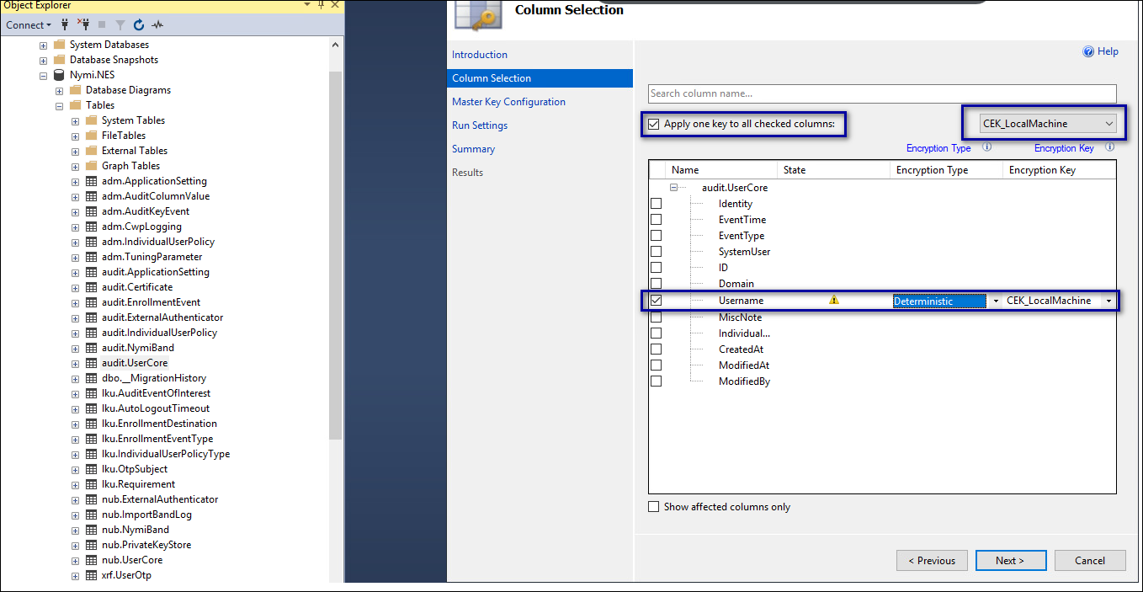
  - Click Next.
  - On the Master Key Configuration page, click Next.
  - On the Run settings page, leave the default setting Proceed to finish now, and then click Next.
  - On the Summary page, review the results, and then click Finish. Click Close.
The following figure provides an example of the Summary page.
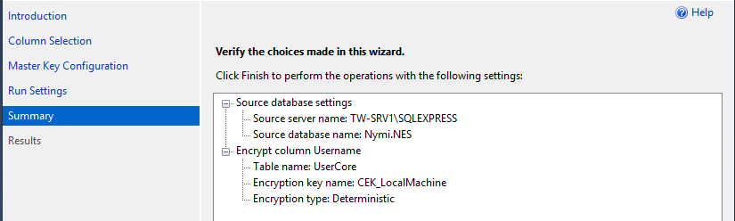
- Encrypt the usernames in the nub.UserCore table by performing the following steps:
  - In Tables, right-click nub.UserCore, and then select Encrypt Columns.
  - On the Introduction page, click Next.
  - Enable Apply one key to all checked columns and ensure that CEK_LocalMachine appears in the list to the right.
  - In the Tables, select username, and then from the Encryption Type list, select Deterministic.
  - Click Next.
  - On the Master Key Configuration page, click Next.
  - On the Run settings page, leave the default setting Proceed to finish now, and then click Next.
  - On the Summary page, review the results, and then click Finish. Click Close.

Set Up a Centralized Nymi Agent
When your environment uses iOS devices, thin clients, and web-based Nymi-enabled Applications, you must deploy a centralized Nymi Agent on a Windows server in the environment, for example, the NES server.
To secure websocket communications, you can configure the Nymi Agent to use TLS certificates.

Install Nymi Agent on a Centralized Server
You can install the Nymi Agent software with the installation wizard or silently from a command prompt.

Performing a Nymi Agent Installation or Update By Using the Installation Wizard
Install the Nymi Agent application, which is included in the Nymi Runtime installation package, on a server in the environment.
When you install the Nymi Runtime software, you can choose to install the Nymi Agent application only.
- Log in to the terminal, with an account that has administrator privileges.
- Create a backup copy of the C:\Nymi\Bluetooth_Endpoint\nbe.toml file.
- Extract the Nymi SDK distribution package.
- From the ..\nymi-sdk\windows\setup folder, right-click the Nymi Runtime Installer version.exe file, and select Run as administrator.
- On the Welcome page, click Install.
- On the User Account Control page, click Yes.
The installation wizard appears. If the installation detects missing prerequisites, perform the steps that appear in the prerequisite wizards.
- On the Welcome to the Nymi Runtime Setup Wizard page, click Next.
- On the Nymi Runtime Setup page, expand Nymi Runtime.
- Select Nymi Bluetooth Endpoint, and then select Entire feature will be unavailable.
The following figure provides an example of the Nymi Runtime Setup window with option to make Nymi Bluetooth Endpoint unavailable.
Figure 65: Nymi Bluetooth Endpoint feature will be unavailable
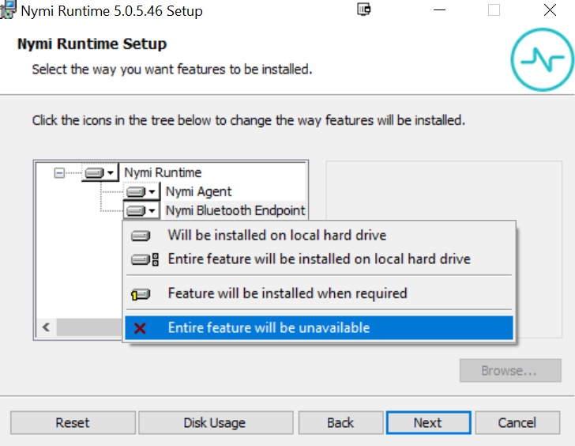
- Observe that Nymi Bluetooth Endpoint is not available, as shown in the following figure, and then click Next.
Figure 66: Nymi Bluetooth Endpoint feature is not available
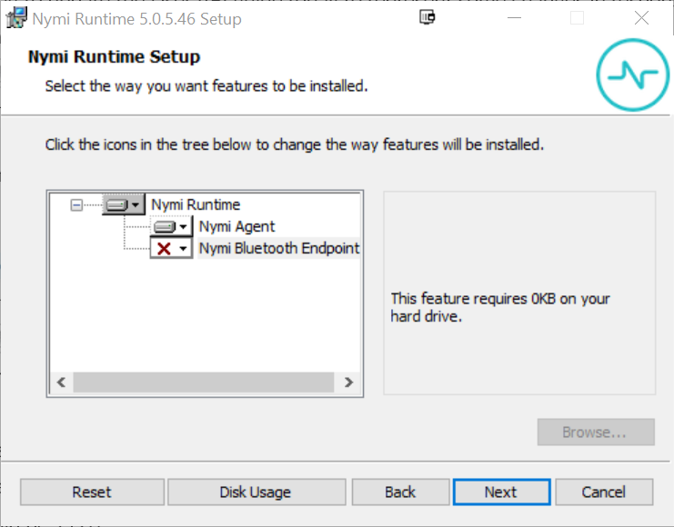
- On the Service Account window, perform one of the following actions to choose the account that starts the service:
  - Accept the default service account NTAuthority\LocalService, click Next.
  - For non-English Windows Operating Systems and for Nymi WebAPI configurations where you install the centralized Nymi Agent on the NES server, choose the LocalSystem account from the drop list, and then click Next.
Note: The service account must have permission to run as a service. Enable Service Log On provides more information about how to modify the local policy to enable this permission for the service account.
The following figure shows the Service Account window.
Figure 67: Nymi Runtime Service Account window
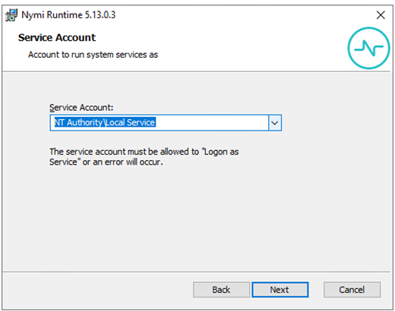
- On the (Optional) Nymi Infrastructure Service Account window, specify the username and password of the Nymi Infrastructure Service Account. When you specify the username, include the domain name, for example tw-lab\nymi_infra_service_acct. Refer to Appendix—Record the CWP Variables for the service account name.
The following figure shows the Nymi Infrastructure Service Account window.
Figure 68: Nymi Infrastructure Service Account window
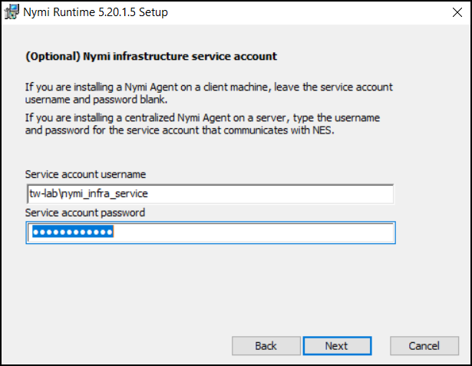
The installer creates the following files in the C:\Nymi\NymiAgent\certs folder:
  - credentials-contains the encrypted credentials for the Nymi Infrastructure Service Account
  - Private key
  - Public key
- On the Ready to install page, click Install.
- Click Finish.
- On the Installation Completed Successfully page, click Close.

Performing a Silent Nymi Agent Installation or Update
Install the Nymi Agent application, which is included in the Nymi Runtime installation package, on a machine in the environment.
When you install the Nymi Runtime software, you can choose to install the Nymi Agent application only.
- You can install the Nymi Agent silently by typing one of the following commands:
  - "Nymi Runtime Installer version.exe" /exenoui InstallEndpoint=0 /q /log NymiRuntimeInstallation.log
  - For installations on non-English operating systems,
"Nymi Runtime Installer version.exe" ServiceAccount="LocalSystem" /exenoui InstallEndpoint=0 /q /log NymiRuntimeInstallation.log
Where you replace version with the version of the Nymi installation file.
Note: Ensure that you enclose the filename in double quotes.
The installation command returns to a command prompt immediately, and the installation completes silently. When the installation completes, Nymi Runtime appears in the Program and Features applet and NymiRuntimeInstallation.log file contains information about the installation.
Note: Alternately, you can track the progress by performing an unattended installation, which displays the installation screens but does not require user intervention by replacing the /q option with the /passive option in the installation command.
- Perform the following steps to ensure that the Nymi Agent uses the Nymi Infrastructure Service Account to communicate with Nymi Enterprise Server(NES).
  - Create a text file named creds.text that contains two lines:
    - Username of the Nymi Infrastructure Service Account
    - Password of the Nymi Infrastructure Service Account
  - Open a Command prompt with the Run as Administrator option.
  - From the command prompt change to the C:\Nymi\NymiAgent\Tools directory, and type the following command:
cryptoutil.exe encrypt-service-account -i C:\Nymi\NymiAgent\creds.text -o C:\Nymi\NymiAgent\
The Cryptoutil tool creates the following files in the C:\Nymi\NymiAgent\certs folder:
    - credentials-contains the encrypted credentials for the Nymi Infrastructure Service Account
    - Private key
    - Public key
  - Permanently delete the C:\Nymi\NymiAgent\creds.txt file.

Adding TLS Certificate for Nymi WebAPI
Nymi WebAPI uses TLS certificates to communicate with Nymi Enterprise Server(NES).
When you configure secure WebSocket (wss), copy the following files to the C:\Nymi\NymiAgent\certs directory:
- CA root certificate bundle in PEM format
- Server certificate in PEM format
- Server certificate private key in PEM format
The Configuring the Nymi Agent toml File for WebAPI section explains how to define the location of the certificate files in the nymi_agent.toml file.

Configuring the Nymi Agent for WebAPI
By default, the Nymi Agent does not use Nymi WebAPI.
You must perform the following steps to enable the centralized Nymi Agent to use the Nymi WebAPI when your environment includes:
- User terminals that access web-based Nymi-enabled Applications(NEAs)
- iOS user terminals that access web-based NEAs or a native iOS access NEAs.
Perform the following steps on the centralized Nymi Agent server to enable WebAPI to support the following use cases.
- Change to the C:\Nymi\NymiAgent directory.
- Rename the C:\Nymi\NymiAgent\nymi_agent_default.toml file to C:\Nymi\NymiAgent\nymi_agent.toml
- Edit the C:\Nymi\NymiAgent\nymi_agent.toml, configure and uncomment the following parameters:
log_level = "warn" | Optional. Defines the debug logging level. Uncomment this line when instructed by Nymi, and then specify one of the following values:  - error—to log only errors  - warn—to log both errors and warnings  - info—to log errors, warnings, and activity  - debug—to log everything including debugging information
nea_name = "NymiWebAPI" | Required. Uncomment this parameter to set the NEA name for the embedded NEA WebAPI server application.
nes_url = "https://server.name.local.com"  For example, https://myserver.name.local.com | Required. Uncomment and specify the host URL for the NES server. Include only the protocol and hostname portion of the URI.
directory_service_id = "instance_name"  For example, directory_service_id = "NES" | Required. Uncomment and specify the instance name for NES. For example, if your NES URL is https://server.name.local.com/NES, the directory/instance name is NES.
credentials_location = certs/ | Required. Uncomment this line and leave the default value.  Note: The certs folder contains the encrypted username and password for the Nymi Infrastructure Service Account.
protocol = "wss" or protocol = "ws" | Required. Defines the Nymi WebAPIcommunication protocol. Choose one of the following options:  - protocol = "wss" to support a secure WebSocket using TLS. Nymi recommends that you configure secure WebSocket using TLS in production environments.  - protocol = "ws" to support a plain WebSocket.
port = 4443 or port = 8080 | Required. Defines the server port on which to listen for Nymi WebAPI client WebSocket connections. The parameter you uncomment depends on the protocol configuration:  - For the ws protocol, uncomment port = 4443.  - For the wss protocol, uncomment port = 8080.  Note: You can set an alternate port using this setting.
cacertfile = "path/certfile.pem"  For example: "certs/LocalLabRootCA3.pem" | Required when the Nymi Agent uses secure WebSocket communications (wss). Uncomment and specify the path to the PEM-formatted CA certificate or bundle for the trusted CA that signs the TLS certificate.
certfile = "path/certfile.pem"  For example: "certs/tw-srv1.tw-lab.local-cert.pem" | Required when the Nymi Agent uses secure WebSocket communications(wss). Uncomment and specify the path to the TLS certificate in PEM format.
keyfile = "path/keyfile.pem"  For example: "certs/tw-srv1.tw-lab.local-key.pem" | Required when the Nymi Agent uses secure WebSocket communications(wss). Uncomment and specify the path to the TLS certificate private key in PEM format.
- Restart the Nymi Agent service.

Install and Configure Endpoints
After you deploy and configure NES, install the appropriate software on each endpoint in your environment.
Endpoints include the enrollment terminal and the user terminals.
Installation and configuration instructions differ for endpoints that use a centralized Nymi Agent or a decentralized Nymi Agent:
- Perform the steps outlined in the section Install and Configure Endpoints with a decentralized Nymi Agent for:
  - Enrollment terminal
  - iOS devices that access native iOS NEAs
  - Windows thick client user terminals that access locally installed NEAs
  - Windows thick clients that use lock control to lock/unlock the desktop
- Perform the steps outlined in the section Install and Configure Endpoints with a centralized Nymi Agent for:
  - iOS devices that access web-based NEAs
  - User terminals that access web-based NEAs
  - Thin client user terminals that access NEAs that are installed on a remote session host
  - Thin client user terminals that unlock the desktop on a remote session host

Install and Configure Endpoints with a Decentralized Nymi Agent
This section for information about how to deploy Nymi components on user terminals for each use case that uses a decentralized Nymi Agent. You can use a user terminal to perform activities for more than one use case.
The following table provides more information about the each use case and endpoint configuration.
Endpoint/Use Case | Description | Nymi Component Requirements
Enrollment terminal | Where users enroll their Nymi Bands by using the Nymi Band Application, and can use the Nymi Band Application to authenticate to their Nymi Bands by using corporate credentials authentication. The Nymi Connected Worker Platform—Administration Guide provides more information about how to configure corporate credentials authentication. | Nymi Band Application
User Terminal for Authentication Tasks | Windows thick client where users access a locally-installed NEA. | Nymi Runtime(Nymi Bluetooth Endpoint and Nymi Agent).
User Terminal for lock and unlock tasks on the user terminal | Windows client where a user uses their Nymi Band to lock or unlock the physical desktop. | Nymi Lock Control  Nymi Runtime(Nymi Bluetooth Endpoint and Nymi Agent)
Note: If the Root CA that issued the NES TLS server certificate is not a Trusted Root CA, you must also install the Root CA certificate for NES on every endpoint.

Bluetooth Adapter Placement
The enrollment terminal and each user terminal requires a Bluetooth adapter. The Bluetooth Low Energy (BLE) radio antenna in the Nymi-supplied BLED112 USB Adapter provides seamless Bluetooth capability between the Nymi Band and devices such as a laptop computer.
To ensure optimal system performance, place the Bluetooth adapter in a location that meets the following criteria:
- Is in clear line of sight to the Nymi Band.
- Is on the same side of the computer that you wear your Nymi Band.
- Is near the computer keyboard.
Note: The presence of liquids between the Nymi Band and Bluetooth adapter negatively affects the Bluetooth signal quality. This includes beverages and the human body. If Bluetooth (BLE) taps behave unexpectedly, consider another placement for the Bluetooth adapter, or edit the Nymi Bluetooth Endpoint configuration file to adjust the signal strength thresholds to perform a BLE tap (see Edit the nbe.toml File).

Set Up the Enrollment Terminal
Before a user can enroll and authenticate the Nymi Band, the NES Administrator must perform the following actions on at least one machine in the environment (the enrollment terminal). You cannot use a thin client as an enrollment terminal.
- Insert the Nymi-supplied Bluetooth adapter into an available USB port.
- Install the Nymi Band Application. The Nymi Band user requires physical access to the enrollment terminal.
- Set the NES_URL registry key.

Importing the Root CA certificate
Perform the following steps only if the Root CA issuing the NES TLS server certificate is not a Trusted Root CA (for example, if a self-signed TLS server certificate is used for NES). Install the Root CA on each user terminal to support the establishment of a connection with the NES host.
While logged into the user terminal as a local administrator, use the certlm application to import the root CA certificate into the Trusted Root Certification Authorities store. For example, on Windows 10, perform the following steps:
- In Control Panel, select Manage Computer Certificates.
- In the certlm window, right-click Trusted Root Certification Authorities, and then select All Tasks > Import.
The following figure shows the certlm window.
Figure 69: certlm application on Windows 10
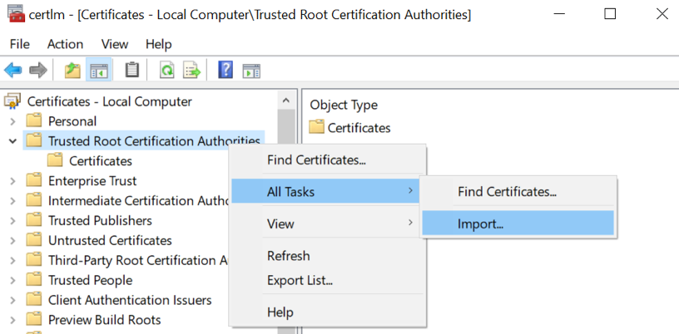
- On the Welcome to the Certificate Import Wizard screen, click Next.
The following figure shows the Welcome to the Certificate Import Wizard screen.
Figure 70: Welcome to the Certificate Import Wizard screen
- On the File to Import screen, click Browse, navigate to the folder that contains the root certificate file, select the file, and then click Open.
- On the File to Import screen, click Next.
The following figure shows the File to Import screen.
Figure 71: File to Import screen
- On the Certificate Store screen, accept the default value Place all certificates in the following store with the value Trusted Root Certification Authorities, and then click Next.
- On the Completing the Certificate Import Wizard screen, click Finish.

Install the Nymi Band Application
Perform the following steps to install the Nymi Band Application on each enrollment terminal that you will use to enroll and authenticate users to their Nymi Bands.
You can perform a customizable installation or a silent installation.

Install the Nymi Band Application Silently
Before you perform a silent installation of the Nymi Band Application you must install the Nymi Runtime software.

Installing the Nymi Runtime Silently
Perform the following steps to install or update the Nymi Runtime and the BLE adapter drivers silently, without user intervention.
- Log in to the network terminal with an account that has administrator privileges.
- Download and extract the Nymi SDK package.
- Launch the command prompt as administrator.
- Change to the ..\nymi-sdk\windows\runtime folder, and then type one of the following commands:
  - "Nymi Runtime Installer version.exe" /exenoui /q /log NymiRuntimeInstallation.log
  - For installations on non-English operating systems,
"Nymi Runtime Installer version.exe" ServiceAccount="LocalSystem" /exenoui /q /log NymiRuntimeInstallation.log
Where you replace version with the version of the Nymi installation file.
Note: Ensure that you enclose the filename in double quotes.
The installation command returns to a command prompt immediately, and the installation completes silently. When the installation completes, Nymi Runtime appears in the Program and Features applet and NymiRuntimeInstallation.log file contains information about the installation.
Note: Alternately, you can track the progress by performing an unattended installation, which displays the installation screens but does not require user intervention by replacing the /q option with the /passive option in the installation command.
In the Windows Services applet, confirm that you can see the Nymi Agent and Nymi Bluetooth Endpoint services, and that the status of each service is Running
If required, you can review the installation log file in the %temp% directory named Nymi Runtime_version_time.log

Installing the Nymi Band Application Silently
Perform the following steps to install or update the Nymi Band Application silently, for example, when you want to install the software remotely by using a software distribution application.
- Save the Nymi Band Application package, provided to you by your Nymi Solution Consultant.
- Launch the command prompt as administrator.
- From the folder that contains the Nymi Band Application, type Nymi-Band-App-installer-v_version.exe /exenoui /q
Where you replace version with the version of the Nymi installation file.
The installation command returns to a command prompt immediately, and the installation completes silently. When the installation completes, the Nymi Band Application and Nymi Runtime applications appear in the Program and Features applet.
Note: Alternately, you can track the progress by performing an unattended installation, which displays the installation screens but does not require user intervention by replacing the /q option with the /passive option in the installation command.

Installing the Nymi Band Application with the Installation Wizard
Perform the following steps to install the Nymi Band Application.
Uninstall the previous version of Nymi Runtime.
- Download the Nymi Band Application package.
- Double-click the Nymi-Band-App-installer-v_version.exe file.
- On the User Account Control window, click Yes.
- On the Prerequisites window, click Next.
- On the Welcome page, click Install.
- On the User Account Control page, click Yes.
The installation wizard appears. If the installation detects missing prerequisites, perform the steps that appear in the prerequisite wizards.
- On the Welcome to the Nymi Runtime Setup Wizard page, click Next.
- On the Nymi Runtime Setup window, click Next.
- On the Service Account window, perform one of the following actions to choose the account that starts the service:
  - Accept the default service account NTAuthority\LocalService, click Next.
  - For non-English Windows Operating Systems, choose the LocalSystem account from the drop list, and then click Next.
Note: The service account must have permission to run as a service. Enable Service Log On provides more information about how to modify the local policy to enable this permission for the service account.
The following figure shows the Service Account window.
Figure 72: Nymi Runtime Service Account window
- On the (Optional) Nymi Infrastructure Service Account, click Next.
Only deployments that use web-based Nymi-enabled Applications(NEAs) with a centralized Nymi Agent require you to configure the Nymi Infrastructure Service Account.
- On the Ready to install page, click Install.
- Click Finish.
- On the Installation Completed Successfully page, click Close.
- On the Welcome to Nymi Band Application Setup Wizard window, click Next.
- On the Select Installation Folder window, click Next to accept the default installation location.
- In the Ready to Install window, click Install.
- On the Completing the Nymi Band Application Setup Wizard window, click Finish.

Configuring the Nymi Enterprise Server URL
After you install the Nymi Band Application, perform the following steps to ensure that the enrollment process connect to the correct Nymi Enterprise Server(NES).
- Run regedit.exe
- On the User Account Control window, click Yes.
- Navigate to HKEY_LOCAL_MACHINE > Software > Nymi.
Note: If you installed the Nymi Band Application on a Citrix server, set navigate to HKEY_CURRENT_USER instead of HKEY_LOCAL_MACHINE
.
- Right-click NES, and then select New > String value.
- In the Value field, type URL.
- Double-click URL and in the Value Data field, type https://nes_server/NES_service_name/ or http://nes_server/NES_service_name depending on the NES configuration
where:
  - nes_server is the FQDN of the NES host. The FQDN consists of the hostname.domain_name. You can also find the FQDN by going to the server on which you deployed NES viewing the properties of the computer. The nes_server is the value that appears in the Full computer name field.
  - NES_service_name is the name of the service mapping for NES in IIS, which maps a virtual directory to a physical directory. You can choose any name for this mapping, but it is recommended that you specify a name that is descriptive to the Connected Worker Platform, for example, NES.
- Click OK.

Disabling Evidian Enrollment
Nymi supports using the same NES server to enroll users in Evidian and non-Evidian environments simultaneously.
On the enrollment terminal which does not enroll users to an Evidian Evidian EAM Controller, perform the following steps.
- Launch regedit.exe
- Navigate to HKEY_LOCAL_MACHINE\SOFTWARE\Nymi
- Right-click NES, and then select New > String value.
- In the Name field, type HideEvidianEnrollmentError
- Edit the key and then in the Value data field, type True.
- Click OK.
- Close Registry Editor.

(Optional) Configuring the Communication Protocol
If you use the enrollment terminal to also access NEAs, perform the following steps to disable the legacy protocol.
Note: After you set this environment variable, user terminals cannot communicate with Nymi Bands that use pre-CWP 1.15.x firmware
- In the Windows search field, type env, and then from the pop-up menu, select Edit the System Environment Variables.
- Click Environment Variables.
- In the System Variables section, click New, and the perform the following actions:
  - In the Variable Name field, type NYMI_NEA_SUPPORT_LEGACY_MODE
  - In the Variable Value field, type 0.
The following figure provides an example of the new variable.
Figure 73: New System Variable window
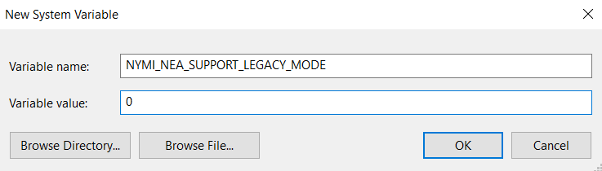
  - Click OK.

Set Up Windows User Terminals for Authentication Tasks
You can use the Nymi Band to perform daily authentication tasks that would normally require the user to supply a user name and password, such as e-signatures in an MES application.
User terminals that you will use for authentication tasks require that you:
- Import the Root CA certificate for NES (when the Root CA that issued the certificate is not a trusted CA).
Apple recommends deploying certificates with a Mobile Device Management (MDM) system. Certificate payloads are automatically trusted for SSL when installed with Configurator, MDM, or as part of an MDM enrollment profile.
Apple Support provides more information.
Note: If you manually import a device profile, you must enable trust for SSL/TLS. Apple Support provides more information.
- Install the Nymi Runtime software.
- Insert the Nymi-supplied Bluetooth adapter into an available USB port.
- Optionally, insert a Nymi-verified NFC reader into an available USB port.

Importing the Root CA certificate
Perform the following steps only if the Root CA issuing the NES TLS server certificate is not a Trusted Root CA (for example, if a self-signed TLS server certificate is used for NES). Install the Root CA on each user terminal to support the establishment of a connection with the NES host.
While logged into the user terminal as a local administrator, use the certlm application to import the root CA certificate into the Trusted Root Certification Authorities store. For example, on Windows 10, perform the following steps:
- In Control Panel, select Manage Computer Certificates.
- In the certlm window, right-click Trusted Root Certification Authorities, and then select All Tasks > Import.
The following figure shows the certlm window.
Figure 74: certlm application on Windows 10
- On the Welcome to the Certificate Import Wizard screen, click Next.
The following figure shows the Welcome to the Certificate Import Wizard screen.
Figure 75: Welcome to the Certificate Import Wizard screen
- On the File to Import screen, click Browse, navigate to the folder that contains the root certificate file, select the file, and then click Open.
- On the File to Import screen, click Next.
The following figure shows the File to Import screen.
Figure 76: File to Import screen
- On the Certificate Store screen, accept the default value Place all certificates in the following store with the value Trusted Root Certification Authorities, and then click Next.
- On the Completing the Certificate Import Wizard screen, click Finish.

(Windows) Install Nymi Runtime
Nymi Runtime facilitates communication between NES and the Nymi Bands.
Install the Nymi Runtime on each user terminal on which you will also install a Nymi-enabled Application. You can perform a customizable installation or a silent installation.
Note: The Bluetooth (BLE) driver is installed with the installation of Nymi Runtime. The BLE driver may also be installed separately by going to the Nymi SDK package and installing the BleDriver .msi file.

Installing the Nymi Runtime Silently
Perform the following steps to install or update the Nymi Runtime and the BLE adapter drivers silently, without user intervention.
- Log in to the network terminal with an account that has administrator privileges.
- Download and extract the Nymi SDK package.
- Launch the command prompt as administrator.
- Change to the ..\nymi-sdk\windows\runtime folder, and then type one of the following commands:
  - "Nymi Runtime Installer version.exe" /exenoui /q /log NymiRuntimeInstallation.log
  - For installations on non-English operating systems,
"Nymi Runtime Installer version.exe" ServiceAccount="LocalSystem" /exenoui /q /log NymiRuntimeInstallation.log
Where you replace version with the version of the Nymi installation file.
Note: Ensure that you enclose the filename in double quotes.
The installation command returns to a command prompt immediately, and the installation completes silently. When the installation completes, Nymi Runtime appears in the Program and Features applet and NymiRuntimeInstallation.log file contains information about the installation.
Note: Alternately, you can track the progress by performing an unattended installation, which displays the installation screens but does not require user intervention by replacing the /q option with the /passive option in the installation command.
In the Windows Services applet, confirm that you can see the Nymi Agent and Nymi Bluetooth Endpoint services, and that the status of each service is Running
If required, you can review the installation log file in the %temp% directory named Nymi Runtime_version_time.log

Performing a Customizable Nymi Runtime Installation or Update
Perform the following steps to install or update Nymi Runtime on a network device, on which you want to install a Nymi-enabled Application.
- Log in to the terminal, with an account that has administrator privileges.
- Create a backup copy of the C:\Nymi\Bluetooth_Endpoint\nbe.toml file.
- Extract the Nymi SDK distribution package.
- From the ..\nymi-sdk\windows\setup folder, right-click the Nymi Runtime Installer version.exe file, and select Run as administrator.
- On the Welcome page, click Install.
- On the User Account Control page, click Yes.
The installation wizard appears. If the installation detects missing prerequisites, perform the steps that appear in the prerequisite wizards.
- On the Welcome to the Nymi Runtime Setup Wizard page, click Next.
- On the Nymi Runtime Setup page, click Next.
- On the Service Account window, perform one of the following actions to choose the account that starts the service:
  - Accept the default service account NTAuthority\LocalService, click Next.
  - For non-English Windows Operating Systems, choose the LocalSystem account from the drop list, and then click Next.
Note: The service account must have permission to run as a service. Enable Service Log On provides more information about how to modify the local policy to enable this permission for the service account.
The following figure shows the Service Account window.
Figure 77: Nymi Runtime Service Account window
- On the (Optional) Nymi Infrastructure Service Account, click Next.
Only deployments that use web-based Nymi-enabled Applications(NEAs) with a centralized Nymi Agent require you to configure the Nymi Infrastructure Service Account.
- On the Ready to install page, click Install.
- Click Finish.
- On the Installation Completed Successfully page, click Close.
In the Windows Services applet, confirm that you can see the Nymi Agent and Nymi Bluetooth Endpoint services, and that the status of each service is Running

Configuring the Connected Worker Platform Communication Protocol
Starting with Connected Worker Platform(CWP) 1.15, the Nymi solution supports a new, high performance protocol over Bluetooth between the Nymi Runtime and Nymi Bands.
Perform the following steps on all user terminals (for Evidian environments on Wearable user terminals only) where users access Nymi-enabled Applications(NEAs) to disable the legacy protocol. The enrollment terminal only requires the environment variable if users access NEAs on the enrollment terminal.
Note: After you set this environment variable, user terminals cannot communicate with Nymi Bands that use pre-CWP 1.15.x firmware
- In the Windows search field, type env, and then from the pop-up menu, select Edit the System Environment Variables.
- Click Environment Variables.
- In the System Variables section, click New, and the perform the following actions:
  - In the Variable Name field, type NYMI_NEA_SUPPORT_LEGACY_MODE
  - In the Variable Value field, type 0.
The following figure provides an example of the new variable.
Figure 78: New System Variable window
  - Click OK.

Set Up Windows User Terminals for Lock and Unlock
You can use the Nymi Band to lock and unlock the desktop of thick client computers.
User terminals on which you will use theNymi Band to lock and unlock a desktop require that you:
- Import the Root CA certificate for NES (when the Root CA that issued the certificate is not a trusted CA).
Apple recommends deploying certificates with a Mobile Device Management (MDM) system. Certificate payloads are automatically trusted for SSL when installed with Configurator, MDM, or as part of an MDM enrollment profile.
Apple Support provides more information.
Note: If you manually import a device profile, you must enable trust for SSL/TLS. Apple Support provides more information.
- Insert the Nymi-supplied Bluetooth adapter into an available USB port.
- Install the Nymi Lock Control software
- Configure the Nymi Bluetooth Endpoint configuration file.

Configuring Nymi Lock Control
Perform the following steps to enable and configure Nymi Lock Control.
By default Nymi Lock Control is not enabled.
- Log in to the NES Administrator Console with an account that is an NES Administrator.
- From the navigation bar, select Policies.
The Policies page appears with a table that displays a list of existing group and individual policies.
- In the Policies window, select the active policy.
- In the Lock Control section, select the Enable Nymi Lock Control option.
The following options appear to customize Nymi Lock Control.
Lock When Away | - Configure Nymi Lock Control with the ability to lock the user terminal when Nymi Lock Control does not detect the authenticated Nymi Band.  - Default: Enabled  - When enabled, Nymi Lock Control locks the user terminal when a user removes an authenticated Nymi Band or when the Nymi Band is not in close proximity of the user terminal. When the Nymi Band is out of range, a 10 second timer appears on the desktop. If the Nymi Band does not return within close range of the user terminal, the terminal will lock.  Ensure that your Group Policy Object(GPO) settings do not push the Do not display the lock screen configuration option to the Nymi Lock Control user terminals.  Note: Edit the nbe.toml file to define close proximity for Nymi Lock Control. Refer to Editing the nbe.toml File.
Unlock When Present | - Configures Nymi Lock Control to check if the Nymi Band is in close proximity before unlocking the user terminal. If not, then unlock fails. You can define how close the Nymi Band must be to the user terminal to allow the user to unlock the terminal with the Nymi Band in the nbe.toml file.  - Default: Enabled  - When enabled, prevents an unauthorized user from unlocking the user terminal while the Nymi Band user is in Bluetooth range, but not in close proximity to the terminal.  - When disabled, allows a user to unlock the user terminal by pressing the Enter key or space bar on the keyboard when the authenticated Nymi Band is within Bluetooth range, but not in close proximity of the user terminal.
Keep Unlocked when Present | - Provides you with the ability to define how the Nymi Band interacts with operating system screen timeouts or sleep settings that lock the user terminal.  - Default: Enabled  - When enabled, overrides any system screen timeouts or sleep settings, and keeps the user terminal unlocked as long as the Nymi Band is present and authenticated.  - When disabled, prevents Nymi Lock Control from overriding any system screen timeouts or sleep settings.
- Click Save.
During enrollment the Nymi Band Application updates the Nymi Band to enable Nymi Lock Control support.
Changing this option does not change the Nymi Band behaviour for existing enrolled Nymi Bands until the user logs into the Nymi Band Application while wearing their authenticated Nymi Band.
When the Nymi Band Application updates on the Nymi Band completes, restart Nymi Lock Control.

Importing the Root CA certificate
Perform the following steps only if the Root CA issuing the NES TLS server certificate is not a Trusted Root CA (for example, if a self-signed TLS server certificate is used for NES). Install the Root CA on each user terminal to support the establishment of a connection with the NES host.
While logged into the user terminal as a local administrator, use the certlm application to import the root CA certificate into the Trusted Root Certification Authorities store. For example, on Windows 10, perform the following steps:
- In Control Panel, select Manage Computer Certificates.
- In the certlm window, right-click Trusted Root Certification Authorities, and then select All Tasks > Import.
The following figure shows the certlm window.
Figure 79: certlm application on Windows 10
- On the Welcome to the Certificate Import Wizard screen, click Next.
The following figure shows the Welcome to the Certificate Import Wizard screen.
Figure 80: Welcome to the Certificate Import Wizard screen
- On the File to Import screen, click Browse, navigate to the folder that contains the root certificate file, select the file, and then click Open.
- On the File to Import screen, click Next.
The following figure shows the File to Import screen.
Figure 81: File to Import screen
- On the Certificate Store screen, accept the default value Place all certificates in the following store with the value Trusted Root Certification Authorities, and then click Next.
- On the Completing the Certificate Import Wizard screen, click Finish.

Install Nymi Lock Control
You can install Nymi Lock Control silently or with the installation wizard.

Installing Nymi Lock Control Silently
To install Nymi Lock Control silently in a centralized Nymi Agent configuration, first install Nymi Bluetooth Endpoint and then install Nymi Lock Control

Installing the Nymi Runtime Silently
Perform the following steps to install or update the Nymi Runtime and the BLE adapter drivers silently, without user intervention.
- Log in to the network terminal with an account that has administrator privileges.
- Download and extract the Nymi SDK package.
- Launch the command prompt as administrator.
- Change to the ..\nymi-sdk\windows\runtime folder, and then type one of the following commands:
  - "Nymi Runtime Installer version.exe" /exenoui /q /log NymiRuntimeInstallation.log
  - For installations on non-English operating systems,
"Nymi Runtime Installer version.exe" ServiceAccount="LocalSystem" /exenoui /q /log NymiRuntimeInstallation.log
Where you replace version with the version of the Nymi installation file.
Note: Ensure that you enclose the filename in double quotes.
The installation command returns to a command prompt immediately, and the installation completes silently. When the installation completes, Nymi Runtime appears in the Program and Features applet and NymiRuntimeInstallation.log file contains information about the installation.
Note: Alternately, you can track the progress by performing an unattended installation, which displays the installation screens but does not require user intervention by replacing the /q option with the /passive option in the installation command.
In the Windows Services applet, confirm that you can see the Nymi Agent and Nymi Bluetooth Endpoint services, and that the status of each service is Running
If required, you can review the installation log file in the %temp% directory named Nymi Runtime_version_time.log

Installing or Updating Nymi Lock Control Silently
Perform the following steps to install or update the Nymi Lock Control silently, for example, when you want to install the software remotely by using a software distribution application.
- Save the Nymi Lock Control package, provided to you by your Nymi Solution Consultant.
- Launch the command prompt as administrator.
- From the folder that contains the Nymi Lock Control, type NymiLockControl-installer-vversion.exe /exenoui /q
Where you replace version with the version of the Nymi installation file.
The installation command returns to a command prompt immediately, and the installation completes silently. When the installation completes, the Nymi Lock Control application appears in the Program and Features applet.
Note: Alternately, you can track the progress by performing an unattended installation, which displays the installation screens but does not require user intervention by replacing the /q option with the /passive option in the installation command.

Installing or Updating Nymi Lock Control with the Installation Wizard
Perform the following steps on each user terminal in the environment.
- Right-click NymiLockControl-installer-vw.x.y.z and select Run as administrator.
- On the User Account Control window, click Yes.
- On the Welcome to the Prerequisites Setup Wizard, click Next.
- On the Prerequisites window, leave the default selections, and then click Next.
- On the Welcome window, click Install.
- On the Welcome to the Nymi Runtime Setup Wizard page, click Next.
- On the Nymi Runtime Setup window, leave the default options, and then click Next
- On the Service Account window, perform one of the following actions to choose the account that starts the service:
  - Accept the default service account NTAuthority\LocalService, click Next.
  - For non-English Windows Operating Systems, choose the LocalSystem account from the drop list, and then click Next.
Note: The service account must have permission to run as a service. Enable Service Log On provides more information about how to modify the local policy to enable this permission for the service account.
The following figure shows the Service Account window.
Figure 82: Nymi Runtime Service Account window
- On the Ready to install page, click Install.
- Click Finish.
- On the Installation Completed Successfully page, click Close.
- On the Welcome to Nymi Lock Control Setup Wizard window, click Next.
- On the Select Installation Folder window, perform the following actions:
  - To change the installation location, click Browse, navigate to a new installation folder, and then click Select Folder
  - To keep the default installation location, click Next.
- On the Ready to Install window, click Install.
- On the Completing the Nymi Lock Control Setup Wizard window, click Finish.

Configuring the Nymi Enterprise Server URL
Create a GPO to push the Nymi Enterprise Server(NES) URL registry key to each user terminal, or perform the following steps to manually create the registry key on the user terminal.
Run regedit as an administrator.
- Navigate to HKEY_LOCAL_MACHINE\Software\Nymi\NES.
Note: If this path does not exist, create the keys.
- In the NES key, create a new string value, as shown in the following figure.
Figure 83: NES registry key
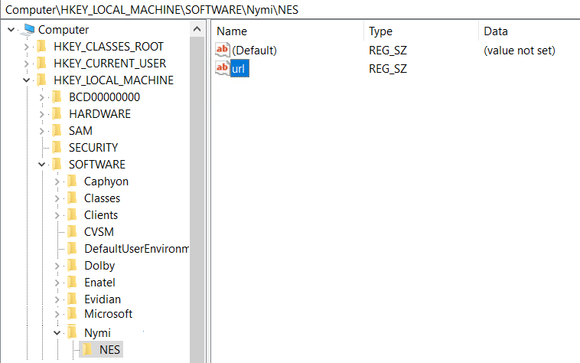
- In the Name field, type URL.
- Edit the string and in the value field, type https://nes_server/instance
Where:
  - nes_server is the Fully Qualified Domain name of the NES host.
  - instance is the services mapping name of the NES web application. The default value is nes.
For example, https://tw-srv1.tw-lab.local/nes
Note: The service mapping name for NES was defined during deployment.
The following figure provides an example of the URL key value.
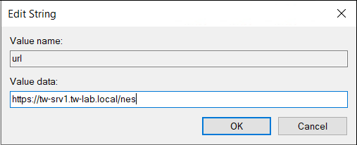

Configuring the Connected Worker Platform Communication Protocol
Starting with Connected Worker Platform(CWP) 1.15, the Nymi solution supports a new, high performance protocol over Bluetooth between the Nymi Runtime and Nymi Bands.
Perform the following steps on all user terminals (for Evidian environments on Wearable user terminals only) where users access Nymi-enabled Applications(NEAs) to disable the legacy protocol. The enrollment terminal only requires the environment variable if users access NEAs on the enrollment terminal.
Note: After you set this environment variable, user terminals cannot communicate with Nymi Bands that use pre-CWP 1.15.x firmware
- In the Windows search field, type env, and then from the pop-up menu, select Edit the System Environment Variables.
- Click Environment Variables.
- In the System Variables section, click New, and the perform the following actions:
  - In the Variable Name field, type NYMI_NEA_SUPPORT_LEGACY_MODE
  - In the Variable Value field, type 0.
The following figure provides an example of the new variable.
Figure 84: New System Variable window
  - Click OK.

Edit the Nymi Bluetooth Endpoint Configuration File
The Nymi Bluetooth Endpoint application enables BLE functionality for Nymi Lock Control and BLE tap. Editing the Nymi Bluetooth Endpoint configuration file adjusts the behavior of these features.
Note: Nymi Lock Control functions with a BLE radio antenna or NFC reader. The settings described in this section refer to Nymi Lock Control with a BLE adapter only, and not an NFC reader.
Nymi Lock Control and BLE tap behavior is dependent on the distance between the Nymi Band and the BLE radio antenna. The distance between the radio antenna and the Nymi Band is represented by changes in the Received Signal Strength Indication (RSSI) value, and is determined by measuring the radio signals received by the BLE radio antenna. Close distances between the Nymi Band and BLE radio antenna result in stronger signals, and far distances result in weak signals. BLE tap and Nymi Lock Control actions occur when the trends in changing RSSI values reach a certain threshold defined in the Nymi Bluetooth Endpoint configuration settings.
The default RSSI values used by Nymi Bluetooth Endpoint may not be optimal for certain users. For example, under default settings the user terminal may unlock when the user is too far away, or the user terminal may accidentally lock while the user is present. In these cases, the BLE radio antenna is too sensitive, not sensitive enough, or the placement of the BLE adapter prevents the Nymi Band from being read consistently. Edit the Nymi Bluetooth Endpoint configuration settings on a user terminal to adjust for these discrepancies.
To adjust the sensitivity of BLE taps and Nymi Lock Control, edit the Received Signal Strength Indication (RSSI) values in the Nymi Bluetooth Endpoint configuration file, nbe.toml.
Note: The nbe.toml file described in this section is only used to apply adjustments to Nymi Lock Control and BLE tap behavior with a BLE radio antenna (ex. USB adapter). If the nbe.toml file is renamed or deleted, Nymi Lock Control and BLE taps behave under the default settings described in Editing the nbe.toml File.

Editing the nbe.toml File

The Nymi Bluetooth Endpoint installation creates a configuration file (nbe.toml) in the located in C:\Nymi\Bluetooth_Endpoint\ folder on Windows, and the /usr/bin directory on HP Thin Pro. This file contains the default values that control BLE tap behavior with the Nymi Band and Bluetooth adapter.
- Make a copy of the C:\Nymi\Bluetooth_Endpoint\nbe.toml file (On HP Thin Pro, /usr/bin/nbe.toml).
- Edit the nbe.toml file with a text editor in administrator mode.
- Edit the RSSI values in the file, as outlined in the following table.
Table 7: RSSI Values
RSSI Value | Default | Description
rssi_window_tap | 10 | This determines the duration the Nymi Band must be within tap-distance of the BLE radio antenna to complete a tap.  A larger value increases the duration required to perform and decrease the sensitivity.
rssi_window_long | 50 | This determines the frequency that Nymi Bluetooth Endpoint checks the distance between the BLE radio antenna and the Nymi Band.  Nymi Bluetooth Endpoint tracks trends in these changes to trigger a Nymi Lock Control action, such as keep unlocked when present, lock when away, or unlock when present.
rssi_tap_threshold | -42  (must be 0 or negative) | This determines the range at which a tap event will occur. A smaller negative value means a closer distance to the BLE antenna.  BLE tap is disabled by default (value = 0). Enter a non-zero, negative number to enable BLE tap. Nymi recommends an RSSI value of -42.  If the Nymi Band maintains a minimum distance specified by rssi_tap_threshold, for the duration of time that is defined by rssi_window_tap, a BLE tap is performed.
rssi_cutoff_close | -70  (must be 0 or negative) | This determines the outer range of the close distance-threshold (excluding tap distance) for Nymi Lock Control.  Enter 0 to bypass the proximity functionality of Nymi Lock Control.  If the Nymi Band maintains a close distance to the BLE radio antenna and the RSSI values measured are within the rssi_cutoff_close value, Nymi Lock Control keeps the user terminal unlocked.  If the Nymi Band moves away from the BLE radio antenna, and the RSSI values measured are on a decreasing trend and goes from the rssi_cutoff_close value to the rssi_cutoff_far value, Nymi Lock Control locks the user terminal.
rssi_cutoff_far | -75  (must be negative) | This determines the outer range of the far distance-threshold (excluding tap distance) for Nymi Lock Control.  If the Nymi Band moves towards the BLE radio antenna, and the RSSI values measured are on an increasing trend and goes from the rssi_cutoff_far value to the rssi_cutoff_close value, Nymi Lock Control unlocks the user terminal.
- Save the nbe.toml file.
- Restart the Nymi Bluetooth Endpoint.
On Windows:
  - Press the Windows key on the keyboard, or click the start button on the toolbar. Enter "Services" in the search bar. The Services application window appears.
  - Search for Nymi Bluetooth Endpoint in the Services application.
  - Right-click Nymi Bluetooth Endpoint and restart it.
On HP Thin Pro:
  - Stop the Nymi Bluetooth Endpoint service by typing killall -9 nbed.
  - Start the Nymi Bluetooth Endpoint by typing /usr/bin/nbedstart.
Once restarted, the Nymi Bluetooth Endpoint application will be updated with the edits made in the nbe.toml file. Updated BLE tap intent and Nymi Lock Control settings will be implemented on the user terminal. If the nbe.toml file is not present, Nymi Bluetooth Endpoint behaves under default settings.

Install and Configure Endpoints with a Centralized Nymi Agent
Review this section for information about how to deploy Nymi components on user terminals for each use case that uses a centralized Nymi Agent.
The following table summarizes each endpoint configuration
Endpoint/Use Case | Description | Nymi Component Requirements
User Terminal for Authentication Tasks (Windows thick client) | Users accesses a web-based NEA. | Nymi Runtime(Nymi Bluetooth Endpoint only)
User Terminal for Authentication Tasks (Windows/Linux Thin Client) | Where a user logs into a remote session host and uses their Nymi Band to perform repetitive tasks that require authentication in a Nymi-enabled Application(NEA) on the remote sessions host. | Nymi Runtime (Nymi Bluetooth Endpoint only)
User Terminal for lock and unlock tasks | Nymi Lock Control  Nymi Runtime(Nymi Bluetooth Endpoint only)  . | Where a user uses their Nymi Band to lock or unlock the desktop of the remote session host.
Note: If the Root CA that issued the NES TLS server certificate is not a Trusted Root CA, you must also install the Root CA certificate for NES on every endpoint.

Set Up Enrollment Terminal
You can install the Nymi Band Application on a Citrix/RDP server or install the Nymi Band Application on a thick client enrollment terminal.
Centralized Enrollment Terminal
In this configuration, you perform the following steps:
- Install the Nymi Band Application on the Citrix/RDP server, without installing Nymi Runtime.
- Configure the Nymi Band Application to use the centralized Nymi Agent.
- Install the Nymi Bluetooth Endpoint on the enrollment terminal.
- Configure the Nymi Bluetooth Endpoint on the enrollment terminal to use the centralized Nymi Agent
Decentralized Enrollment Terminal
In this configuration you install the Nymi Band Application and the Nymi Runtime software on a thick client enrollment terminal.

Deploy a Centralized Enrollment Terminal
Perform the following steps to install the Nymi Band Application on a Citrx/RDP server that multiple thin clients can access.

Install a Centralized Nymi Band Application
You can install the Nymi Band Application on a Citrix RDP server using the installation wizard or silently.

Install the Nymi Band Application Silently
Before you perform a silent installation of the Nymi Band Application you must install the Nymi Runtime software.

Installing Nymi Bluetooth Endpoint Silently
- Run a Command Prompt as administrator.
You can install the Nymi Bluetooth Endpoint silently by typing one of the following commands:
  - "Nymi Runtime Installer version.exe" /exenoui InstallAgent=0 /q /log NymiRuntimeInstallation.log
  - For installations on non-English operating systems,
"Nymi Runtime Installer version.exe" ServiceAccount="LocalSystem" /exenoui InstallAgent=0 /q /log NymiRuntimeInstallation.log
Where you replace version with the version of the Nymi installation file.
Note: Ensure that you enclose the filename in double quotes.
The installation command returns to a command prompt immediately, and the installation completes silently. When the installation completes, Nymi Runtime appears in the Program and Features applet and NymiRuntimeInstallation.log file contains information about the installation.
Note: Alternately, you can track the progress by performing an unattended installation, which displays the installation screens but does not require user intervention by replacing the /q option with the /passive option in the installation command.
In the Windows Services applet, confirm that you can see Nymi Bluetooth Endpoint service, and that the status of the service is Running

Installing the Nymi Band Application Silently
Perform the following steps to install or update the Nymi Band Application silently, for example, when you want to install the software remotely by using a software distribution application.
- Save the Nymi Band Application package, provided to you by your Nymi Solution Consultant.
- Launch the command prompt as administrator.
- From the folder that contains the Nymi Band Application, type Nymi-Band-App-installer-v_version.exe /exenoui /q
Where you replace version with the version of the Nymi installation file.
The installation command returns to a command prompt immediately, and the installation completes silently. When the installation completes, the Nymi Band Application and Nymi Runtime applications appear in the Program and Features applet.
Note: Alternately, you can track the progress by performing an unattended installation, which displays the installation screens but does not require user intervention by replacing the /q option with the /passive option in the installation command.

Installing the Nymi Band Application with the Installation Wizard
Perform the following steps to install the Nymi Band Application.
- Download the Nymi Band Application package.
- Double-click the Nymi-Band-App-installer-v_version.exe file.
- On the User Account Control window, click Yes.
- On the Prerequisites window, click Next.
- On the Welcome page, click Install.
- On the User Account Control page, click Yes.
The installation wizard appears. If the installation detects missing prerequisites, perform the steps that appear in the prerequisite wizards.
- On the Welcome to the Nymi Runtime Setup Wizard page, click Next.
- On the Nymi Runtime Setup window, expand Nymi Runtime.
- Observe that Nymi Agent is not available, as shown in the following figure, and then click Next.
Figure 85: Nymi Agent feature is not available
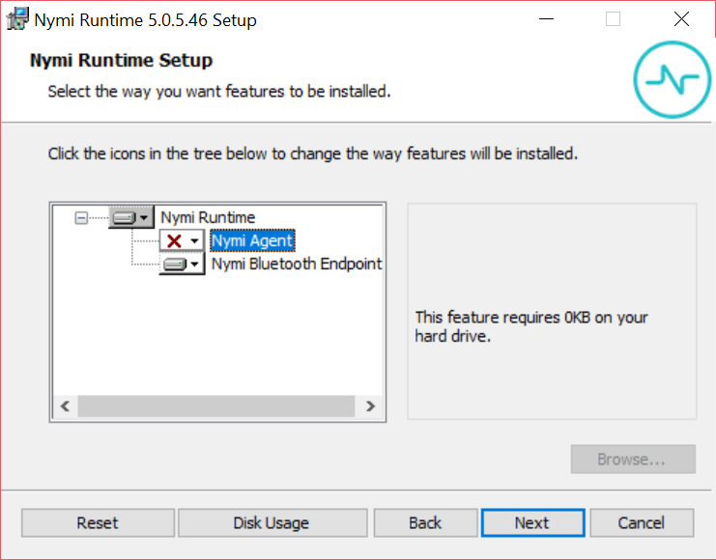
- On the Service Account window, perform one of the following actions to choose the account that starts the service:
  - Accept the default service account NTAuthority\LocalService, click Next.
  - For non-English Windows Operating Systems, choose the LocalSystem account from the drop list, and then click Next.
Note: The service account must have permission to run as a service. Enable Service Log On provides more information about how to modify the local policy to enable this permission for the service account.
The following figure shows the Service Account window.
Figure 86: Nymi Runtime Service Account window
- On the Ready to install page, click Install.
- Click Finish.
- On the Installation Completed Successfully page, click Close.
- On the Welcome to Nymi Band Application Setup Wizard window, click Next.
- On the Select Installation Folder window, click Next to accept the default installation location.
- In the Ready to Install window, click Install.
- On the Completing the Nymi Band Application Setup Wizard window, click Finish.

Configuring Nymi Band Application to use a Centralized Nymi Agent
Perform the following steps on the enrollment terminal to configure the Nymi Band Application to use a centralized Nymi Agent.
- Run regedit.exe
- On the User Account Control window, click Yes.
- Navigate to HKEY_LOCAL_MACHINE > Software > Nymi.
Note: If you installed the Nymi Band Application on a Citrix server, set navigate to HKEY_CURRENT_USER instead of HKEY_LOCAL_MACHINE
.
- Right-click NES, and then select New > String value.
- In the Value field, type agent_url.
- Edit the agent_url key, and in the Value data field, type the URL to the Nymi Agent service, in the following format:
protocol://agent_FQDN:agent_port/socket/websocket
where:
  - protocol is the websocket protocol to use to connect to the Nymi Agent:
    - ws for websocket.
    - wss for secure websocket
  - agent_FQDN is the fully qualified domain name of the centralized Nymi Agent server.
  - agent_port is the port on which to connect to the centralized Nymi Agent server, for example 9120.
For example:
agent_url = "ws://agent.nymi.com:9120/socket/websocket"

Configuring the Nymi Enterprise Server URL
After you install the Nymi Band Application, perform the following steps to ensure that the enrollment process connect to the correct Nymi Enterprise Server(NES).
- Run regedit.exe
- On the User Account Control window, click Yes.
- Navigate to HKEY_LOCAL_MACHINE > Software > Nymi.
Note: If you installed the Nymi Band Application on a Citrix server, set navigate to HKEY_CURRENT_USER instead of HKEY_LOCAL_MACHINE
.
- Right-click NES, and then select New > String value.
- In the Value field, type URL.
- Double-click URL and in the Value Data field, type https://nes_server/NES_service_name/ or http://nes_server/NES_service_name depending on the NES configuration
where:
  - nes_server is the FQDN of the NES host. The FQDN consists of the hostname.domain_name. You can also find the FQDN by going to the server on which you deployed NES viewing the properties of the computer. The nes_server is the value that appears in the Full computer name field.
  - NES_service_name is the name of the service mapping for NES in IIS, which maps a virtual directory to a physical directory. You can choose any name for this mapping, but it is recommended that you specify a name that is descriptive to the Connected Worker Platform, for example, NES.
- Click OK.

Editing the Nymi Bluetooth Endpoint Configuration File
The Nymi Bluetooth Endpoint file uses the nbe.toml file to define the location of a remote Nymi Agent.
Perform the following steps to specify the URL to the remote Nymi Agent.
- Make a copy of the C:\Nymi\Bluetooth_Endpoint\nbe.toml file (On HP Thin Pro, /usr/bin/nbe.toml).
- Edit the nbe.toml file with a text editor in administrator mode.
- Edit the default agent_url parameter and replace the default IP address (127.0.0.1) with the FQDN of the machine that is running the remote Nymi Agent.
For example:
agent_url = "ws://agent.nymi.com:9120/socket/websocket"
where agent.nymi.com is the FQDN of the remote Nymi Agent machine.
- Save the nbe.toml file.
- Restart the Nymi Bluetooth Endpoint service.
You can use Group Policies to push the modified nbe.toml file to the C:\Nymi\Bluetooth_Endpoint folder on each user terminal.

Deploy a Decentralized Enrollment Terminal
Install the Nymi Band Application, which also installs the Nymi Runtime software on a thick client.

Install the Nymi Band Application
Perform the following steps to install the Nymi Band Application on each enrollment terminal that you will use to enroll and authenticate users to their Nymi Bands.
You can perform a customizable installation or a silent installation.

Install the Nymi Band Application Silently
Before you perform a silent installation of the Nymi Band Application you must install the Nymi Runtime software.

Installing the Nymi Runtime Silently
Perform the following steps to install or update the Nymi Runtime and the BLE adapter drivers silently, without user intervention.
- Log in to the network terminal with an account that has administrator privileges.
- Download and extract the Nymi SDK package.
- Launch the command prompt as administrator.
- Change to the ..\nymi-sdk\windows\runtime folder, and then type one of the following commands:
  - "Nymi Runtime Installer version.exe" /exenoui /q /log NymiRuntimeInstallation.log
  - For installations on non-English operating systems,
"Nymi Runtime Installer version.exe" ServiceAccount="LocalSystem" /exenoui /q /log NymiRuntimeInstallation.log
Where you replace version with the version of the Nymi installation file.
Note: Ensure that you enclose the filename in double quotes.
The installation command returns to a command prompt immediately, and the installation completes silently. When the installation completes, Nymi Runtime appears in the Program and Features applet and NymiRuntimeInstallation.log file contains information about the installation.
Note: Alternately, you can track the progress by performing an unattended installation, which displays the installation screens but does not require user intervention by replacing the /q option with the /passive option in the installation command.
In the Windows Services applet, confirm that you can see the Nymi Agent and Nymi Bluetooth Endpoint services, and that the status of each service is Running
If required, you can review the installation log file in the %temp% directory named Nymi Runtime_version_time.log

Installing the Nymi Band Application Silently
Perform the following steps to install or update the Nymi Band Application silently, for example, when you want to install the software remotely by using a software distribution application.
- Save the Nymi Band Application package, provided to you by your Nymi Solution Consultant.
- Launch the command prompt as administrator.
- From the folder that contains the Nymi Band Application, type Nymi-Band-App-installer-v_version.exe /exenoui /q
Where you replace version with the version of the Nymi installation file.
The installation command returns to a command prompt immediately, and the installation completes silently. When the installation completes, the Nymi Band Application and Nymi Runtime applications appear in the Program and Features applet.
Note: Alternately, you can track the progress by performing an unattended installation, which displays the installation screens but does not require user intervention by replacing the /q option with the /passive option in the installation command.

Installing the Nymi Band Application with the Installation Wizard
Perform the following steps to install the Nymi Band Application.
Uninstall the previous version of Nymi Runtime.
- Download the Nymi Band Application package.
- Double-click the Nymi-Band-App-installer-v_version.exe file.
- On the User Account Control window, click Yes.
- On the Prerequisites window, click Next.
- On the Welcome page, click Install.
- On the User Account Control page, click Yes.
The installation wizard appears. If the installation detects missing prerequisites, perform the steps that appear in the prerequisite wizards.
- On the Welcome to the Nymi Runtime Setup Wizard page, click Next.
- On the Nymi Runtime Setup window, click Next.
- On the Service Account window, perform one of the following actions to choose the account that starts the service:
  - Accept the default service account NTAuthority\LocalService, click Next.
  - For non-English Windows Operating Systems, choose the LocalSystem account from the drop list, and then click Next.
Note: The service account must have permission to run as a service. Enable Service Log On provides more information about how to modify the local policy to enable this permission for the service account.
The following figure shows the Service Account window.
Figure 87: Nymi Runtime Service Account window
- On the (Optional) Nymi Infrastructure Service Account, click Next.
Only deployments that use web-based Nymi-enabled Applications(NEAs) with a centralized Nymi Agent require you to configure the Nymi Infrastructure Service Account.
- On the Ready to install page, click Install.
- Click Finish.
- On the Installation Completed Successfully page, click Close.
- On the Welcome to Nymi Band Application Setup Wizard window, click Next.
- On the Select Installation Folder window, click Next to accept the default installation location.
- In the Ready to Install window, click Install.
- On the Completing the Nymi Band Application Setup Wizard window, click Finish.

Configuring the Nymi Enterprise Server URL
After you install the Nymi Band Application, perform the following steps to ensure that the enrollment process connect to the correct Nymi Enterprise Server(NES).
- Run regedit.exe
- On the User Account Control window, click Yes.
- Navigate to HKEY_LOCAL_MACHINE > Software > Nymi.
Note: If you installed the Nymi Band Application on a Citrix server, set navigate to HKEY_CURRENT_USER instead of HKEY_LOCAL_MACHINE
.
- Right-click NES, and then select New > String value.
- In the Value field, type URL.
- Double-click URL and in the Value Data field, type https://nes_server/NES_service_name/ or http://nes_server/NES_service_name depending on the NES configuration
where:
  - nes_server is the FQDN of the NES host. The FQDN consists of the hostname.domain_name. You can also find the FQDN by going to the server on which you deployed NES viewing the properties of the computer. The nes_server is the value that appears in the Full computer name field.
  - NES_service_name is the name of the service mapping for NES in IIS, which maps a virtual directory to a physical directory. You can choose any name for this mapping, but it is recommended that you specify a name that is descriptive to the Connected Worker Platform, for example, NES.
- Click OK.

(Optional) Configuring the Communication Protocol
If you use the enrollment terminal to also access NEAs, perform the following steps to disable the legacy protocol.
Note: After you set this environment variable, user terminals cannot communicate with Nymi Bands that use pre-CWP 1.15.x firmware
- In the Windows search field, type env, and then from the pop-up menu, select Edit the System Environment Variables.
- Click Environment Variables.
- In the System Variables section, click New, and the perform the following actions:
  - In the Variable Name field, type NYMI_NEA_SUPPORT_LEGACY_MODE
  - In the Variable Value field, type 0.
The following figure provides an example of the new variable.
Figure 88: New System Variable window
  - Click OK.

Set Up User Terminals for Authentication Tasks
You can use the Nymi Band to perform daily authentication tasks that would normally require a username and password in an MES application that reside on VMware Horizon thin clients a remote session host .
- Import the Root CA certificate for NES (when the Root CA that issued the certificate is not a trusted CA).
Apple recommends deploying certificates with a Mobile Device Management (MDM) system. Certificate payloads are automatically trusted for SSL when installed with Configurator, MDM, or as part of an MDM enrollment profile.
Apple Support provides more information.
Note: If you manually import a device profile, you must enable trust for SSL/TLS. Apple Support provides more information.
- Install the Nymi Bluetooth Endpoint service.
- Insert the Nymi-supplied Bluetooth adapter into an available USB port.
- Optionally, insert a Nymi-verified NFC reader into an available USB port.

Bluetooth Adapter Placement
The enrollment terminal and each user terminal requires a Bluetooth adapter. The Bluetooth Low Energy (BLE) radio antenna in the Nymi-supplied BLED112 USB Adapter provides seamless Bluetooth capability between the Nymi Band and devices such as a laptop computer.
To ensure optimal system performance, place the Bluetooth adapter in a location that meets the following criteria:
- Is in clear line of sight to the Nymi Band.
- Is on the same side of the computer that you wear your Nymi Band.
- Is near the computer keyboard.
Note: The presence of liquids between the Nymi Band and Bluetooth adapter negatively affects the Bluetooth signal quality. This includes beverages and the human body. If Bluetooth (BLE) taps behave unexpectedly, consider another placement for the Bluetooth adapter, or edit the Nymi Bluetooth Endpoint configuration file to adjust the signal strength thresholds to perform a BLE tap (see Edit the nbe.toml File).

Importing the TLS Certificate into Firefox
If you have issued your own TLS root certificate using a private certificate authority (CA), before Firefox can open a WebSocket connection for the NEA, you need to import the TLS certificate.
See https://wiki.mozilla.org/CA/AddRootToFirefox in the Mozilla documentation for more information.
- Open Firefox web browser.
- In the right pane, navigate to Options.
- Select Privacy and Security.
- Under Certificates click View Certificates and then select Authorities.
- Click Import and select the TLS root certificate from your machine.
- Click OK.
- Run the Nymi WebAPI and open the WebSocket connection by using Firefox.

Importing the Root CA Certificate in Citrix/RDP Environments
Perform the following steps only if the Root CA issuing the NES TLS server certificate is not a Trusted Root CA (for example, if a self-signed TLS server certificate is used for NES). Install the Root CA on each user terminal on which you installed Nymi Bluetooth Endpoint to support the establishment of a connection with the NES host.
While logged into the user terminal as a local administrator, use the certlm application to import the root CA certificate into the Trusted Root Certification Authorities store. For example, on Windows 10, perform the following steps:
- In Control Panel, select Manage Computer Certificates.
- In the certlm window, right-click Trusted Root Certification Authorities, and then select All Tasks > Import.
The following figure shows the certlm window.
Figure 89: certlm application on Windows 10
- On the Welcome to the Certificate Import Wizard screen, click Next.
The following figure shows the Welcome to the Certificate Import Wizard screen.
Figure 90: Welcome to the Certificate Import Wizard screen
- On the File to Import screen, click Browse, navigate to the folder that contains the root certificate file, select the file, and then click Open.
- On the File to Import screen, click Next.
The following figure shows the File to Import screen.
Figure 91: File to Import screen
- On the Certificate Store screen, accept the default value Place all certificates in the following store with the value Trusted Root Certification Authorities, and then click Next.
- On the Completing the Certificate Import Wizard screen, click Finish.

(Windows) Install the Nymi Bluetooth Endpoint
You can install the software with the installation wizard or silently from a command prompt.

Installing the Nymi Bluetooth Endpoint By Using the Installation Wizard
Install the Nymi Bluetooth Endpoint, which is included in the Nymi Runtime installation package, on each Citrix or RDP client in the environment. When you install the Nymi Runtime software, you can choose to install the Nymi Bluetooth Endpoint only.
Perform the following steps to install Nymi Bluetooth Endpoint manually.
- Log in to the terminal, with an account that has administrator privileges.
- Create a backup copy of the C:\Nymi\Bluetooth_Endpoint\nbe.toml file.
- Extract the Nymi SDK distribution package.
- From the ..\nymi-sdk\windows\setup folder, right-click the Nymi Runtime Installer version.exe file, and select Run as administrator.
- On the Welcome page, click Install.
- On the User Account Control page, click Yes.
The installation wizard appears. If the installation detects missing prerequisites, perform the steps that appear in the prerequisite wizards.
- On the Welcome to the Nymi Runtime Setup Wizard page, click Next.
- On the Nymi Runtime Setup window, expand Nymi Runtime.
- Select Nymi Agent, and then select Entire feature will be unavailable, as shown in the following figure, and then click Next.
Figure 92: Nymi Agent feature will be unavailable
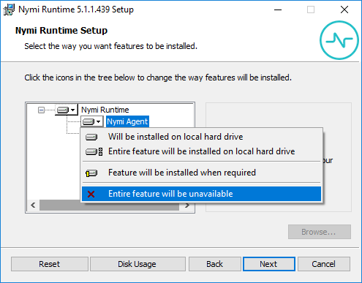
- Observe that Nymi Agent is not available, as shown in the following figure, and then click Next.
Figure 93: Nymi Agent feature is not available
- On the Service Account window, perform one of the following actions to choose the account that starts the service:
  - Accept the default service account NTAuthority\LocalService, click Next.
  - For non-English Windows Operating Systems, choose the LocalSystem account from the drop list, and then click Next.
Note: The service account must have permission to run as a service. Enable Service Log On provides more information about how to modify the local policy to enable this permission for the service account.
The following figure shows the Service Account window.
Figure 94: Nymi Runtime Service Account window
- On the Ready to install page, click Install.
- Click Finish.
- On the Installation Completed Successfully page, click Close.
In the Windows Services applet, confirm that you can see Nymi Bluetooth Endpoint service, and that the status of the service is Running

Installing Nymi Bluetooth Endpoint Silently
- Run a Command Prompt as administrator.
You can install the Nymi Bluetooth Endpoint silently by typing one of the following commands:
  - "Nymi Runtime Installer version.exe" /exenoui InstallAgent=0 /q /log NymiRuntimeInstallation.log
  - For installations on non-English operating systems,
"Nymi Runtime Installer version.exe" ServiceAccount="LocalSystem" /exenoui InstallAgent=0 /q /log NymiRuntimeInstallation.log
Where you replace version with the version of the Nymi installation file.
Note: Ensure that you enclose the filename in double quotes.
The installation command returns to a command prompt immediately, and the installation completes silently. When the installation completes, Nymi Runtime appears in the Program and Features applet and NymiRuntimeInstallation.log file contains information about the installation.
Note: Alternately, you can track the progress by performing an unattended installation, which displays the installation screens but does not require user intervention by replacing the /q option with the /passive option in the installation command.
In the Windows Services applet, confirm that you can see Nymi Bluetooth Endpoint service, and that the status of the service is Running

(HP Thin Pro) Installing Nymi Bluetooth Endpoint
Follow the instructions below to manually install Nymi Bluetooth Endpoint manually. Retrieve the installation file nbed-cron_x.y.z_amd64.deb from Nymi.
Retrieve the installation file nbed-cron_x.y.z_amd64.deb from Nymi.
- Switch your user mode to Administrator from the system menu, or log in by entering an the credentials of a person in the domain admin group.
  - Right-click the desktop or click Start.
  - Click Switch to Administrator from the menu. You will be prompted to enter the administrator password.
The screen is surrounded by a red border when in administrator mode.
- Extract the file, nbed-cron_x.x.z_amd64.deb, from the Nymi distribution package and save it to the machine. Where x.y.z is the version of the file. Note the file path.
- Unlock read/write access with X Terminal.
  - Click Start and go to Tools.
  - Click X Terminal.
  - Type fsunlock
- In X Terminal change the directory to the file location of nbed-cron_x.y.z_amd64.deb and install the extracted file.
dpkg -i nbed-cron_x.y.z_amd64.deb
Where you replace x.y.z with the actual version number of the file.
- Reboot the client.

(Windows and HP Thin Pro) Editing the Nymi Bluetooth Endpoint Configuration File
The Nymi Bluetooth Endpoint file uses the nbe.toml file to define the location of a remote Nymi Agent.
Perform the following steps to specify the URL to the remote Nymi Agent.
- Make a copy of the C:\Nymi\Bluetooth_Endpoint\nbe.toml file (On HP Thin Pro, /usr/bin/nbe.toml).
- Edit the nbe.toml file with a text editor in administrator mode.
- Edit the default agent_url parameter and perform the following actions:
  - Replace the default IP address (127.0.0.1) with the FQDN of the Centralized Nymi Agent server.
  - For secure WebSocket (wss), replace ws with wss.
For example:
agent_url = "wss://agent.nymi.com:9120/socket/websocket"
where the Nymi Agent uses secure WebSocket and agent.nymi.com is the FQDN of the remote Nymi Agent machine.
- Save the nbe.toml file.
- Restart the Nymi Bluetooth Endpoint.
On Windows:
  - Press the Windows key on the keyboard, or click the start button on the toolbar. Enter "Services" in the search bar. The Services application window appears.
  - Search for Nymi Bluetooth Endpoint in the Services application.
  - Right-click Nymi Bluetooth Endpoint and restart it.
On HP Thin Pro:
  - Stop the Nymi Bluetooth Endpoint service by typing killall -9 nbed.
  - Start the Nymi Bluetooth Endpoint by typing /usr/bin/nbedstart.
- On HP Thin Pro only, revert the file system to read-only access.
  - Open X Terminal.
  - Type:
fslock
  - Close the terminal.
- On HP Thin Pro only, Revert to User mode from the system menu, or log in using the credentials of a person in the user domain group.
You can use Group Policies to push the modified nbe.toml file to the C:\Nymi\Bluetooth_Endpoint folder on each user terminal.

(IGEL) Installing Nymi Bluetooth Endpoint
Use the UMS server to host the Nymi Bluetooth Endpoint package and perform the installation of the application on IGEL thin clients.

Uploading Nymi Packages to Universal Management Suite
Follow the instructions below to upload the Nymi Bluetooth Endpoint package to the Universal Management Suite (UMS) server.
Obtain the installation package from Nymi.
- Extract the installation package to a machine that has access to the UMS Console.
- Connect to the UMS Console.
- In UMS Console, right-click the Files folder in the left navigation pane, and then select New File.
The New file window appears.
- In the File Source section, select the appropriate source option, for example, Upload Local File to UMS Server, and then navigate to the folder location that contains the nymi.tar.bz2 file, select the file, and then click Open.
- Click OK.
- Right-click the Files folder in the left navigation pane, and then select New File.
The New file window appears.
- In the File Source section, select the appropriate source option, for example, Upload Local File to UMS Server , and then navigate to the folder location that contains the nymi.inf file, select the file, and then click Open.
- Click OK.
The following figure provides a example of the Files folder with the files. Make note of the value in Download URL field for each file, as you will require is information in the Customizing the Custom Partition section.
Figure 95: Files window
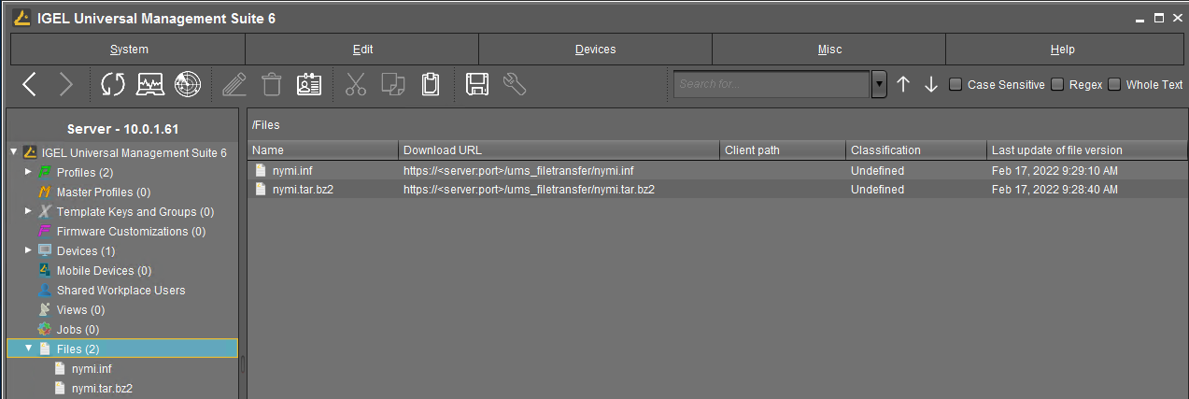

Creating a Profile and Custom Partition
Perform the following instructions to create a profile and partition on the UMS server for the Nymi Bluetooth Endpoint software installation.
- Connect to the UMS Console, right-click the Profiles folder, and then from the context menu, select New Profile.
The New Profile window appears.
- In the Profile Name field, type Nymi.
- In the Description field, type Install the Nymi Custom Partition.
The following figure provides an example of the New Profile window.
Figure 96: New Profile window
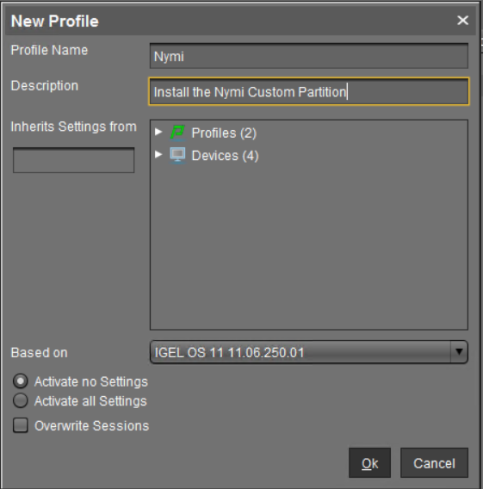
- Click OK.
The Setup window opens.
- Navigate to System > Firmware Customization > Custom Partition > Partition.
- Unlock the Enable Partition setting by clicking the orange triangle so that it turns blue, and then select Enable Partition.
The following figure shows the window with the orangle triangle.
Figure 97: Unlock
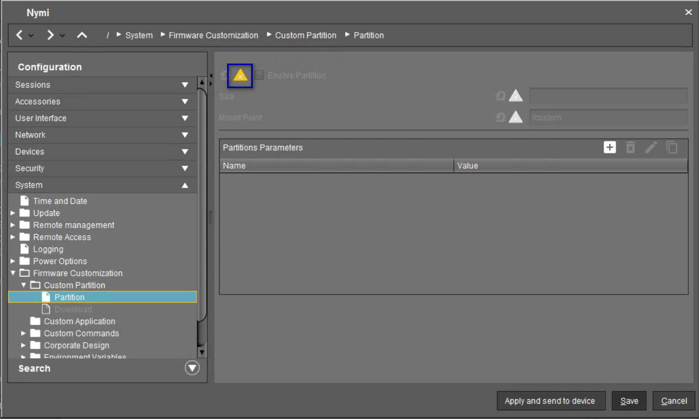
- Unlock the Size setting by clicking the orange triangle so that it turns blue. For the size value, type 120M, as shown in the following figure.
Figure 98: Set UMS partition size
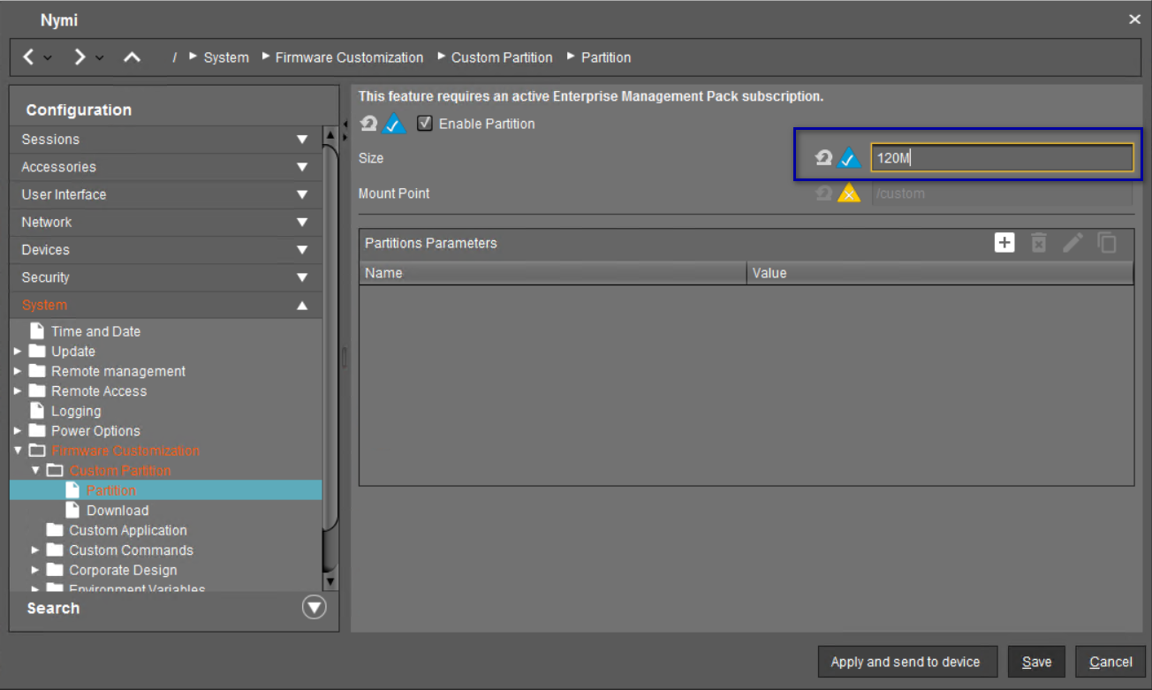
- Leave the mount point value as /custom.
- In the Partitions Parameters list, click [+] (Add).
A dialog box appears.
- In the Add box, perform the following actions.
  - In the Name field, type AGENT_URL.
  - In the Value field, type ws://agent_host:9120/socket/websocket
where agent_host is the IP address of the server on which you installed the Nymi Agent.
  - Click OK.
The following figure provides an example of Nymi partition window.
Figure 99: Partition window
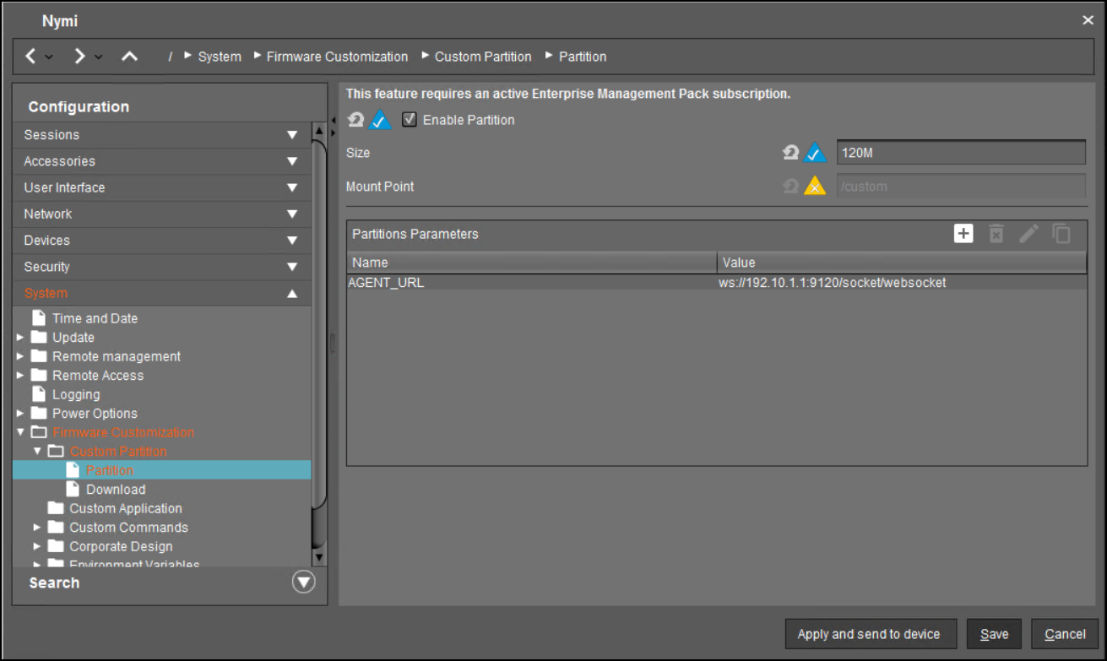
  - Click Save.

Customizing the Custom Partition
After you create the Nymi partition, perform the following actions in the UMS Console to customize the Nymi Bluetooth Endpoint installation.
- Double-click the Nymi profile.
- From the Configuration navigation pane for the partition, expand System > Firmware Customization > Custom Commands > Base, as shown in the following figure.
Figure 100: Base menu option
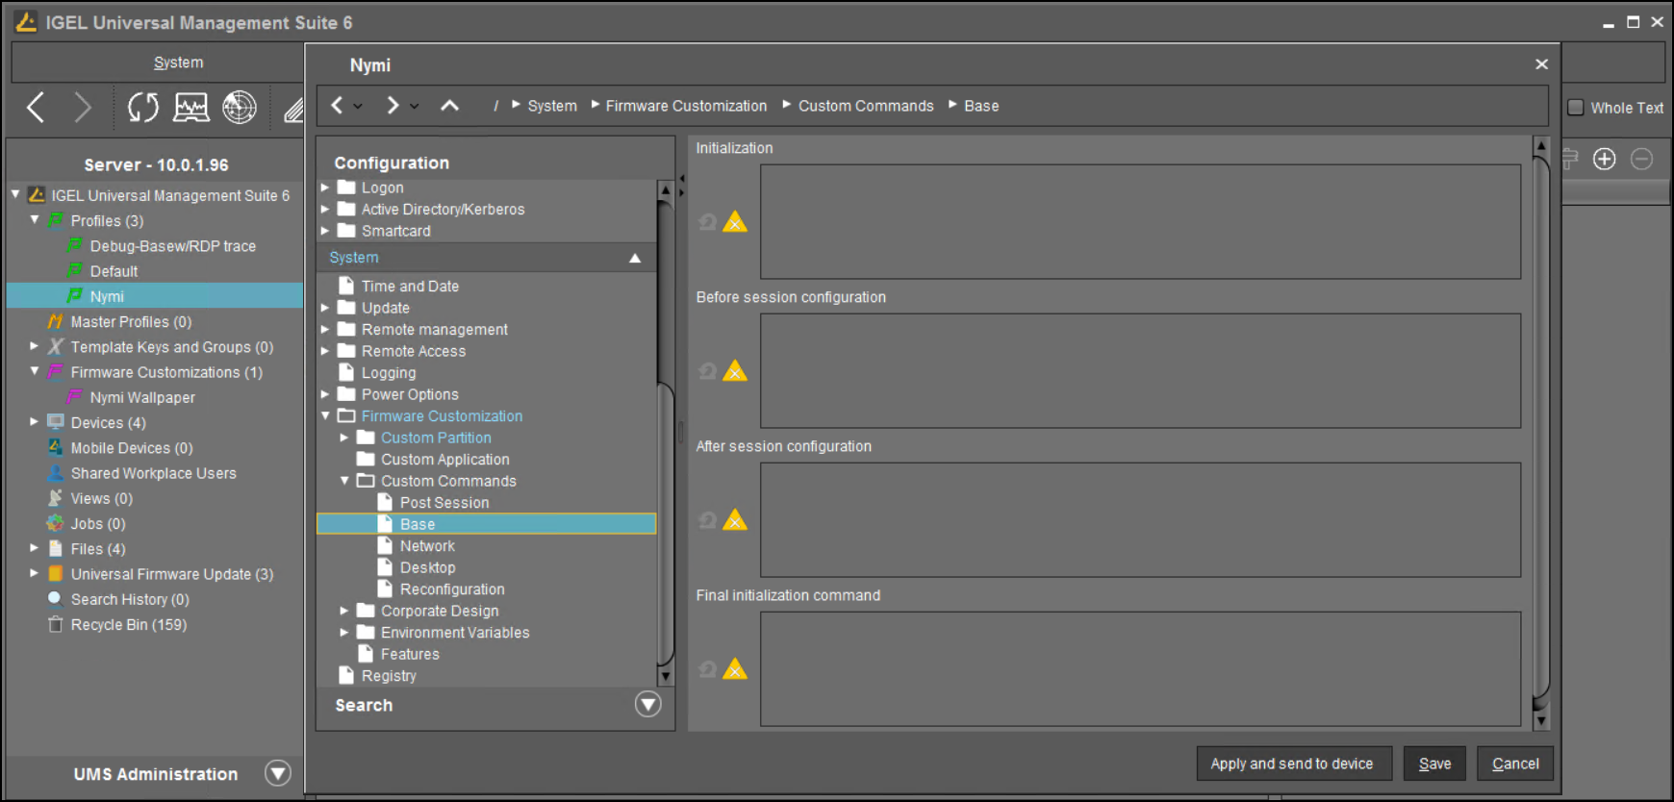
A dialog box appears.
- Perform the following actions in Nymi Base Commands dialog box.
  - Unlock the Initialization setting by clicking the orange triangle so that it turns blue.
  - In the Initialization field, type modprobe cdc-acm.
  - Unlock the Final Initialization Command setting by clicking the orange triangle so that it turns blue.
  - In the Final Initialization Command field, type /custom/nymi/usr/lib/nymi/nbedstart&
  - Click Save.
The following figure provides an example of the Nymi Base Commands window.
Figure 101: Nymi Base Commands
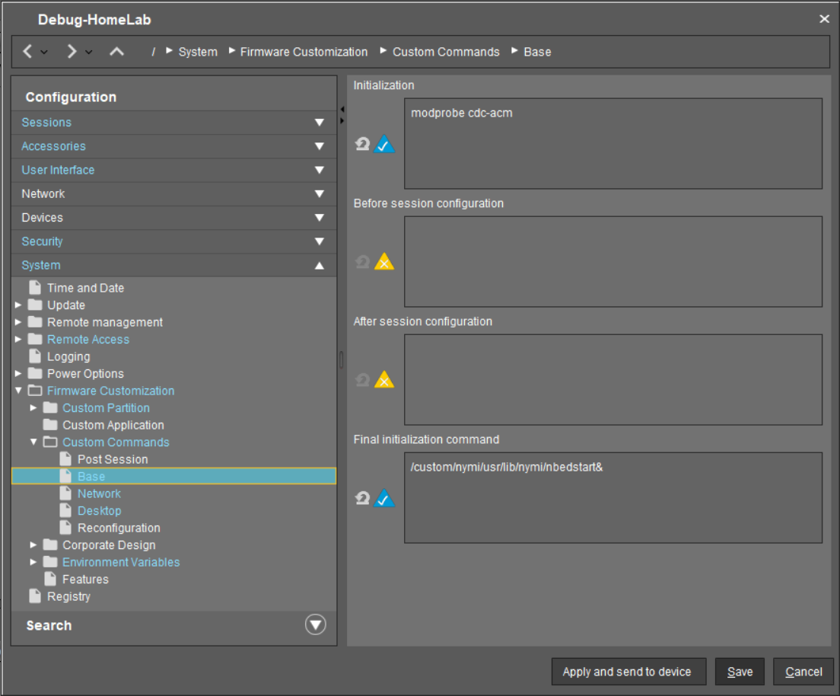
- Double-click the Nymi profile.
- From the Configuration navigation pane for the partition, expand System > Firmware Customization > Custom Partition > Download, as shown in the following figure.
The following figure provides an example of the Download option.
Figure 102: Downloads
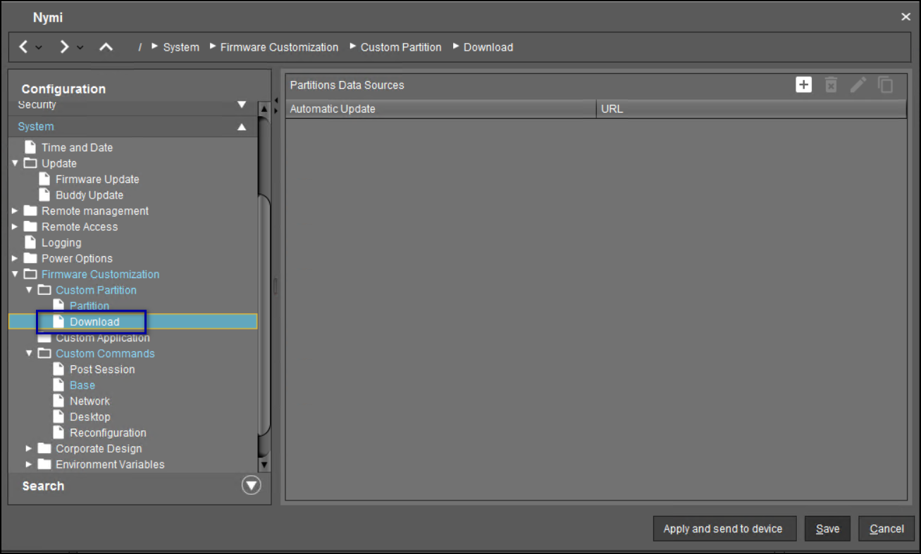
- In the Partitions Data Sources section, click [+] (Add).
A dialog box appears.
- Perform the following actions in the Add window.
  - In the URL field, type the Download URL path for the nymi.inf file.
For example, https://10.0.1.61:8443/ums_filetransfer/nymi.inf
  - In the Username field, type the username of a user that has access to the UMS file transfer location.
  - In the Password field, type the password for the user account that has access to the UMS file transfer location.
  - In the Final Action field, type /custom/nymi/custompart-nymi init.
  - Click OK.
The following figure provides an example of the Add window.
Figure 103: Add window
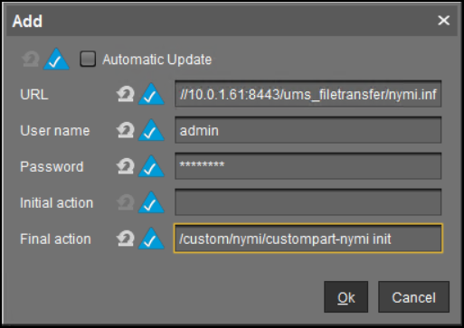
- Click Save.

Assigning the Profile to iGel Devices
Assign the Nymi profile to the IGEL devices.
Perform the following steps in the UMS Console.
- In the left navigation pane, select Profiles > Nymi.
- In the Assigned Objects pane that appears on the right side of the window, click [+] Add.
The Select Assignable Objects window appears, as shown in the following figure.
Figure 104: Select Assignable Objects window
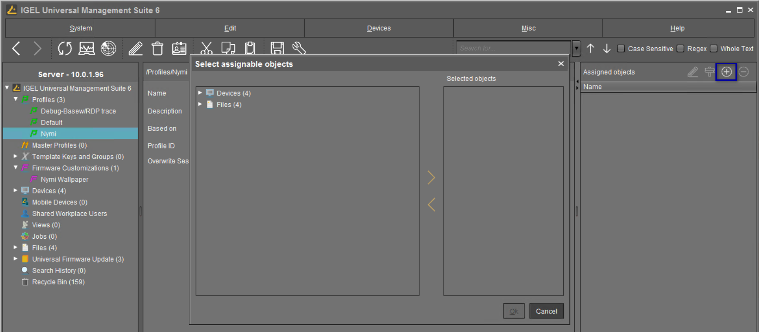
- In the left pane, expand Devices, select the IGEL clients, and then click the > button.
The IGEL clients that you select appear in the Selected objects pane, as shown in the following figure.
Figure 105: Selected Objects
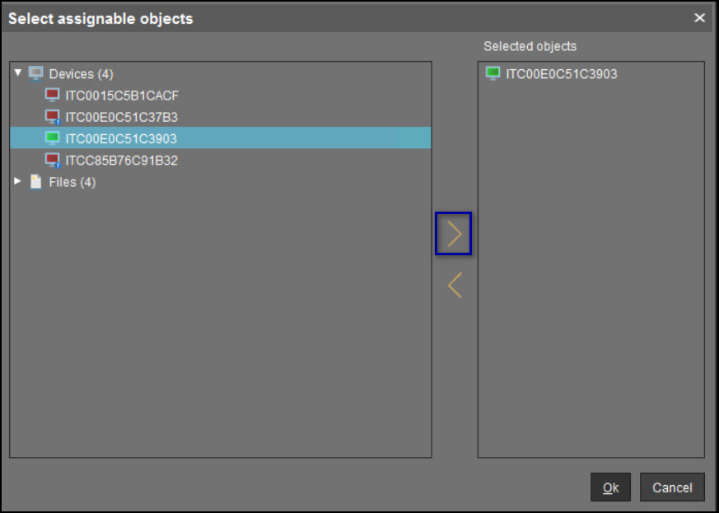
- Click OK.
- On the Update time? window, select Now, and then click OK.
The following figure provides an example of the Update time window.
Figure 106: Update time window
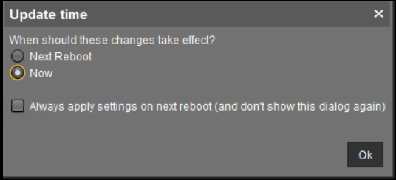
The Nymi Bluetooth Endpoint package installs on the selected IGEL client.
- After the installation completes on the IGEL client, reboot the IGEL client.

(Windows and HP Thin Pro) Editing the Nymi Bluetooth Endpoint Configuration File
The Nymi Bluetooth Endpoint file uses the nbe.toml file to define the location of a remote Nymi Agent.
Perform the following steps to specify the URL to the remote Nymi Agent.
- Make a copy of the C:\Nymi\Bluetooth_Endpoint\nbe.toml file (On HP Thin Pro, /usr/bin/nbe.toml).
- Edit the nbe.toml file with a text editor in administrator mode.
- Edit the default agent_url parameter and perform the following actions:
  - Replace the default IP address (127.0.0.1) with the FQDN of the Centralized Nymi Agent server.
  - For secure WebSocket (wss), replace ws with wss.
For example:
agent_url = "wss://agent.nymi.com:9120/socket/websocket"
where the Nymi Agent uses secure WebSocket and agent.nymi.com is the FQDN of the remote Nymi Agent machine.
- Save the nbe.toml file.
- Restart the Nymi Bluetooth Endpoint.
On Windows:
  - Press the Windows key on the keyboard, or click the start button on the toolbar. Enter "Services" in the search bar. The Services application window appears.
  - Search for Nymi Bluetooth Endpoint in the Services application.
  - Right-click Nymi Bluetooth Endpoint and restart it.
On HP Thin Pro:
  - Stop the Nymi Bluetooth Endpoint service by typing killall -9 nbed.
  - Start the Nymi Bluetooth Endpoint by typing /usr/bin/nbedstart.
- On HP Thin Pro only, revert the file system to read-only access.
  - Open X Terminal.
  - Type:
fslock
  - Close the terminal.
- On HP Thin Pro only, Revert to User mode from the system menu, or log in using the credentials of a person in the user domain group.
You can use Group Policies to push the modified nbe.toml file to the C:\Nymi\Bluetooth_Endpoint folder on each user terminal.

Configuring the Connected Worker Platform Communication Protocol
Starting with Connected Worker Platform(CWP) 1.15, the Nymi solution supports a new, high performance protocol over Bluetooth between the Nymi Runtime and Nymi Bands.
Perform the following steps on all user terminals (for Evidian environments on Wearable user terminals only) where users access Nymi-enabled Applications(NEAs) to disable the legacy protocol. The enrollment terminal only requires the environment variable if users access NEAs on the enrollment terminal.
Note: After you set this environment variable, user terminals cannot communicate with Nymi Bands that use pre-CWP 1.15.x firmware
- In the Windows search field, type env, and then from the pop-up menu, select Edit the System Environment Variables.
- Click Environment Variables.
- In the System Variables section, click New, and the perform the following actions:
  - In the Variable Name field, type NYMI_NEA_SUPPORT_LEGACY_MODE
  - In the Variable Value field, type 0.
The following figure provides an example of the new variable.
Figure 107: New System Variable window
  - Click OK.

Set Up User Terminals for Lock and Unlock
You can use the Nymi Band to lock and unlock the desktop of the user terminal that you use to connect to the remote session hosts. You can also use the Nymi Band to lock and unlock virtual desktops.
User terminals on which you will use the Nymi Band to lock and unlock require that you:
- Import the Root CA certificate for NES (when the Root CA that issued the certificate is not a trusted CA).
Apple recommends deploying certificates with a Mobile Device Management (MDM) system. Certificate payloads are automatically trusted for SSL when installed with Configurator, MDM, or as part of an MDM enrollment profile.
Apple Support provides more information.
Note: If you manually import a device profile, you must enable trust for SSL/TLS. Apple Support provides more information.
- Insert the Nymi-supplied Bluetooth adapter into an available USB port.
- Install the Nymi Bluetooth Endpoint service.
- Install the Nymi Lock Control software
- Configure the Nymi Bluetooth Endpoint configuration file.

Configuring Nymi Lock Control
Perform the following steps to enable and configure Nymi Lock Control.
By default Nymi Lock Control is not enabled.
- Log in to the NES Administrator Console with an account that is an NES Administrator.
- From the navigation bar, select Policies.
The Policies page appears with a table that displays a list of existing group and individual policies.
- In the Policies window, select the active policy.
- In the Lock Control section, select the Enable Nymi Lock Control option.
The following options appear to customize Nymi Lock Control.
Lock When Away | - Configure Nymi Lock Control with the ability to lock the user terminal when Nymi Lock Control does not detect the authenticated Nymi Band.  - Default: Enabled  - When enabled, Nymi Lock Control locks the user terminal when a user removes an authenticated Nymi Band or when the Nymi Band is not in close proximity of the user terminal. When the Nymi Band is out of range, a 10 second timer appears on the desktop. If the Nymi Band does not return within close range of the user terminal, the terminal will lock.  Ensure that your Group Policy Object(GPO) settings do not push the Do not display the lock screen configuration option to the Nymi Lock Control user terminals.  Note: Edit the nbe.toml file to define close proximity for Nymi Lock Control. Refer to Editing the nbe.toml File.
Unlock When Present | - Configures Nymi Lock Control to check if the Nymi Band is in close proximity before unlocking the user terminal. If not, then unlock fails. You can define how close the Nymi Band must be to the user terminal to allow the user to unlock the terminal with the Nymi Band in the nbe.toml file.  - Default: Enabled  - When enabled, prevents an unauthorized user from unlocking the user terminal while the Nymi Band user is in Bluetooth range, but not in close proximity to the terminal.  - When disabled, allows a user to unlock the user terminal by pressing the Enter key or space bar on the keyboard when the authenticated Nymi Band is within Bluetooth range, but not in close proximity of the user terminal.
Keep Unlocked when Present | - Provides you with the ability to define how the Nymi Band interacts with operating system screen timeouts or sleep settings that lock the user terminal.  - Default: Enabled  - When enabled, overrides any system screen timeouts or sleep settings, and keeps the user terminal unlocked as long as the Nymi Band is present and authenticated.  - When disabled, prevents Nymi Lock Control from overriding any system screen timeouts or sleep settings.
- Click Save.
During enrollment the Nymi Band Application updates the Nymi Band to enable Nymi Lock Control support.
Changing this option does not change the Nymi Band behaviour for existing enrolled Nymi Bands until the user logs into the Nymi Band Application while wearing their authenticated Nymi Band.
When the Nymi Band Application updates on the Nymi Band completes, restart Nymi Lock Control.

Importing the Root CA Certificate in Citrix/RDP Environments
Perform the following steps only if the Root CA issuing the NES TLS server certificate is not a Trusted Root CA (for example, if a self-signed TLS server certificate is used for NES). Install the Root CA on each user terminal on which you installed Nymi Bluetooth Endpoint to support the establishment of a connection with the NES host.
While logged into the user terminal as a local administrator, use the certlm application to import the root CA certificate into the Trusted Root Certification Authorities store. For example, on Windows 10, perform the following steps:
- In Control Panel, select Manage Computer Certificates.
- In the certlm window, right-click Trusted Root Certification Authorities, and then select All Tasks > Import.
The following figure shows the certlm window.
Figure 108: certlm application on Windows 10
- On the Welcome to the Certificate Import Wizard screen, click Next.
The following figure shows the Welcome to the Certificate Import Wizard screen.
Figure 109: Welcome to the Certificate Import Wizard screen
- On the File to Import screen, click Browse, navigate to the folder that contains the root certificate file, select the file, and then click Open.
- On the File to Import screen, click Next.
The following figure shows the File to Import screen.
Figure 110: File to Import screen
- On the Certificate Store screen, accept the default value Place all certificates in the following store with the value Trusted Root Certification Authorities, and then click Next.
- On the Completing the Certificate Import Wizard screen, click Finish.

Install Nymi Lock Control
You can install Nymi Lock Control silently or with the installation wizard.

Installing Nymi Lock Control Silently
To install Nymi Lock Control silently in a centralized Nymi Agent configuration, first install Nymi Bluetooth Endpoint and then install Nymi Lock Control

Installing Nymi Bluetooth Endpoint Silently
- Run a Command Prompt as administrator.
You can install the Nymi Bluetooth Endpoint silently by typing one of the following commands:
  - "Nymi Runtime Installer version.exe" /exenoui InstallAgent=0 /q /log NymiRuntimeInstallation.log
  - For installations on non-English operating systems,
"Nymi Runtime Installer version.exe" ServiceAccount="LocalSystem" /exenoui InstallAgent=0 /q /log NymiRuntimeInstallation.log
Where you replace version with the version of the Nymi installation file.
Note: Ensure that you enclose the filename in double quotes.
The installation command returns to a command prompt immediately, and the installation completes silently. When the installation completes, Nymi Runtime appears in the Program and Features applet and NymiRuntimeInstallation.log file contains information about the installation.
Note: Alternately, you can track the progress by performing an unattended installation, which displays the installation screens but does not require user intervention by replacing the /q option with the /passive option in the installation command.
In the Windows Services applet, confirm that you can see Nymi Bluetooth Endpoint service, and that the status of the service is Running

Installing or Updating Nymi Lock Control Silently
Perform the following steps to install or update the Nymi Lock Control silently, for example, when you want to install the software remotely by using a software distribution application.
- Save the Nymi Lock Control package, provided to you by your Nymi Solution Consultant.
- Launch the command prompt as administrator.
- From the folder that contains the Nymi Lock Control, type NymiLockControl-installer-vversion.exe /exenoui /q
Where you replace version with the version of the Nymi installation file.
The installation command returns to a command prompt immediately, and the installation completes silently. When the installation completes, the Nymi Lock Control application appears in the Program and Features applet.
Note: Alternately, you can track the progress by performing an unattended installation, which displays the installation screens but does not require user intervention by replacing the /q option with the /passive option in the installation command.

Installing Nymi Lock Control with the Installation Wizard
Perform the following steps on the RDP sessions host/ Citrix server.
- Right-click NymiLockControl-installer-vw.x.y.z and select Run as administrator.
- On the User Account Control window, click Yes.
- On the Welcome to the Prerequisites Setup Wizard, click Next.
- On the Prerequisites window, leave the default selections, and then click Next.
- On the Welcome window, click Install.
- On the Welcome to the Nymi Runtime Setup Wizard page, click Next.
- On the Nymi Runtime Setup window, expand Nymi Runtime.
- Select Nymi Agent, and then select Entire feature will be unavailable, as shown in the following figure, and then click Next.
Figure 111: Nymi Agent feature will be unavailable
- On the Service Account window, perform one of the following actions to choose the account that starts the service:
  - Accept the default service account NTAuthority\LocalService, click Next.
  - For non-English Windows Operating Systems, choose the LocalSystem account from the drop list, and then click Next.
Note: The service account must have permission to run as a service. Enable Service Log On provides more information about how to modify the local policy to enable this permission for the service account.
The following figure shows the Service Account window.
Figure 112: Nymi Runtime Service Account window
- On the Ready to install page, click Install.
- Click Finish.
- On the Installation Completed Successfully page, click Close.
- On the Welcome to Nymi Lock Control Setup Wizard window, click Next.
- On the Select Installation Folder window, perform the following actions:
  - To change the installation location, click Browse, navigate to a new installation folder, and then click Select Folder
  - To keep the default installation location, click Next.
- On the Ready to Install window, click Install.
- On the Completing the Nymi Lock Control Setup Wizard window, click Finish.

(Windows and HP Thin Pro) Editing the Nymi Bluetooth Endpoint Configuration File
The Nymi Bluetooth Endpoint file uses the nbe.toml file to define the location of a remote Nymi Agent.
Perform the following steps to specify the URL to the remote Nymi Agent.
- Make a copy of the C:\Nymi\Bluetooth_Endpoint\nbe.toml file (On HP Thin Pro, /usr/bin/nbe.toml).
- Edit the nbe.toml file with a text editor in administrator mode.
- Edit the default agent_url parameter and perform the following actions:
  - Replace the default IP address (127.0.0.1) with the FQDN of the Centralized Nymi Agent server.
  - For secure WebSocket (wss), replace ws with wss.
For example:
agent_url = "wss://agent.nymi.com:9120/socket/websocket"
where the Nymi Agent uses secure WebSocket and agent.nymi.com is the FQDN of the remote Nymi Agent machine.
- Save the nbe.toml file.
- Restart the Nymi Bluetooth Endpoint.
On Windows:
  - Press the Windows key on the keyboard, or click the start button on the toolbar. Enter "Services" in the search bar. The Services application window appears.
  - Search for Nymi Bluetooth Endpoint in the Services application.
  - Right-click Nymi Bluetooth Endpoint and restart it.
On HP Thin Pro:
  - Stop the Nymi Bluetooth Endpoint service by typing killall -9 nbed.
  - Start the Nymi Bluetooth Endpoint by typing /usr/bin/nbedstart.
- On HP Thin Pro only, revert the file system to read-only access.
  - Open X Terminal.
  - Type:
fslock
  - Close the terminal.
- On HP Thin Pro only, Revert to User mode from the system menu, or log in using the credentials of a person in the user domain group.
You can use Group Policies to push the modified nbe.toml file to the C:\Nymi\Bluetooth_Endpoint folder on each user terminal.

Setting the NES URL
After you install the Nymi applications, create a registry key to define the NES URL on the RDP session host/ Citrix server.
- Run regedit.exe
- On the User Account Control window, click Yes.
- Navigate to HKEY_LOCAL_MACHINE > Software > Nymi.
- Right-click NES, and then select New > String value.
- In the Value field, type URL.
- Double-click URL and in the Value Data field, type https://nes_server/NES_service_name/ or http://nes_server/NES_service_name depending on the NES configuration
where:
  - nes_server is the FQDN of the NES host. The FQDN consists of the hostname.domain_name. You can also find the FQDN by going to the server on which you deployed NES viewing the properties of the computer. The nes_server is the value that appears in the Full computer name field.
  - NES_service_name is the name of the service mapping for NES in IIS, which maps a virtual directory to a physical directory. You can choose any name for this mapping, but it is recommended that you specify a name that is descriptive to the Connected Worker Platform, for example, NES.
- Click OK.

Configuring the Connected Worker Platform Communication Protocol
Starting with Connected Worker Platform(CWP) 1.15, the Nymi solution supports a new, high performance protocol over Bluetooth between the Nymi Runtime and Nymi Bands.
Perform the following steps on all user terminals (for Evidian environments on Wearable user terminals only) where users access Nymi-enabled Applications(NEAs) to disable the legacy protocol. The enrollment terminal only requires the environment variable if users access NEAs on the enrollment terminal.
Note: After you set this environment variable, user terminals cannot communicate with Nymi Bands that use pre-CWP 1.15.x firmware
- In the Windows search field, type env, and then from the pop-up menu, select Edit the System Environment Variables.
- Click Environment Variables.
- In the System Variables section, click New, and the perform the following actions:
  - In the Variable Name field, type NYMI_NEA_SUPPORT_LEGACY_MODE
  - In the Variable Value field, type 0.
The following figure provides an example of the new variable.
Figure 113: New System Variable window
  - Click OK.

Configuring support for Citrix/RDP Lock and Unlock
To use Nymi Lock Control to lock and unlock a RDP session host or Citrix server, disable Network Level Authentication (NLA).
Perform the following steps on each user terminal.
- Run regedit.exe
- From the File menu, select Connect Network Registry
- Type the name of the RDP session host or Citrix server, and then click OK.
- Navigaate to HKLM\SYSTEM\CurrentControlSet\Control\Terminal Server\WinStations\RDP-Tcp
- Edit the SecurityLayer key and change the value to 0.
- Click OK.
- Close regedit.exe.

Configuring Support for Virtual Desktop Lock and Unlock
To unlock virtual desktops with Nymi Lock Control, configure Client IP Caching on the user terminal.
Perform the following steps on the user terminal to support desktop unlock with the Nymi Band in a virtual desktop environment.
- Run regedit.exe
- Navigate to HKEY_LOCAL_MACHINE\SOFTWARE\Nymi.
- Right-click Nymi Lock Control, and then select New > DWORD (32-bit).
- In the Value field, type CacheClientIp.
- Double-click ClientCacheIp and in the Value Data field, type 00000001.
- Click OK.
- Right-click Nymi Lock Control, and then select New > String value.
- In the Value field, type ViewClientVariable.
- Double-click ViewClientVariable and in the Value Data field, type ViewClient_Broker_Remote_IP_Address .
- Click OK.
Note: This functionality is not supported in a shared remote desktop environment such as Citrix Virtual Applications. In such an environment, this setting causes unpredictable behavior when more than one user is connected to an NEA at the same time.

Updating Connected Worker Platform
Review the following information to plan your update. Infrastructure refers to NES, the Nymi Band Application and the Nymi Runtime software.
Update the Nymi components in the following order:
- Nymi Enterprise Server(NES)
- Nymi Band Application on the enrollment terminal.
- Centralized Nymi Agent
- Nymi Runtime on the user terminals, to update the Nymi Bluetooth Endpoint and local Nymi Agent.
- Nymi Lock Control and Nymi-enabled Applications(NEAs) on the user terminal.
- Nymi Band firmware.
Note: You cannot update Nymi Band 2.0 with Connected Worker Platform(CWP) firmware or use Nymi Band 2.0 with CWP infrastructure.
CWP 1.12.x and later provides NEA developers with enhancements that optimize Bluetooth tap performance for web-based NEAs. After you update the NEA to a version that uses the new functionality available starting with the CWP 1.12.x Nymi SDK (Authenticated Tap), ensure that each user with a Nymi Band that was enrolled prior to the update logs in to the Nymi Band Application while wearing their authenticated Nymi Band. The Nymi Band Application applies changes to the Nymi Band that support the optimization.
Consider the following information:
- You must update the Nymi Band Application on the enrollment terminal before you attempt any new enrollments with a CWP 1.16.0 NES.
- You can update NES, Nymi Band Application, and Nymi Runtime directly from NEE 3.3.x or CWP 1.3.x and later.
- You can use a Nymi Band 3.0 that runs the pre-CWP 1.16.x firmware with CWP 1.16.x infrastructure; however, new functionality is not available.
- You cannot use a Nymi Band 3.0 that runs CWP 1.12.x and later firmware with pre-CWP1.12.x infrastructure.
- The CWP 1.16.x Nymi Band Application can only enroll and externally authenticate Nymi Bands with the CWP 1.6 and later firmware.
- When you update the firmware from NEE 3.3.0 and earlier, you must re-enroll the Nymi Band.

Creating the Nymi Infrastructure Service Account
Connected Worker Platform(CWP) 1.12.x and later solution uses a service account to support interprocess and SQL server communications. When you update from 1.9.x and earlier, you can use an existing service account, for example the one that you created for connectivity to to a remote SQL server or create a new account.
If you create a new account in Active Directory, ensure that the account meets the following requirements:
- User account is a domain user.
- Password never expires.
Nymi recommends that you name the service account nymi_infra_service, to align with product documentation.
Record the account name and domain in Appendix—Record the CWP Variables, which specify the credentials during the NES deployment.

Updating NES
When you update earlier versions of Nymi Enterprise Server(NES) to the current version of NES, there are new configuration parameters that you must provide.
Note: Starting with Connected Worker Platform 1.15.0, the size of the SymmetricKeyId column length has been increased from 36 to 512 characters. If you use another database instance as a backup for the NES SQL database, ensure that you update the size of the SymmetricKeyId column length in the nub.NymiBand and audit.NymiBand tables.
To update a previous version of NES, perform the following steps:
- Extract the NES installation package to a local directory on the NES host.
- From the directory that contains the extracted NES installation package, run ..\NesInstaller\install.exe.
- On the User Access Control window, click Yes.
- On the Open File - Security warning window, click Run.
- If applicable, on the User Access Control page, review the Microsoft .NET EULA, and then click Accept. Complete the .NET installation and continue with the NES installation.
- On the Application Install Security Warning window, click Install.
- On the Open File - Security warning window, click Run.
- On the left navigation pane, click Location, and then perform the following steps.
  - In the Install Root field, confirm that the path to the NES services is correct, as it was specified during the initial deployment.
The default location is C:\inetpub\wwwroot.
  - In the Instance Name field, type the descriptive name that was specified during the initial deployment for the NES web application instance name. For example, NES. See Configuration Attribute Values in the Nymi Connected Worker Platform—Deployment Guide.
Note: Ensure that the values that you specify in the Install Root and Instance Name match the values that you specified when you deployed the previous version of NES. When the values that you specified in the Install Root and Instance Name are correct, the Location test results will show Install Type: Update/ Re-Install. If there is no match for the values entered, the Location test results will show New Installation for the Install Type. The following figure provides an example of the Location window for an NES upgrade.
Figure 114: Update / Reinstall installation type
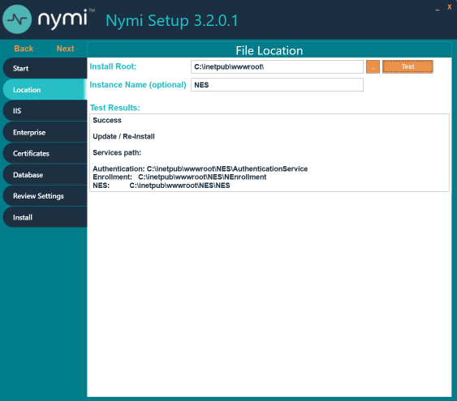
- In the left navigation pane, click Enterprise, scroll down to the Nymi Infrastructure Service Account section. In the User Name field, enter the Nymi Infrastructure Service Account in the format domain\name.
- In the left navigation pane, click Certificates, and perform the following actions.
  - From the Full Chain list, click the ellipses (...) and navigate to the folder that contains Full Chain PFX certificate file, and then select the file.
  - In the Password Required pop-up, type the Full Chain certificate password, and then click OK.
- In the left navigation pane, click Install.
- Click Update.
Note: If the update option is not available, the Install Root or Instance Name fields on the Location tab are not the same values that were specified when you deployed the previous NES version.
- On the Update NES window, click Yes to reapply the configuration.
The Install window display the status of the update process.
- When the Install window displays the Installation Complete message, close the Nymi Setup window.

Update Centralized Nymi Agent
Update the Centralized Nymi Agent silently or by using the installation wizard.

Uninstalling the Nymi Runtime
Perform the following steps to remove Nymi Runtime.
- Backup configuration files.
  - For user terminals that use Nymi Lock Control, navigate to C:\Nymi\Bluetooth_Endpoint and make a copy of the nbe.toml file.
  - For centralized Nymi Agent, navigate to C:\Nymi\NymiAgent and make a copy of the nymi_agent.toml file.
- Stop the Nymi services, including the Nymi Bluetooth Endpoint and Nymi Agent .
Note: For a Centralized Nymi Agent deployment, the Centralized Nymi Agent server does not have the Nymi Bluetooth Endpoint service and the user terminals do not have the Nymi Agent service.
- In Add or Remove programs, select Nymi Runtime, and then click Uninstall.

Install Nymi Agent on a Centralized Server
You can install the Nymi Agent software with the installation wizard or silently from a command prompt.

Performing a Nymi Agent Installation or Update By Using the Installation Wizard
Install the Nymi Agent application, which is included in the Nymi Runtime installation package, on a server in the environment.
When you install the Nymi Runtime software, you can choose to install the Nymi Agent application only.
- Log in to the terminal, with an account that has administrator privileges.
- Create a backup copy of the C:\Nymi\Bluetooth_Endpoint\nbe.toml file.
- Extract the Nymi SDK distribution package.
- From the ..\nymi-sdk\windows\setup folder, right-click the Nymi Runtime Installer version.exe file, and select Run as administrator.
- On the Welcome page, click Install.
- On the User Account Control page, click Yes.
The installation wizard appears. If the installation detects missing prerequisites, perform the steps that appear in the prerequisite wizards.
- On the Welcome to the Nymi Runtime Setup Wizard page, click Next.
- On the Nymi Runtime Setup page, expand Nymi Runtime.
- Select Nymi Bluetooth Endpoint, and then select Entire feature will be unavailable.
The following figure provides an example of the Nymi Runtime Setup window with option to make Nymi Bluetooth Endpoint unavailable.
Figure 115: Nymi Bluetooth Endpoint feature will be unavailable
- Observe that Nymi Bluetooth Endpoint is not available, as shown in the following figure, and then click Next.
Figure 116: Nymi Bluetooth Endpoint feature is not available
- On the Service Account window, perform one of the following actions to choose the account that starts the service:
  - Accept the default service account NTAuthority\LocalService, click Next.
  - For non-English Windows Operating Systems and for Nymi WebAPI configurations where you install the centralized Nymi Agent on the NES server, choose the LocalSystem account from the drop list, and then click Next.
Note: The service account must have permission to run as a service. Enable Service Log On provides more information about how to modify the local policy to enable this permission for the service account.
The following figure shows the Service Account window.
Figure 117: Nymi Runtime Service Account window
- On the (Optional) Nymi Infrastructure Service Account window, specify the username and password of the Nymi Infrastructure Service Account. When you specify the username, include the domain name, for example tw-lab\nymi_infra_service_acct. Refer to Appendix—Record the CWP Variables for the service account name.
The following figure shows the Nymi Infrastructure Service Account window.
Figure 118: Nymi Infrastructure Service Account window
The installer creates the following files in the C:\Nymi\NymiAgent\certs folder:
  - credentials-contains the encrypted credentials for the Nymi Infrastructure Service Account
  - Private key
  - Public key
- On the Ready to install page, click Install.
- Click Finish.
- On the Installation Completed Successfully page, click Close.

Performing a Silent Nymi Agent Installation or Update
Install the Nymi Agent application, which is included in the Nymi Runtime installation package, on a machine in the environment.
When you install the Nymi Runtime software, you can choose to install the Nymi Agent application only.
- You can install the Nymi Agent silently by typing one of the following commands:
  - "Nymi Runtime Installer version.exe" /exenoui InstallEndpoint=0 /q /log NymiRuntimeInstallation.log
  - For installations on non-English operating systems,
"Nymi Runtime Installer version.exe" ServiceAccount="LocalSystem" /exenoui InstallEndpoint=0 /q /log NymiRuntimeInstallation.log
Where you replace version with the version of the Nymi installation file.
Note: Ensure that you enclose the filename in double quotes.
The installation command returns to a command prompt immediately, and the installation completes silently. When the installation completes, Nymi Runtime appears in the Program and Features applet and NymiRuntimeInstallation.log file contains information about the installation.
Note: Alternately, you can track the progress by performing an unattended installation, which displays the installation screens but does not require user intervention by replacing the /q option with the /passive option in the installation command.
- Perform the following steps to ensure that the Nymi Agent uses the Nymi Infrastructure Service Account to communicate with Nymi Enterprise Server(NES).
  - Create a text file named creds.text that contains two lines:
    - Username of the Nymi Infrastructure Service Account
    - Password of the Nymi Infrastructure Service Account
  - Open a Command prompt with the Run as Administrator option.
  - From the command prompt change to the C:\Nymi\NymiAgent\Tools directory, and type the following command:
cryptoutil.exe encrypt-service-account -i C:\Nymi\NymiAgent\creds.text -o C:\Nymi\NymiAgent\
The Cryptoutil tool creates the following files in the C:\Nymi\NymiAgent\certs folder:
    - credentials-contains the encrypted credentials for the Nymi Infrastructure Service Account
    - Private key
    - Public key
  - Permanently delete the C:\Nymi\NymiAgent\creds.txt file.

Updating the Enrollment Terminal
Update the Nymi Runtime and Nymi Band Application on each enrollment terminal in the environment.

Uninstalling the Nymi Runtime
Perform the following steps to remove Nymi Runtime.
- Backup configuration files.
  - For user terminals that use Nymi Lock Control, navigate to C:\Nymi\Bluetooth_Endpoint and make a copy of the nbe.toml file.
  - For centralized Nymi Agent, navigate to C:\Nymi\NymiAgent and make a copy of the nymi_agent.toml file.
- Stop the Nymi services, including the Nymi Bluetooth Endpoint and Nymi Agent .
Note: For a Centralized Nymi Agent deployment, the Centralized Nymi Agent server does not have the Nymi Bluetooth Endpoint service and the user terminals do not have the Nymi Agent service.
- In Add or Remove programs, select Nymi Runtime, and then click Uninstall.

Deploy a Centralized Enrollment Terminal
Perform the following steps to install the Nymi Band Application on a Citrx/RDP server that multiple thin clients can access.

Install a Centralized Nymi Band Application
You can install the Nymi Band Application on a Citrix RDP server using the installation wizard or silently.

Install the Nymi Band Application Silently
Before you perform a silent installation of the Nymi Band Application you must install the Nymi Runtime software.

Installing Nymi Bluetooth Endpoint Silently
Uninstall the previous version of Nymi Runtime.
- Create a backup copy of the C:\Nymi\Bluetooth_Endpoint\nbe.toml file.
- Run a Command Prompt as administrator.
You can install the Nymi Bluetooth Endpoint silently by typing one of the following commands:
  - "Nymi Runtime Installer version.exe" /exenoui InstallAgent=0 /q /log NymiRuntimeInstallation.log
  - For installations on non-English operating systems,
"Nymi Runtime Installer version.exe" ServiceAccount="LocalSystem" /exenoui InstallAgent=0 /q /log NymiRuntimeInstallation.log
Where you replace version with the version of the Nymi installation file.
Note: Ensure that you enclose the filename in double quotes.
The installation command returns to a command prompt immediately, and the installation completes silently. When the installation completes, Nymi Runtime appears in the Program and Features applet and NymiRuntimeInstallation.log file contains information about the installation.
Note: Alternately, you can track the progress by performing an unattended installation, which displays the installation screens but does not require user intervention by replacing the /q option with the /passive option in the installation command.
- Stop the Nymi Bluetooth Endpoint service.
- C:\Nymi\Bluetooth_Endpoint\nbe.toml file with your backup copy.
- Start the Nymi Bluetooth Endpoint service.

Installing the Nymi Band Application Silently
Perform the following steps to install or update the Nymi Band Application silently, for example, when you want to install the software remotely by using a software distribution application.
- Save the Nymi Band Application package, provided to you by your Nymi Solution Consultant.
- Launch the command prompt as administrator.
- From the folder that contains the Nymi Band Application, type Nymi-Band-App-installer-v_version.exe /exenoui /q
Where you replace version with the version of the Nymi installation file.
The installation command returns to a command prompt immediately, and the installation completes silently. When the installation completes, the Nymi Band Application and Nymi Runtime applications appear in the Program and Features applet.
Note: Alternately, you can track the progress by performing an unattended installation, which displays the installation screens but does not require user intervention by replacing the /q option with the /passive option in the installation command.

Installing the Nymi Band Application with the Installation Wizard
Perform the following steps to install the Nymi Band Application.
Uninstall the previous version of Nymi Runtime.
- Create a backup copy of the C:\Nymi\Bluetooth_Endpoint\nbe.toml file.
- Download the Nymi Band Application package.
- Double-click the Nymi-Band-App-installer-v_version.exe file.
- On the User Account Control window, click Yes.
- On the Prerequisites window, click Next.
- On the Welcome page, click Install.
- On the User Account Control page, click Yes.
The installation wizard appears. If the installation detects missing prerequisites, perform the steps that appear in the prerequisite wizards.
- On the Welcome to the Nymi Runtime Setup Wizard page, click Next.
- On the Nymi Runtime Setup window, expand Nymi Runtime.
- Observe that Nymi Agent is not available, as shown in the following figure, and then click Next.
Figure 119: Nymi Agent feature is not available
- On the Service Account window, perform one of the following actions to choose the account that starts the service:
  - Accept the default service account NTAuthority\LocalService, click Next.
  - For non-English Windows Operating Systems, choose the LocalSystem account from the drop list, and then click Next.
Note: The service account must have permission to run as a service. Enable Service Log On provides more information about how to modify the local policy to enable this permission for the service account.
The following figure shows the Service Account window.
Figure 120: Nymi Runtime Service Account window
- On the Ready to install page, click Install.
- Click Finish.
- On the Installation Completed Successfully page, click Close.
- On the Welcome to Nymi Band Application Setup Wizard window, click Next.
- On the Select Installation Folder window, click Next to accept the default installation location.
- In the Ready to Install window, click Install.
- On the Completing the Nymi Band Application Setup Wizard window, click Finish.
- Stop the Nymi Bluetooth Endpoint service.
- C:\Nymi\Bluetooth_Endpoint\nbe.toml file with your backup copy.
- Start the Nymi Bluetooth Endpoint service.

Deploy a Decentralized Enrollment Terminal
Install the Nymi Band Application, which also installs the Nymi Runtime software on a thick client.

Install the Nymi Band Application
Perform the following steps to install the Nymi Band Application on each enrollment terminal that you will use to enroll and authenticate users to their Nymi Bands.
You can perform a customizable installation or a silent installation.

Install the Nymi Band Application Silently
Before you perform a silent installation of the Nymi Band Application you must install the Nymi Runtime software.

Installing the Nymi Runtime Silently
Perform the following steps to install or update the Nymi Runtime and the BLE adapter drivers silently, without user intervention.
- Log in to the network terminal with an account that has administrator privileges.
- Download and extract the Nymi SDK package.
- Launch the command prompt as administrator.
- Change to the ..\nymi-sdk\windows\runtime folder, and then type one of the following commands:
  - "Nymi Runtime Installer version.exe" /exenoui /q /log NymiRuntimeInstallation.log
  - For installations on non-English operating systems,
"Nymi Runtime Installer version.exe" ServiceAccount="LocalSystem" /exenoui /q /log NymiRuntimeInstallation.log
Where you replace version with the version of the Nymi installation file.
Note: Ensure that you enclose the filename in double quotes.
The installation command returns to a command prompt immediately, and the installation completes silently. When the installation completes, Nymi Runtime appears in the Program and Features applet and NymiRuntimeInstallation.log file contains information about the installation.
Note: Alternately, you can track the progress by performing an unattended installation, which displays the installation screens but does not require user intervention by replacing the /q option with the /passive option in the installation command.
In the Windows Services applet, confirm that you can see the Nymi Agent and Nymi Bluetooth Endpoint services, and that the status of each service is Running
If required, you can review the installation log file in the %temp% directory named Nymi Runtime_version_time.log

Installing the Nymi Band Application Silently
Perform the following steps to install or update the Nymi Band Application silently, for example, when you want to install the software remotely by using a software distribution application.
- Save the Nymi Band Application package, provided to you by your Nymi Solution Consultant.
- Launch the command prompt as administrator.
- From the folder that contains the Nymi Band Application, type Nymi-Band-App-installer-v_version.exe /exenoui /q
Where you replace version with the version of the Nymi installation file.
The installation command returns to a command prompt immediately, and the installation completes silently. When the installation completes, the Nymi Band Application and Nymi Runtime applications appear in the Program and Features applet.
Note: Alternately, you can track the progress by performing an unattended installation, which displays the installation screens but does not require user intervention by replacing the /q option with the /passive option in the installation command.

Installing the Nymi Band Application with the Installation Wizard
Perform the following steps to install the Nymi Band Application.
Uninstall the previous version of Nymi Runtime.
- Download the Nymi Band Application package.
- Double-click the Nymi-Band-App-installer-v_version.exe file.
- On the User Account Control window, click Yes.
- On the Prerequisites window, click Next.
- On the Welcome page, click Install.
- On the User Account Control page, click Yes.
The installation wizard appears. If the installation detects missing prerequisites, perform the steps that appear in the prerequisite wizards.
- On the Welcome to the Nymi Runtime Setup Wizard page, click Next.
- On the Nymi Runtime Setup window, click Next.
- On the Service Account window, perform one of the following actions to choose the account that starts the service:
  - Accept the default service account NTAuthority\LocalService, click Next.
  - For non-English Windows Operating Systems, choose the LocalSystem account from the drop list, and then click Next.
Note: The service account must have permission to run as a service. Enable Service Log On provides more information about how to modify the local policy to enable this permission for the service account.
The following figure shows the Service Account window.
Figure 121: Nymi Runtime Service Account window
- On the (Optional) Nymi Infrastructure Service Account, click Next.
Only deployments that use web-based Nymi-enabled Applications(NEAs) with a centralized Nymi Agent require you to configure the Nymi Infrastructure Service Account.
- On the Ready to install page, click Install.
- Click Finish.
- On the Installation Completed Successfully page, click Close.
- On the Welcome to Nymi Band Application Setup Wizard window, click Next.
- On the Select Installation Folder window, click Next to accept the default installation location.
- In the Ready to Install window, click Install.
- On the Completing the Nymi Band Application Setup Wizard window, click Finish.

Updating the Centralized Nymi Agent and Windows Thin Clients
To update the CentralizedNymi Agent server and thin clients, you must remove the Nymi Runtime software, and then install the new version of the Nymi Runtime software with the appropriate Nymi Runtime components.

Uninstalling the Nymi Runtime
Perform the following steps to remove Nymi Runtime.
- Backup configuration files.
  - For user terminals that use Nymi Lock Control, navigate to C:\Nymi\Bluetooth_Endpoint and make a copy of the nbe.toml file.
  - For centralized Nymi Agent, navigate to C:\Nymi\NymiAgent and make a copy of the nymi_agent.toml file.
- Stop the Nymi services, including the Nymi Bluetooth Endpoint and Nymi Agent .
Note: For a Centralized Nymi Agent deployment, the Centralized Nymi Agent server does not have the Nymi Bluetooth Endpoint service and the user terminals do not have the Nymi Agent service.
- In Add or Remove programs, select Nymi Runtime, and then click Uninstall.

Update Centralized Nymi Agent
Update the Centralized Nymi Agent silently or by using the installation wizard.

Performing a Nymi Agent Installation or Update By Using the Installation Wizard
Install the Nymi Agent application, which is included in the Nymi Runtime installation package, on a server in the environment.
When you install the Nymi Runtime software, you can choose to install the Nymi Agent application only.
- Log in to the terminal, with an account that has administrator privileges.
- Create a backup copy of the C:\Nymi\Bluetooth_Endpoint\nbe.toml file.
- Extract the Nymi SDK distribution package.
- From the ..\nymi-sdk\windows\setup folder, right-click the Nymi Runtime Installer version.exe file, and select Run as administrator.
- On the Welcome page, click Install.
- On the User Account Control page, click Yes.
The installation wizard appears. If the installation detects missing prerequisites, perform the steps that appear in the prerequisite wizards.
- On the Welcome to the Nymi Runtime Setup Wizard page, click Next.
- On the Nymi Runtime Setup page, expand Nymi Runtime.
- Select Nymi Bluetooth Endpoint, and then select Entire feature will be unavailable.
The following figure provides an example of the Nymi Runtime Setup window with option to make Nymi Bluetooth Endpoint unavailable.
Figure 122: Nymi Bluetooth Endpoint feature will be unavailable
- Observe that Nymi Bluetooth Endpoint is not available, as shown in the following figure, and then click Next.
Figure 123: Nymi Bluetooth Endpoint feature is not available
- On the Service Account window, perform one of the following actions to choose the account that starts the service:
  - Accept the default service account NTAuthority\LocalService, click Next.
  - For non-English Windows Operating Systems and for Nymi WebAPI configurations where you install the centralized Nymi Agent on the NES server, choose the LocalSystem account from the drop list, and then click Next.
Note: The service account must have permission to run as a service. Enable Service Log On provides more information about how to modify the local policy to enable this permission for the service account.
The following figure shows the Service Account window.
Figure 124: Nymi Runtime Service Account window
- On the (Optional) Nymi Infrastructure Service Account window, specify the username and password of the Nymi Infrastructure Service Account. When you specify the username, include the domain name, for example tw-lab\nymi_infra_service_acct. Refer to Appendix—Record the CWP Variables for the service account name.
The following figure shows the Nymi Infrastructure Service Account window.
Figure 125: Nymi Infrastructure Service Account window
The installer creates the following files in the C:\Nymi\NymiAgent\certs folder:
  - credentials-contains the encrypted credentials for the Nymi Infrastructure Service Account
  - Private key
  - Public key
- On the Ready to install page, click Install.
- Click Finish.
- On the Installation Completed Successfully page, click Close.

Configuring Nymi Agent
Perform the following actions when the user terminal accesses web-based Nymi-enabled Applications(NEAs) with a centralized Nymi Agent.
Perform the following steps on the centralized Nymi Agent server.
- Change to the C:\Nymi\NymiAgent directory.
- Rename the C:\Nymi\NymiAgent\nymi_agent_default.toml file to C:\Nymi\NymiAgent\nymi_agent.toml
- Perform the following steps to ensure that the Nymi Agent uses the Nymi Infrastructure Service Account to communicate with NES.
  - Create a text file named creds.text that contains two lines:
    - Username of the Nymi Infrastructure Service Account in the format domain\username
    - Password of the Nymi Infrastructure Service Account
  - From a command prompt change to the C:\Nymi\NymiAgent\Tools directory, and type the following command:
cryptoutil.exe encrypt-service-account -i C:\Nymi\NymiAgent\creds.text -o C:\Nymi\NymiAgent\
The Cryptoutil tool creates the following files in the C:\Nymi\NymiAgent\certs folder:
    - credentials-contains the encrypted credentials for the Nymi Infrastructure Service Account
    - Private key
    - Public key
  - Permanently delete the C:\Nymi\NymiAgent\creds.txt file.
- Edit the C:\Nymi\NymiAgent\nymi_agent.toml, and uncomment parameter credentials_location = certs/
- Restart the Nymi Agent service.

Performing a Silent Nymi Agent Installation or Update
Install the Nymi Agent application, which is included in the Nymi Runtime installation package, on a machine in the environment.
When you install the Nymi Runtime software, you can choose to install the Nymi Agent application only.
- You can install the Nymi Agent silently by typing one of the following commands:
  - "Nymi Runtime Installer version.exe" /exenoui InstallEndpoint=0 /q /log NymiRuntimeInstallation.log
  - For installations on non-English operating systems,
"Nymi Runtime Installer version.exe" ServiceAccount="LocalSystem" /exenoui InstallEndpoint=0 /q /log NymiRuntimeInstallation.log
Where you replace version with the version of the Nymi installation file.
Note: Ensure that you enclose the filename in double quotes.
The installation command returns to a command prompt immediately, and the installation completes silently. When the installation completes, Nymi Runtime appears in the Program and Features applet and NymiRuntimeInstallation.log file contains information about the installation.
Note: Alternately, you can track the progress by performing an unattended installation, which displays the installation screens but does not require user intervention by replacing the /q option with the /passive option in the installation command.
- Perform the following steps to ensure that the Nymi Agent uses the Nymi Infrastructure Service Account to communicate with Nymi Enterprise Server(NES).
  - Create a text file named creds.text that contains two lines:
    - Username of the Nymi Infrastructure Service Account
    - Password of the Nymi Infrastructure Service Account
  - Open a Command prompt with the Run as Administrator option.
  - From the command prompt change to the C:\Nymi\NymiAgent\Tools directory, and type the following command:
cryptoutil.exe encrypt-service-account -i C:\Nymi\NymiAgent\creds.text -o C:\Nymi\NymiAgent\
The Cryptoutil tool creates the following files in the C:\Nymi\NymiAgent\certs folder:
    - credentials-contains the encrypted credentials for the Nymi Infrastructure Service Account
    - Private key
    - Public key
  - Permanently delete the C:\Nymi\NymiAgent\creds.txt file.

(Windows) Install the Nymi Bluetooth Endpoint
You can install the software with the installation wizard or silently from a command prompt.

Installing the Nymi Bluetooth Endpoint By Using the Installation Wizard
Install the Nymi Bluetooth Endpoint, which is included in the Nymi Runtime installation package, on each Citrix or RDP client in the environment. When you install the Nymi Runtime software, you can choose to install the Nymi Bluetooth Endpoint only.
Uninstall the previous version of Nymi Runtime.
Perform the following steps to install Nymi Bluetooth Endpoint manually.
- Create a backup copy of the C:\Nymi\Bluetooth_Endpoint\nbe.toml file.
- Log in to the terminal, with an account that has administrator privileges.
- Create a backup copy of the C:\Nymi\Bluetooth_Endpoint\nbe.toml file.
- Extract the Nymi SDK distribution package.
- From the ..\nymi-sdk\windows\setup folder, right-click the Nymi Runtime Installer version.exe file, and select Run as administrator.
- On the Welcome page, click Install.
- On the User Account Control page, click Yes.
The installation wizard appears. If the installation detects missing prerequisites, perform the steps that appear in the prerequisite wizards.
- On the Welcome to the Nymi Runtime Setup Wizard page, click Next.
- On the Nymi Runtime Setup window, expand Nymi Runtime.
- Select Nymi Agent, and then select Entire feature will be unavailable, as shown in the following figure, and then click Next.
Figure 126: Nymi Agent feature will be unavailable
- Observe that Nymi Agent is not available, as shown in the following figure, and then click Next.
Figure 127: Nymi Agent feature is not available
- On the Service Account window, perform one of the following actions to choose the account that starts the service:
  - Accept the default service account NTAuthority\LocalService, click Next.
  - For non-English Windows Operating Systems and for Nymi WebAPI configurations where you install the centralized Nymi Agent on the NES server, choose the LocalSystem account from the drop list, and then click Next.
Note: The service account must have permission to run as a service. Enable Service Log On provides more information about how to modify the local policy to enable this permission for the service account.
The following figure shows the Service Account window.
Figure 128: Nymi Runtime Service Account window
- On the Ready to install page, click Install.
- Click Finish.
- On the Installation Completed Successfully page, click Close.
- Stop the Nymi Bluetooth Endpoint service.
- C:\Nymi\Bluetooth_Endpoint\nbe.toml file with your backup copy.
- Start the Nymi Bluetooth Endpoint service.

Installing Nymi Bluetooth Endpoint Silently
Uninstall the previous version of Nymi Runtime.
- Create a backup copy of the C:\Nymi\Bluetooth_Endpoint\nbe.toml file.
- Run a Command Prompt as administrator.
You can install the Nymi Bluetooth Endpoint silently by typing one of the following commands:
  - "Nymi Runtime Installer version.exe" /exenoui InstallAgent=0 /q /log NymiRuntimeInstallation.log
  - For installations on non-English operating systems,
"Nymi Runtime Installer version.exe" ServiceAccount="LocalSystem" /exenoui InstallAgent=0 /q /log NymiRuntimeInstallation.log
Where you replace version with the version of the Nymi installation file.
Note: Ensure that you enclose the filename in double quotes.
The installation command returns to a command prompt immediately, and the installation completes silently. When the installation completes, Nymi Runtime appears in the Program and Features applet and NymiRuntimeInstallation.log file contains information about the installation.
Note: Alternately, you can track the progress by performing an unattended installation, which displays the installation screens but does not require user intervention by replacing the /q option with the /passive option in the installation command.
- Stop the Nymi Bluetooth Endpoint service.
- C:\Nymi\Bluetooth_Endpoint\nbe.toml file with your backup copy.
- Start the Nymi Bluetooth Endpoint service.

Update Nymi Lock Control
If you use Nymi Lock Control on the user terminal, you can update Nymi Lock Control silently or by using the installation wizard.

Updating Nymi Lock Control with the Installation Wizard
Perform the following steps on each user terminal in the environment.
- Right-click NymiLockControl-installer-vw.x.y.z and select Run as administrator.
- On the User Account Control window, click Yes.
- On the Welcome to Nymi Lock Control Setup Wizard window, click Next.
- On the Select Installation Folder window, perform the following actions:
  - To change the installation location, click Browse, navigate to a new installation folder, and then click Select Folder
  - To keep the default installation location, click Next.
- On the Ready to Install window, click Install.
- On the Completing the Nymi Lock Control Setup Wizard window, click Finish.

Installing or Updating Nymi Lock Control Silently
Perform the following steps to install or update the Nymi Lock Control silently, for example, when you want to install the software remotely by using a software distribution application.
- Save the Nymi Lock Control package, provided to you by your Nymi Solution Consultant.
- Launch the command prompt as administrator.
- From the folder that contains the Nymi Lock Control, type NymiLockControl-installer-vversion.exe /exenoui /q
Where you replace version with the version of the Nymi installation file.
The installation command returns to a command prompt immediately, and the installation completes silently. When the installation completes, the Nymi Lock Control application appears in the Program and Features applet.
Note: Alternately, you can track the progress by performing an unattended installation, which displays the installation screens but does not require user intervention by replacing the /q option with the /passive option in the installation command.

Update IGEL Clients
Update the Nymi Bluetooth Endpoint software on the IGEL clients.

Uploading Nymi Packages to Universal Management Suite
Follow the instructions below to upload the Nymi Bluetooth Endpoint package to the Universal Management Suite (UMS) server.
Obtain the installation package from Nymi.
- Extract the installation package to a machine that has access to the UMS Console.
- Connect to the UMS Console.
- In UMS Console, right-click the Files folder in the left navigation pane, and then select New File.
The New file window appears.
- In the File Source section, select the appropriate source option, for example, Upload Local File to UMS Server, and then navigate to the folder location that contains the nymi.tar.bz2 file, select the file, and then click Open.
- Click OK.
- Right-click the Files folder in the left navigation pane, and then select New File.
The New file window appears.
- In the File Source section, select the appropriate source option, for example, Upload Local File to UMS Server , and then navigate to the folder location that contains the nymi.inf file, select the file, and then click Open.
- Click OK.
The following figure provides a example of the Files folder with the files. Make note of the value in Download URL field for each file, as you will require is information in the Customizing the Custom Partition section.
Figure 129: Files window

Updating Nymi Bluetooth Endpoint on IGEL
Perform the following steps to update the Nymi software on an IGEL user terminal.
The procedure requires you to reboot the client.
- Perform the following steps to take the partition offline.
  - From the UMS console, in the Profiles section, right-click the profile that contains the Nymi custom partition, and then select Edit Configuration.
  - Navigate to System > Firmware Customization > Custom Partition > Partition.
  - Clear the Enable Partition option, as shown in the following figure.
Figure 130: Disable the Partition option
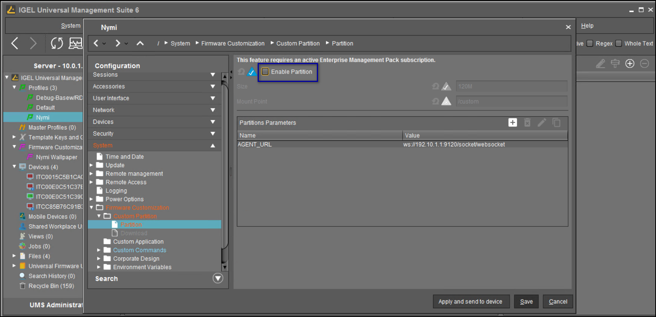
  - Click Apply and send to device.
  - On the Update time dialog box, select Now, and then click Ok.
The following figure shows the Update time dialog.
Figure 131: Update time window
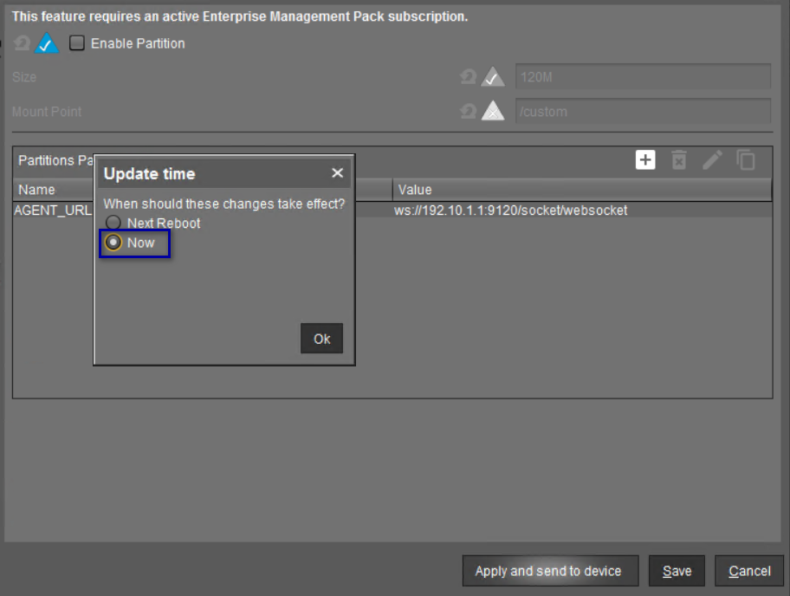
- Click Save.
- From the left navigation pane in the UMS console, right-click the device that contains the profile for the Nymi custom partition, and then select Reboot.
Figure 132: Reboot option
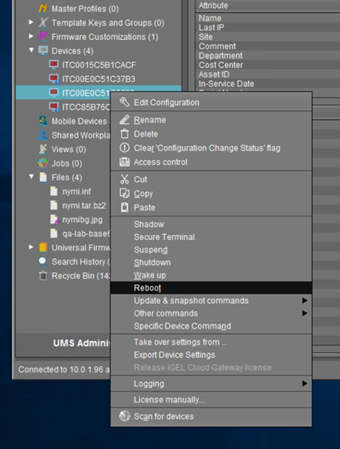
- Perform the following steps after the device reboot completes to confirm that the custom partition does not appear:
  - In the left navigation pane of the UMS Console, right-click on the device, and then select Shadow, as shown in the following figure.
Figure 133: Shadow option
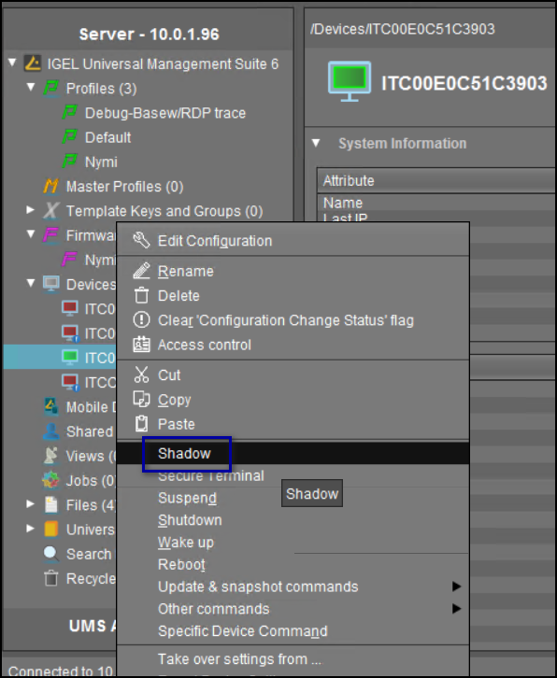
  - When prompted, type the login credentials.
  - On the Desktop, open a terminal window.
  - Type the following command to change to the root directory: cd /.
  - Type ls -l and confirm that the /custom partition does not appear in the output.
Note: If the partition appears, repeat the steps to disable the partition on all devices that contain the Nymi custom partition
- In the left navigation pane of the UMS Console, in the Files section, right-click nymi.inf, and then select Delete, as shown in the following figure.
Figure 134: Delete menu option
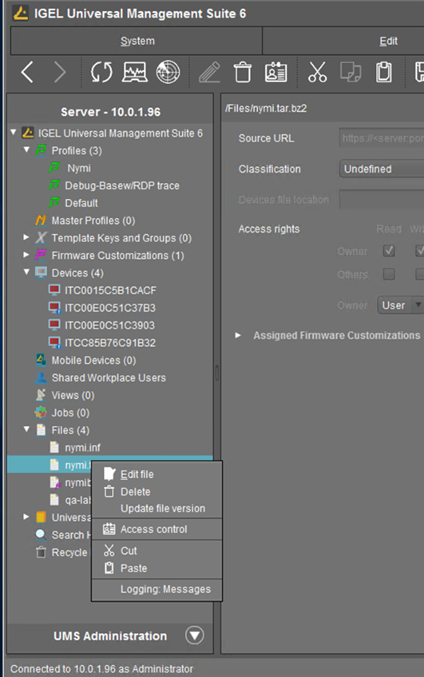
- In the left navigation pane of the UMS Console, in the Files section, right-click nymi.tar.bz2, and then select Delete.
- In the left navigation pane of the UMS Console, right-click Files, and then select New File. Navigate to the folder that contains the new nymi.inf, and then select the file.
- In the left navigation pane of the UMS Console, right-click Files, and then select New File. Navigate to the folder that contains the new nymi.tar.bz2, and then select the file.
- From the left navigation pane in the UMS console, right-click the device that contains the profile for the Nymi custom partition, and then select Reboot.
- From the UMS console, in the Profiles section, right-click the profile that contains the Nymi custom partition, and then select Edit Configuration.
- Navigate to System > Firmware Customization > Custom Partition > Partition.
- Select the Enable Partition option.
- Click Apply and send to device.
- On the Update time dialog box, select Now, and then click Ok.
- From the left navigation pane in the UMS console, right-click the device that contains the profile for the Nymi custom partition, and then select Reboot.

Updating Thick Client User Terminals
Update the Nymi Runtime software on Windows user terminals that use the Nymi Band to perform authentication tasks. In Citrix/RDP environments, update the Nymi Runtimesoftware on server that acts as the centralized Nymi Agent.

Uninstalling the Nymi Runtime
Perform the following steps to remove Nymi Runtime.
- Backup configuration files.
  - For user terminals that use Nymi Lock Control, navigate to C:\Nymi\Bluetooth_Endpoint and make a copy of the nbe.toml file.
  - For centralized Nymi Agent, navigate to C:\Nymi\NymiAgent and make a copy of the nymi_agent.toml file.
- Stop the Nymi services, including the Nymi Bluetooth Endpoint and Nymi Agent .
Note: For a Centralized Nymi Agent deployment, the Centralized Nymi Agent server does not have the Nymi Bluetooth Endpoint service and the user terminals do not have the Nymi Agent service.
- In Add or Remove programs, select Nymi Runtime, and then click Uninstall.

(Windows) Install Nymi Runtime
Nymi Runtime facilitates communication between NES and the Nymi Bands.
Install the Nymi Runtime on each user terminal on which you will also install a Nymi-enabled Application. You can perform a customizable installation or a silent installation.
Note: The Bluetooth (BLE) driver is installed with the installation of Nymi Runtime. The BLE driver may also be installed separately by going to the Nymi SDK package and installing the BleDriver .msi file.

Installing Nymi Runtime with the Installation Wizard
Perform the following steps to install or update Nymi Runtime on a network device, on which you want to install a Nymi-enabled Application.
Uninstall the previous version of Nymi Runtime.
- Create a backup copy of the C:\Nymi\Bluetooth_Endpoint\nbe.toml file.
- Log in to the terminal, with an account that has administrator privileges.
- Create a backup copy of the C:\Nymi\Bluetooth_Endpoint\nbe.toml file.
- Extract the Nymi SDK distribution package.
- From the ..\nymi-sdk\windows\setup folder, right-click the Nymi Runtime Installer version.exe file, and select Run as administrator.
- On the Welcome page, click Install.
- On the User Account Control page, click Yes.
The installation wizard appears. If the installation detects missing prerequisites, perform the steps that appear in the prerequisite wizards.
- On the Welcome to the Nymi Runtime Setup Wizard page, click Next.
- On the Nymi Runtime Setup page, click Next.
- On the Service Account window, perform one of the following actions to choose the account that starts the service:
  - Accept the default service account NTAuthority\LocalService, click Next.
  - For non-English Windows Operating Systems, choose the LocalSystem account from the drop list, and then click Next.
Note: The service account must have permission to run as a service. Enable Service Log On provides more information about how to modify the local policy to enable this permission for the service account.
The following figure shows the Service Account window.
Figure 135: Nymi Runtime Service Account window
- On the (Optional) Nymi Infrastructure Service Account, click Next.
Only deployments that use web-based Nymi-enabled Applications(NEAs) with a centralized Nymi Agent require you to configure the Nymi Infrastructure Service Account.
- On the Ready to install page, click Install.
- Click Finish.
- On the Installation Completed Successfully page, click Close.
- Stop the Nymi Bluetooth Endpoint service.
- C:\Nymi\Bluetooth_Endpoint\nbe.toml file with your backup copy.
- Start the Nymi Bluetooth Endpoint service.

Installing Nymi Runtime Silently
Perform the following steps to update the Nymi Runtime without user intervention.
Uninstall the previous version of Nymi Runtime.
- Create a backup copy of the C:\Nymi\Bluetooth_Endpoint\nbe.toml file.
- Log in to the user terminal with an account that has administrator privileges.
- Extract the Nymi SDK distribution package.
- Launch the command prompt as administrator.
- Change to the ..\nymi-sdk\windows\runtime folder, and then type one of the following commands:
  - "Nymi Runtime Installer version.exe" /exenoui /q /log NymiRuntimeInstallation.log
  - For installations on non-English operating systems,
"Nymi Runtime Installer version.exe" ServiceAccount="LocalSystem" /exenoui /q /log NymiRuntimeInstallation.log
Where you replace version with the version of the Nymi installation file.
Note: Ensure that you enclose the filename in double quotes.
The installation command returns to a command prompt immediately, and the installation completes silently. When the installation completes, Nymi Runtime appears in the Program and Features applet and NymiRuntimeInstallation.log file contains information about the installation.
Note: Alternately, you can track the progress by performing an unattended installation, which displays the installation screens but does not require user intervention by replacing the /q option with the /passive option in the installation command.
- Stop the Nymi Bluetooth Endpoint service.
- C:\Nymi\Bluetooth_Endpoint\nbe.toml file with your backup copy.
- Start the Nymi Bluetooth Endpoint service.
If required, you can review the installation log file in the %temp% directory named Nymi Runtime_version_time.log

(HP Thin Pro) Installing Nymi Bluetooth Endpoint
Follow the instructions below to manually install Nymi Bluetooth Endpoint manually. Retrieve the installation file nbed-cron_x.y.z_amd64.deb from Nymi.
Retrieve the installation file nbed-cron_x.y.z_amd64.deb from Nymi.
- Switch your user mode to Administrator from the system menu, or log in by entering an the credentials of a person in the domain admin group.
  - Right-click the desktop or click Start.
  - Click Switch to Administrator from the menu. You will be prompted to enter the administrator password.
The screen is surrounded by a red border when in administrator mode.
- Extract the file, nbed-cron_x.x.z_amd64.deb, from the Nymi distribution package and save it to the machine. Where x.y.z is the version of the file. Note the file path.
- Unlock read/write access with X Terminal.
  - Click Start and go to Tools.
  - Click X Terminal.
  - Type fsunlock
- In X Terminal change the directory to the file location of nbed-cron_x.y.z_amd64.deb and install the extracted file.
dpkg -i nbed-cron_x.y.z_amd64.deb
Where you replace x.y.z with the actual version number of the file.
- Reboot the client.

Update Nymi Lock Control
If you use Nymi Lock Control on the user terminal, you can update Nymi Lock Control silently or by using the installation wizard.

Installing or Updating Nymi Lock Control with the Installation Wizard
Perform the following steps on each user terminal in the environment.
- Right-click NymiLockControl-installer-vw.x.y.z and select Run as administrator.
- On the User Account Control window, click Yes.
- On the Welcome to the Prerequisites Setup Wizard, click Next.
- On the Prerequisites window, leave the default selections, and then click Next.
- On the Welcome window, click Install.
- On the Welcome to the Nymi Runtime Setup Wizard page, click Next.
- On the Nymi Runtime Setup window, leave the default options, and then click Next
- On the Service Account window, perform one of the following actions to choose the account that starts the service:
  - Accept the default service account NTAuthority\LocalService, click Next.
  - For non-English Windows Operating Systems, choose the LocalSystem account from the drop list, and then click Next.
Note: The service account must have permission to run as a service. Enable Service Log On provides more information about how to modify the local policy to enable this permission for the service account.
The following figure shows the Service Account window.
Figure 136: Nymi Runtime Service Account window
- On the Ready to install page, click Install.
- Click Finish.
- On the Installation Completed Successfully page, click Close.
- On the Welcome to Nymi Lock Control Setup Wizard window, click Next.
- On the Select Installation Folder window, perform the following actions:
  - To change the installation location, click Browse, navigate to a new installation folder, and then click Select Folder
  - To keep the default installation location, click Next.
- On the Ready to Install window, click Install.
- On the Completing the Nymi Lock Control Setup Wizard window, click Finish.

Installing or Updating Nymi Lock Control Silently
Perform the following steps to install or update the Nymi Lock Control silently, for example, when you want to install the software remotely by using a software distribution application.
- Save the Nymi Lock Control package, provided to you by your Nymi Solution Consultant.
- Launch the command prompt as administrator.
- From the folder that contains the Nymi Lock Control, type NymiLockControl-installer-vversion.exe /exenoui /q
Where you replace version with the version of the Nymi installation file.
The installation command returns to a command prompt immediately, and the installation completes silently. When the installation completes, the Nymi Lock Control application appears in the Program and Features applet.
Note: Alternately, you can track the progress by performing an unattended installation, which displays the installation screens but does not require user intervention by replacing the /q option with the /passive option in the installation command.

Updating the Nymi Band Firmware
Nymi provides a firmware updater utility to update Nymi Bands.
You can update one Nymi Band at a time or up to 5 consecutive Nymi Bands that are on charge and within bluetooth range of the computer that runs the utility.
During the update process, the utility provides the operator with high-level status information about the process. The upgrade process generates a log file that details the Nymi Bands that were updated, including serial numbers and firmware versions.
When the utility completes a Nymi Band update, the utility scans for other Nymi Bands in the vicinity (within Bluetooth range) that require an update. If a Nymi Band is found, the update is started on another Nymi Band. The utility keeps running until terminated by the user.

Updating the Firmware on Multiple Nymi Bands
You can update the firmware on a maximum of five Nymi Bands at one time. Attempting to update more than five concurrently may require the user to stop and manually restart the firmware update utility.
Updating the firmware on multiple Nymi Bands concurrently requires the following:
- Windows 10 computer.
- USB hub.
- Up to 5 Bluetooth adapters.
- Enough charging cradles to fill the ports in the USB hub (less the ports for the Bluetooth Adpaters).
- Download and extract the firmware package into a directory of your choice on a Windows computer. For example, C:\Nymi_firmware.
- If the Windows machine has the Nymi Band Application or Nymi Runtime installed on it, stop the Nymi Bluetooth Endpoint service.
- Disable or extend sleep mode on computer to prevent the utility from terminating when the computer goes to sleep.
- Plug the USB hub into an electrical outlet, and then into a USB port on the Windows machine.
- Plug up to 5 Bluetooth Adapters into the USB hub.
- Plug Nymi Band charging cradles into the remaining ports on the USB hub, and put a Nymi Band on each cradle.
Note: If you put a drained Nymi Band on charge, the charging icon appears, and the update process starts when there is a sufficient battery charge on the Nymi Band.
- From a command prompt on the Windows computer, change to the directory that contains the fw_updater_GOLD_<version>.exe file.
The firmware update utility interface appears and provides the following information:
  - Firmware version—The version of firmware version that the utility applies to eligible Nymi Bands.
  - Number of available BLE adapters—Number of Bluetooth Adapters that the utility detects in bluetooth range.
  - Number of in progress updates—Number of Nymi Band that are in STAND BY or DOWNLOAD state
  - Total number of Nymi Bands that are updated during the session. The following figure provides an example of the interface.
Figure 137: Firmware update utility interface
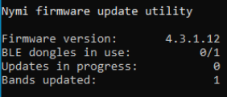
The utility scans the Bluetooth adapters on the USB hub for a Nymi Band that has a firmware version that is older than the version in the firmware package, or a Nymi Band with recovery firmware. When the utility detects a Nymi Band that requires the update, the Nymi Band screen displays STAND BY, and when the utility starts the transfer of the firmware to the Nymi Band, the Nymi Band screen displays DOWNLOAD.
Note: The utility requires the Nymi Bands to be in close proximity of the Bluetooth adapter(s) before the firmware update transfers to the Nymi Band. The range varies with the environment, and the default range is approximately 6-18 inches. The default range is limited to avoid unintended updates of Nymi Bands. If an increased range is desired, run the utility with the --rssi value argument, where value is in the range of -50 to -99. A lower RSSI value (closer to -99) provides longer range, while a larger value (eg. -50) will decrease it. By default a value of -60 is used.
- When the Nymi Band firmware download completes, the Nymi Band automatically restarts and applies the update. A brief SUCCESS message appears when the update completes. Take the completed Nymi Band off charge and plug in another Nymi Band that requires updating.
The firmware update process takes about 5 minutes.
- To stop the application, press Ctrl+C.
When the utility terminates, Nymi Bands that were in the process of downloading software will revert back to the previous firmware version.
- If required, restart the Nymi Bluetooth Endpoint service.
Some firmware updates, require you to re-enroll the Nymi Band, review Updating Nymi Connected Worker Platform for more information.

Updating the Firmware on a Nymi Band
You can update the firmware on a Nymi Band that you plug into a machine that has access to the firmware update utility.
Updating the firmware on a Nymi Band requires the following:
- Windows 10 computer with 2 USB ports.
- One Bluetooth adapter.
- One charging cradle.
- Download and extract the firmware package into a directory of your choice on a Windows computer. For example, C:\Nymi_firmware.
- Disable or extend sleep mode on computer to prevent the utility from terminating when the computer goes to sleep.
- If the Windows machine has the Nymi Band Application or Nymi Runtime installed on it, stop the Nymi Bluetooth Endpoint service.
- Plug the Bluetooth Adapter into a USB port on the Windows machine.
- Plug Nymi Band charging cradles into other USB port, and put the Nymi Band on the cradle.
Note: If you put a drained Nymi Band on charge, the charging icon appears, and the update process starts when there is a sufficient battery charge on the Nymi Band.
- Change to the directory that contains the fw_updater_GOLD_version.exe file, right-click on the file, and then select Run as administrator.
The firmware update utility interface appears and provides the following information:
  - Firmware version—The version of firmware version that the utility applies to eligible Nymi Bands.
  - Number of available BLE adapters—Number of Bluetooth Adapters that the utility detects in bluetooth range.
  - Number of in progress updates—Number of Nymi Band that are in STAND BY or DOWNLOAD state
  - Total number of Nymi Bands that are updated during the session. The following figure provides an example of the interface.
Figure 138: Firmware update utility interface
The utility scans the Bluetooth adapter for a Nymi Band that has a firmware version that is older than the version in the firmware package, or a Nymi Band with recovery firmware. When the utility detects a Nymi Band that requires the update, the Nymi Band screen displays STAND BY, and when the utility starts the transfer of the firmware to the Nymi Band, the Nymi Band screen displays DOWNLOAD.
- When the Nymi Band firmware download completes, the Nymi Band automatically restarts and applies the update. A brief SUCCESS message appears when the update completes. Take the completed Nymi Band off charge and plug in another Nymi Band that requires updating.
The firmware update process takes about 5 minutes.
- The firmware update utility continues to scan the Bluetooth Adapter for a Nymi Band that requires an update. To stop the utility, press Ctrl+C.
If you stop the utility while a firmware update was in progress of downloading the software, the Nymi Band reverts back to the previous firmware version.
- If required, restart the Nymi Bluetooth Endpoint service.
Some firmware updates, require you to re-enroll the Nymi Band, review Updating Nymi Connected Worker Platform for more information.

Firmware updater log files

By default, the firmware update utility creates two files in the same location as that contains the fw_updater_gold_v<version>.exe file, which you can view at any time during the firmware update process.
Note: You can use the --log argument to define an alternate location for the files.
- result_log.csv—Contains summary information about the Nymi Bands that the firmware update utility updates.
- fw_updater.log—Contains system diagnostic information about actions that utility runs during Nymi Band firmware updates. The utility creates a maximum of 5 rotating log files. Each of these log files cannot exceed 10MB.

Changing the Connected Worker Platform Communication Protocol
Starting with Connected Worker Platform(CWP) 1.15, the Nymi solution supports a new, high performance protocol over Bluetooth between the Nymi Runtime and Nymi Bands.
After you update all CWP components, including Nymi Band firmware on all Nymi Bands to CWP 1.15.x and later, perform the following steps on all Windows user terminals (for Evidian environments on Wearable user terminals only) where users access Nymi-enabled Applications(NEAs) to disable the legacy protocol. The enrollment terminal only requires the environment variable if users access NEAs on the enrollment terminal.
Note: After you set this environment variable, user terminals cannot communicate with Nymi Bands that use pre-CWP 1.15.x firmware
- In the Windows search field, type env, and then from the pop-up menu, select Edit the System Environment Variables.
- Click Environment Variables.
- In the System Variables section, click New, and the perform the following actions:
  - In the Variable Name field, type NYMI_NEA_SUPPORT_LEGACY_MODE
  - In the Variable Value field, type 0.
The following figure provides an example of the new variable.
Figure 139: New System Variable window
  - Click OK.

Appendix—Recording the CWP Variables
Throughout the deployment process, you will perform configuration tasks that you will be required to remember later on.
Use the following table to keep track of values for variables that you define when you deploy the CWP solution.
Table 8: CWP Values
Component | CWP Backend Variable Name | When Used | Value
Nymi Enterprise Server(NES) FDQN |  | NES deployment
NES URL | NES_URL | Connect to the NES Administrator Console
NES Communication port number (LDAP/LDAPS) | CORP_LDAP_PORT | CWP Backend deployment (cca script)
NES Administrators group name and user accounts |  | NES deployment  CWP Backend deployment (cca script)
NES Administrator accounts |  | Access to NES Administrator Console
Nymi Infrastructure service account |  | Nymi Agent communications with NES and NES communications with the SQL server.

Appendix—Recording the CWP Component FQDNs
Throughout the deployment process, you will perform configuration tasks that you will be required to remember later on.
Use the following table to keep track of FQDNs for various components in the CWP solution.
Table 9: CWP Values
Component | FQDN
Nymi Enterprise Server(NES) FDQN
Centralized Nymi Agent & virtual server port #
Centralized Nymi Agent with WebAPI enabled & virtual server port #

Appendix—TLS Certificates Expiration Dates

The Connected Worker Platform(CWP) makes use of a server TLS certificates. Each certificate has an expiration date. Record the expiration date of each certificate as you go through the deployment procedure and keep this sheet for your records. Renew certificates before the expiration date to avoid disruption of CWP services. For more details on certificate management, see the Nymi Connected Worker Platform—Administration Guide.
Table 10: Certificate Expiration Dates
Certificate Type | Expiration Date
Nymi Enterprise Server(NES) TLS Server Certificate
Nymi Agent(WebAPI)

